**Date: 18-12-2023**

**DEVOPS**

Devops is combination of development and operational team

**Date: 19-12-2023**

**Linux**

**Class- 2**

Devops is combination of 4-5 teams. the work which done by 4-5 teams whole work will done by only Devops engineer.

By using Devops and AWS we will get to know how to monitor and deploy and also, we can get to know how to work with cloud.

How to deploy?

Devops is nothing but **methodology**. Methodology means it is an algorithm type. It give’s step by step process.

Before Devops we have

Business team and Architect team are major teams for any project.

Business team – gather all requirements from client and how to provide security. Gives update for clients

How to deploy codes?

**Date: 02-01-2024**

**Class - 1**

**Devops Tools**

Git --- 5-7 days

Maven

Tomcat server

Docker

Kubernetes

Terraform

Jenkins

Ansible

**Git:**

It’s a source code management tool (SCM tool) or Version control tool

Developers, testers, Aws and Devops Engineer, Maintenance team almost in organization will use git.

What is the use of git?

Developers will use sts to develop code. Same organization each developers has different tasks if we need code from other person then we can use pendrive, mail etc… to merge the code, but for this organization won’t accept because code must maintain safety.

To control this process, we “**Git Tool”**.

We have Git and GitHub.

Difference between git and GitHub?

Git is nothing but in local developer has written code that code we need to move to GitHub

Git is used to transfer code from local machine to GitHub

Local Machine

GitHub

Used for storage purpose

We can store many numbers of developer’s code

90% of developer use windows operating system

For Git we need to install app

For GitHub we need to create account we don’t have apps for GitHub

SVN, GIT BUCKET, GIT LAVEN are other tools similar to git

Mostly in organizations use “Git” tool to transfer the data from local system to GitHub

After installing if we are right click in home page we can see “open Git GUI here”, “Open Git Bash here”.

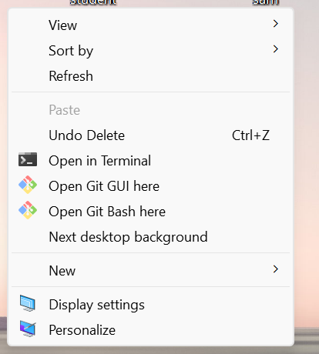

Git we can learn in two ways:

1. Terminal Based
2. UI Based

Here we can learn both ways.

Now creating one folder in windows D folder name “gitdecprac”

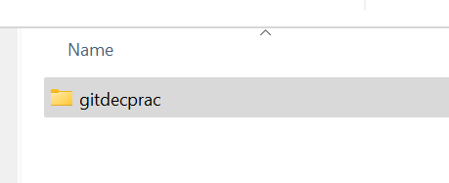

Now I’m opening **gitdecprac** then here **rightclick** select **Open Git Bash here**

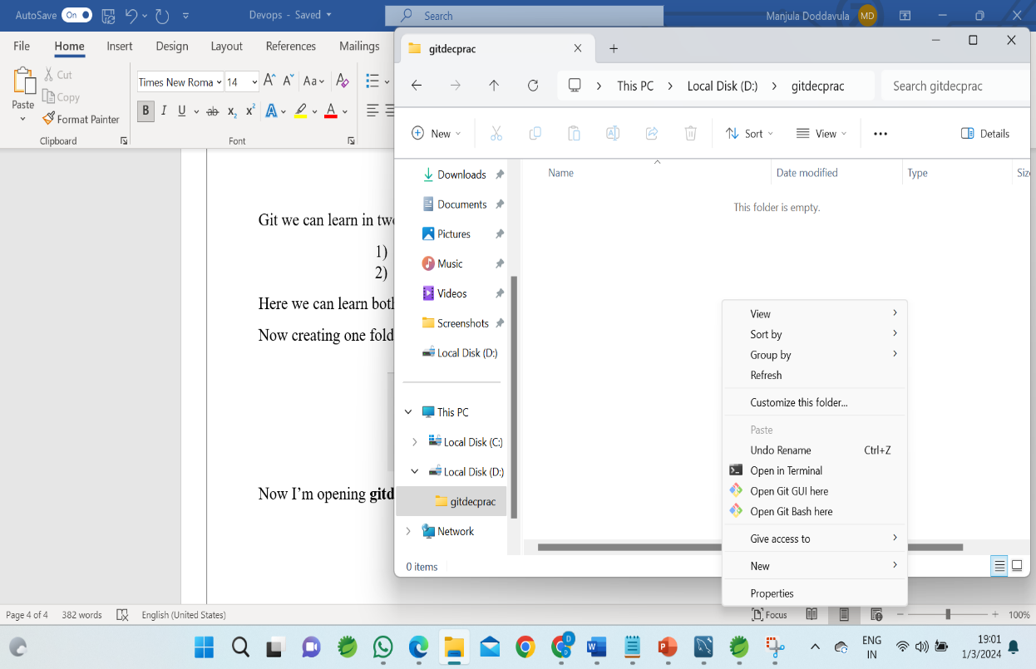

Then terminal will open here

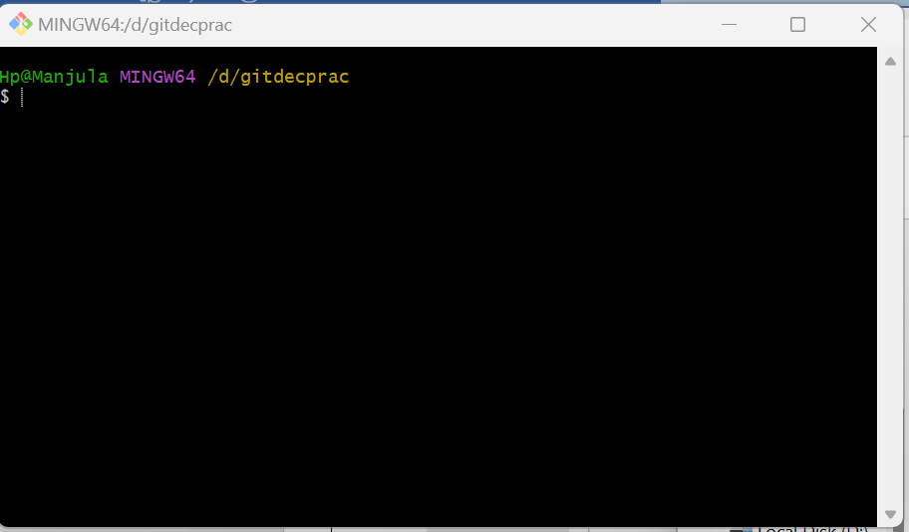

In this Git Bash we can communicate through commands

In Git GUI – graphical user interface

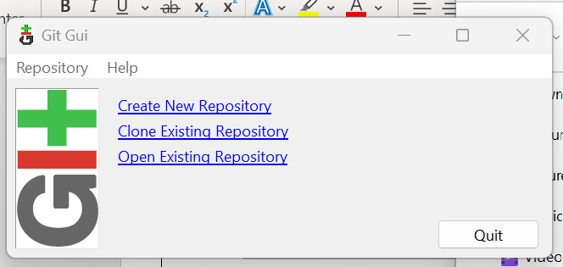

Mostly in organization use terminal mode.

After entering into **gitdecprac** we don’t have any files.

If we are giving commands in terminal, it will throw errors

**git status** is a command it throws a **fatal error**

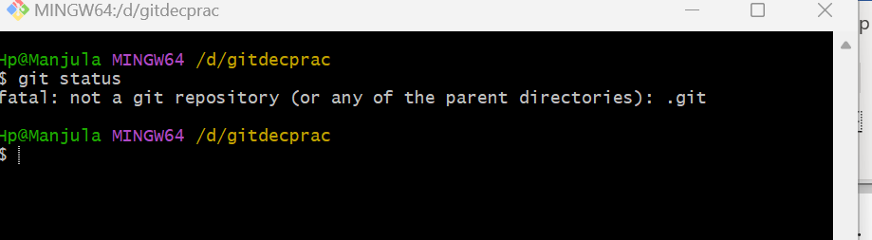

not only if we are using any command, it throws **fatal error**

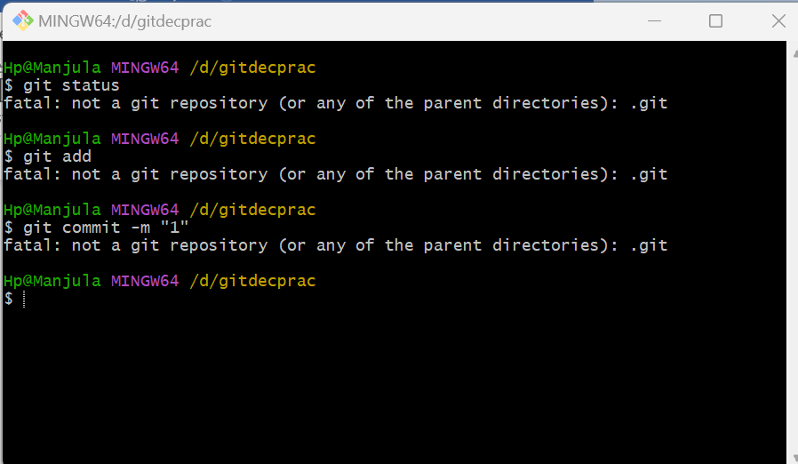

Here we are giving different commands but we are getting same error.

Basically, git commands need in particular folder we need to have “**.git**” folder

After creating folder, we need to give “**git init**”

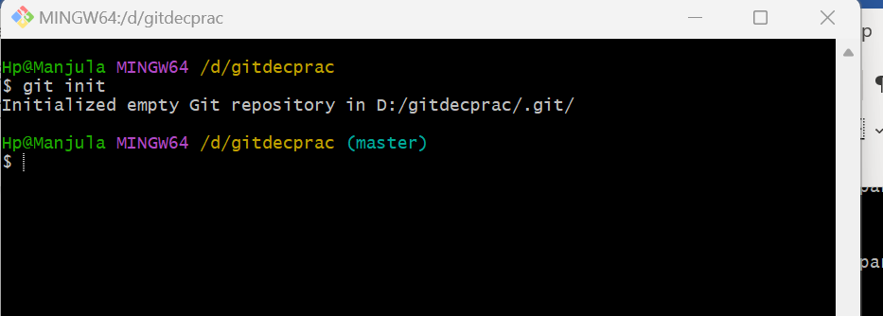

**Git init** - initializing the git command in gitdecprac

Why we need to initialize in this gitdecprac folder?

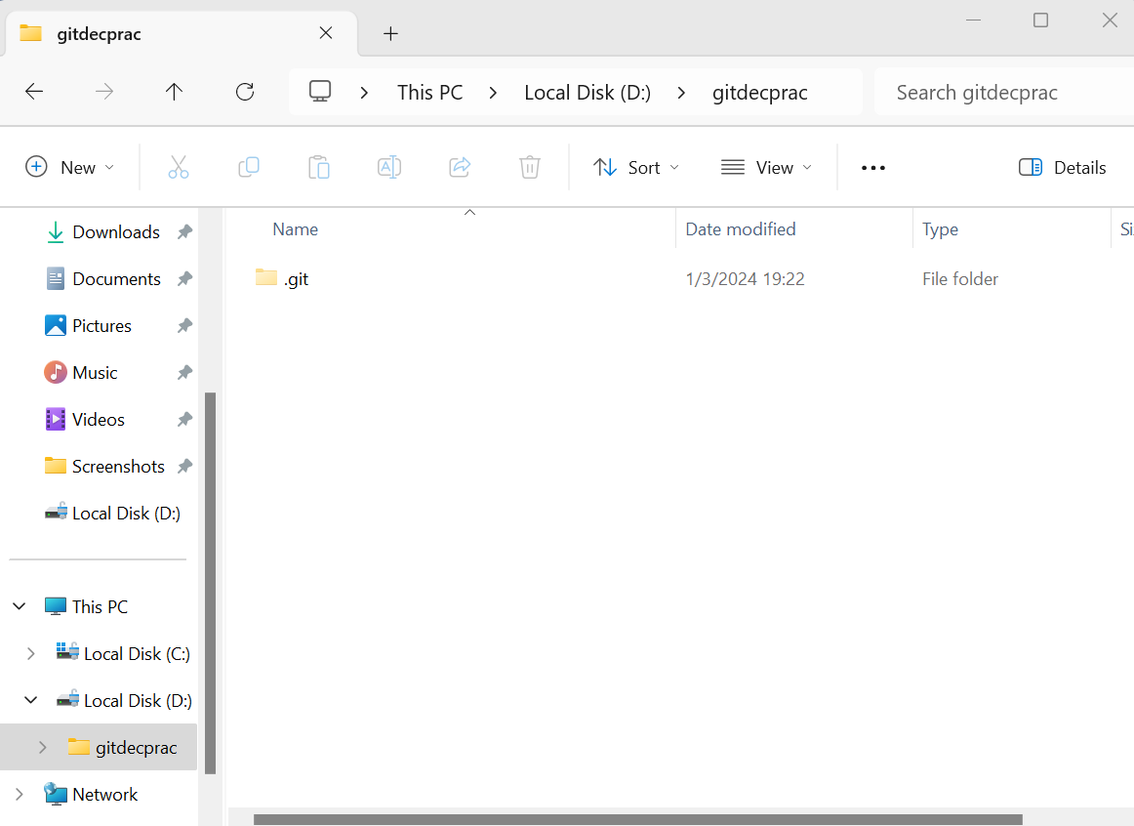

Infront of folder/file we have dot means it will treat as hidden folder/file.

If we want see hidden files select **view** and click on **hidden items**

Inside **.git**  we have some directories and some files.

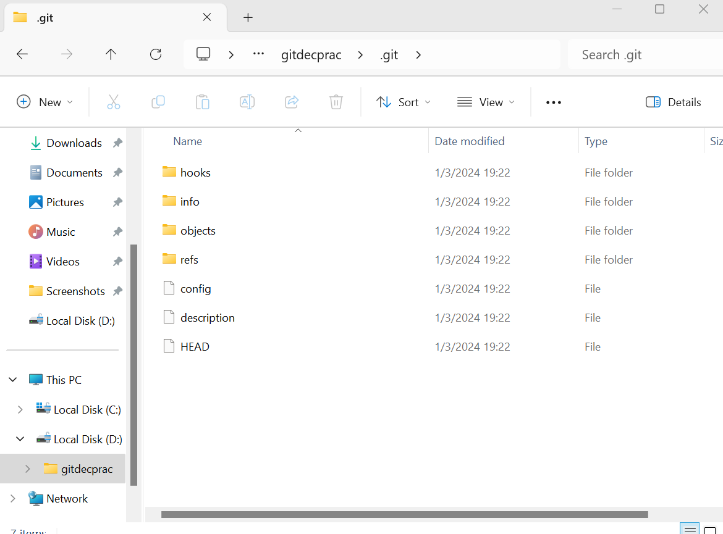

After **git init** we can give any command, we won’t get any error. Because we have initialized **.git**  so we won’t get any error.

Without **.git** folder we are using commands it will throw errors.

Internally **.git** create 3faces

GitHub

1. Workspace area
2. Staging/index area
3. Local repository

Workspace area

Staging area

Local repository

Git

How to move file from workspace area to staging area?

If file is in workspace area, then message will show’s “**untracked files**”

If file is in Staging area, then message will show’s “**Changes to be committed**”

If file is in Local repository the message will show’s “**working tree clean**”

Only one time we to initialize the git at starting of the creation of the file. Once “**.git**” folder is created no need to initialize the git again we can use folder directly.

How to create empty file?

By using **touch** command, we can create empty file.

By using **ls -la** command, we can see weather file is created or not.

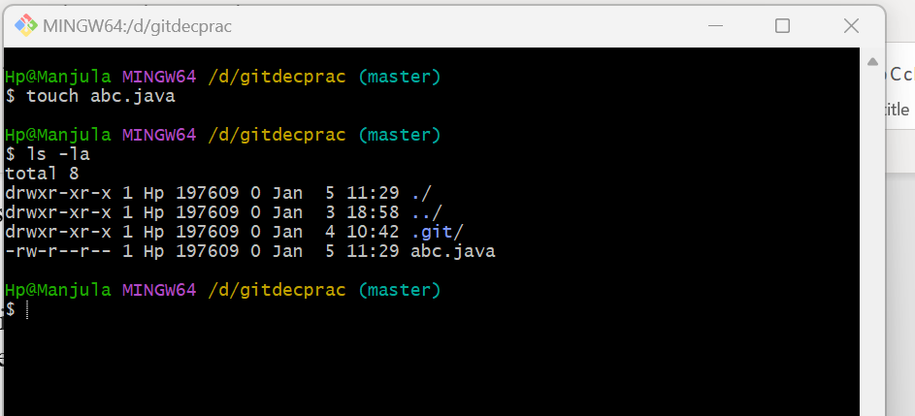

If one file is created then we get where that file is located.

How find in which stage file located?

By using “**git status**” command we can find where file located

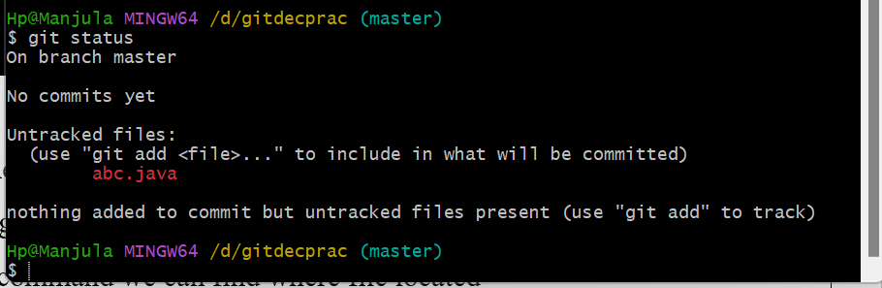

If untracked files are displaying then the file must be located in workspace area.

Now file need to move from workspace area to staging area

By using “**git add abc.java**” command we can move file from workspace area to staging area.

We can use **git status** command to check status of file where file is located.

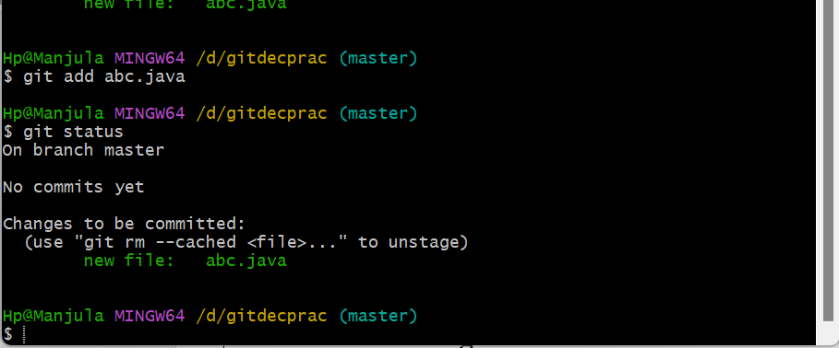

Now file is located in staging area.

Form here to we need to change into local repository. By using **git commit -m “label message”**

label message – we can give anything

**git commit -m “testing purpose”**

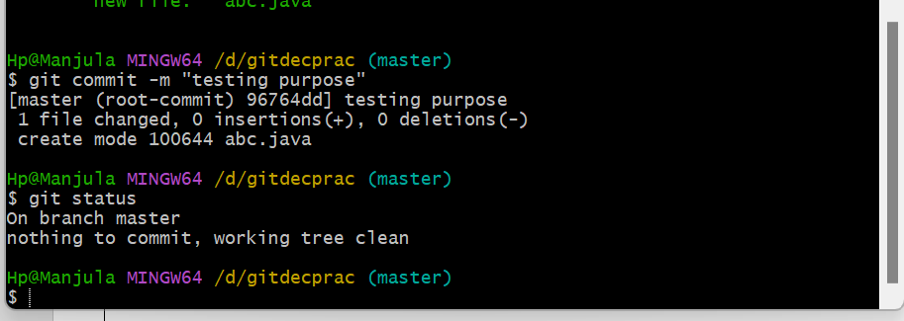

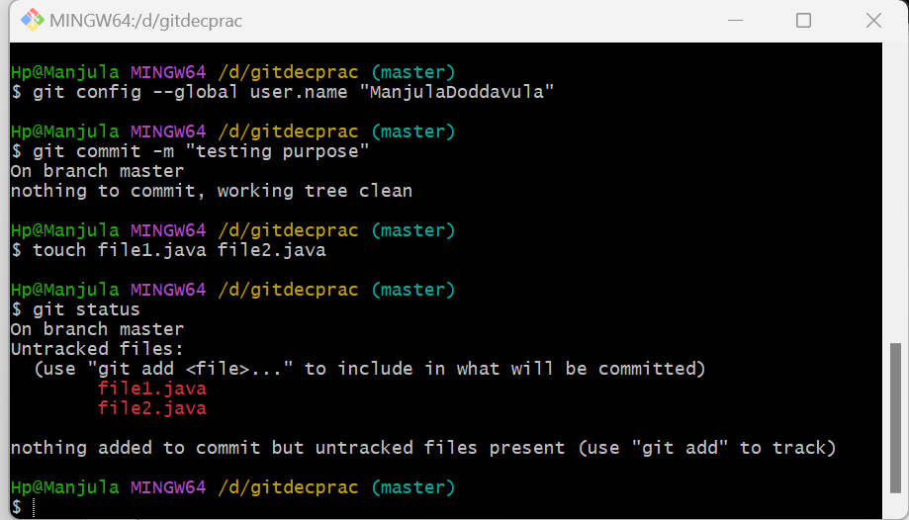

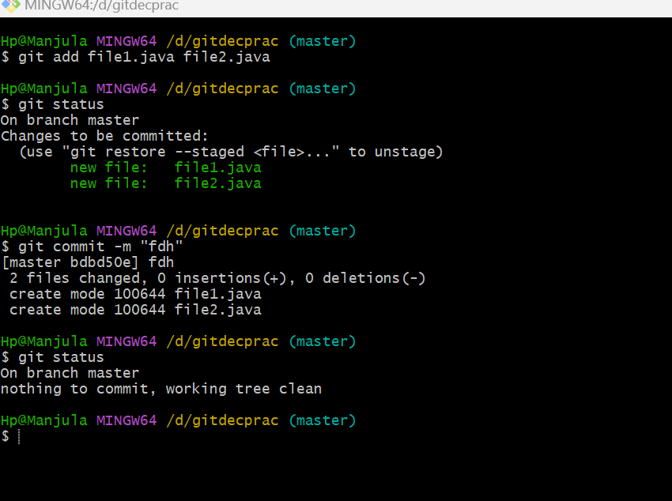

If we are creating file, it must be created in workspace area.

From workspace area to we can change it to staging area.

From staging area to local repository

If we have 10files at a time we need to move then we need to use “**git add .**” command used to move to staging area

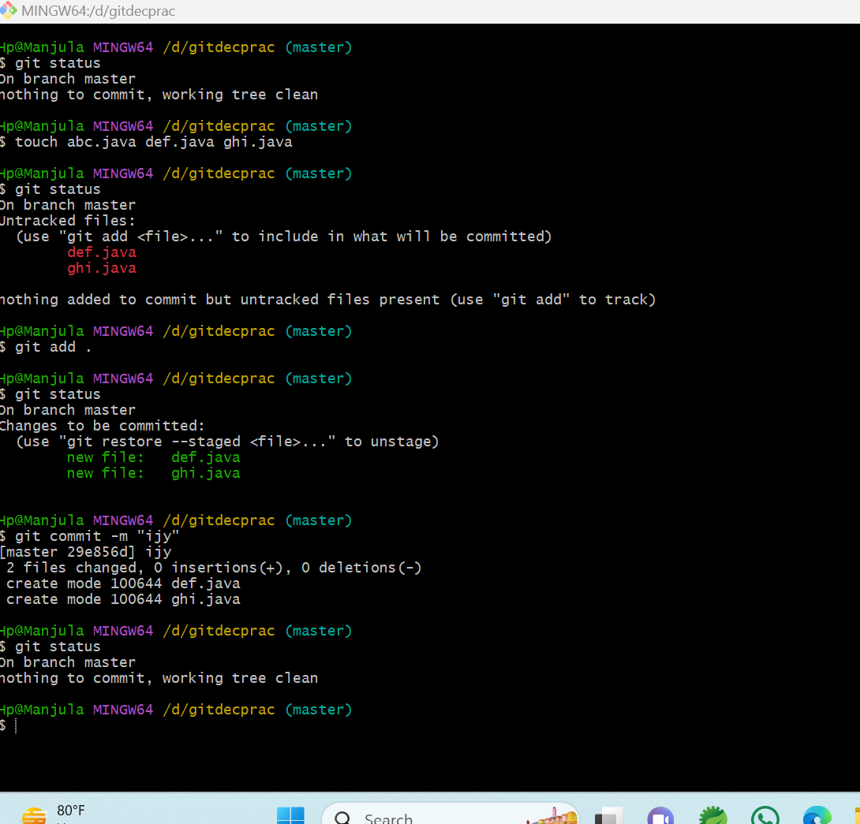

**Note:**

**git init:** used to initialize the .git file in new folder

to create empty files, we use - **touch filename**

**git status** – used to check where file is located

**git add filename** or **git add .** – used move file from workspace area to staging area

**git commit** -m “label message” – used to move file from staging area to local repository

**label message** – we can give anything in label message

**Date: 03-01-2024**

**Class -2**

In GitHub we need to create repository.

In this repository we can store our files.

How to create repository?

Here we need to give repository name, description, public and add a readme file

Click on create repository.

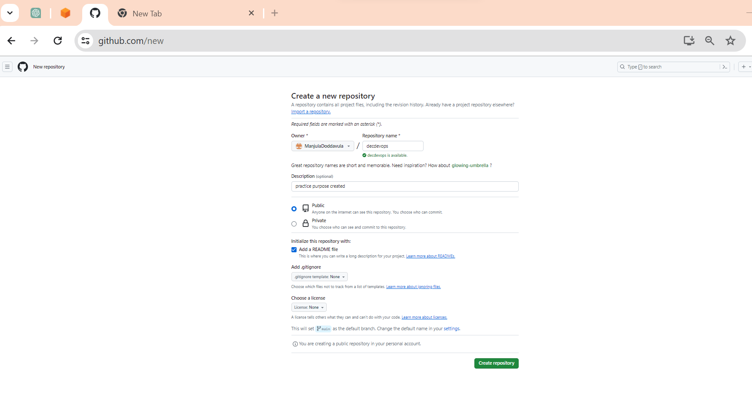

Now repository is created with decdevops

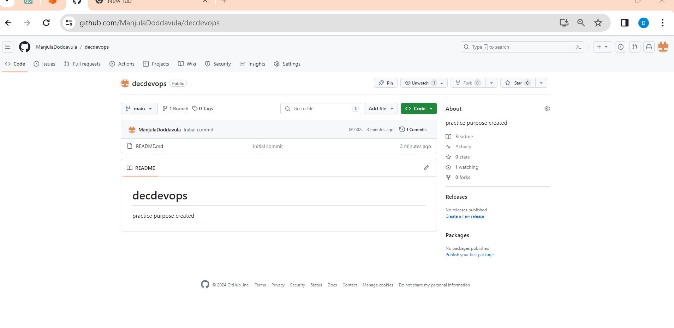

To access GitHub, we need login in github.com. runs in online

For git we are installed git software. Git runs in local system

If we want to store file in GitHub, we need communication between git and github

We can create communication in 2-3 ways we can generate

Mostly in organization used

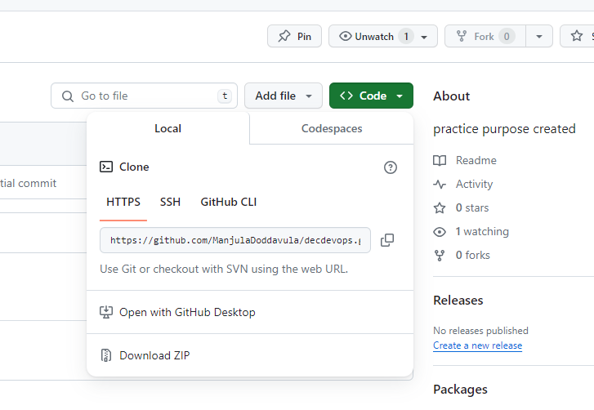

Here we select HTTPS link

**git clone**  [**https://github.com/ManjulaDoddavula/decdevops.git**](https://github.com/ManjulaDoddavula/decdevops.git) - used to clone both git and github

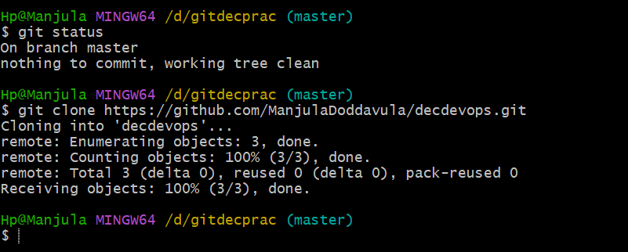

Here clone method created one folder for github repository.

By default **“.git”** folder will create and we have another folder README.md

If we double click on REANME.md it will show same description which have given in GitHub.

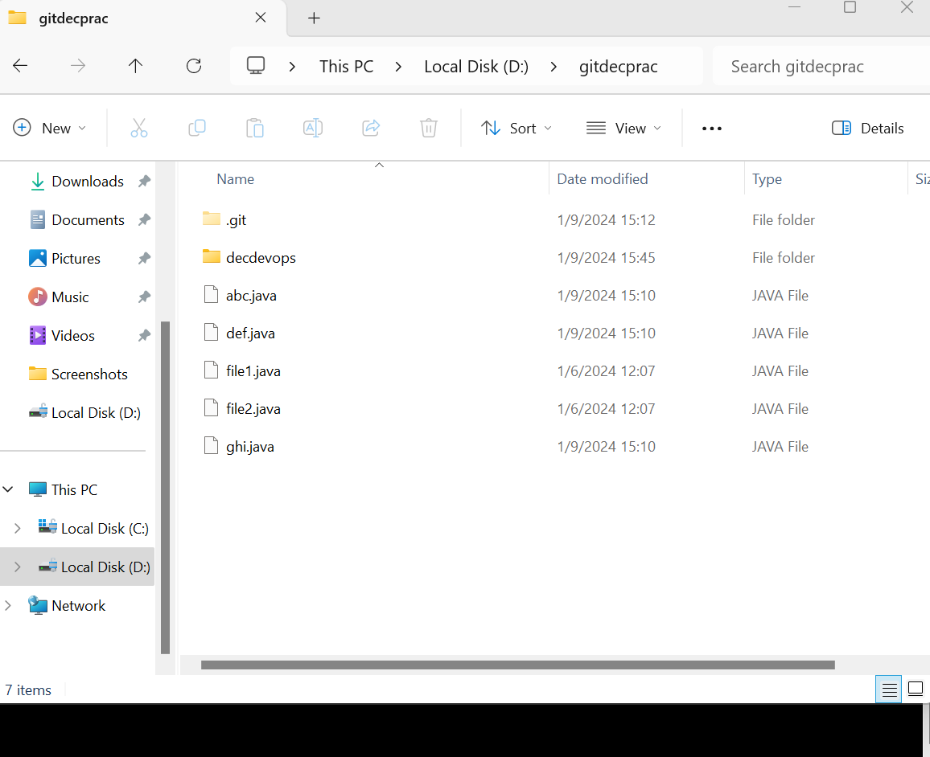

git clone URL – URL converted as folder in our folder.

if we are checking files contained in our folder using **ls -la**. It will show all folders including GitHub repository

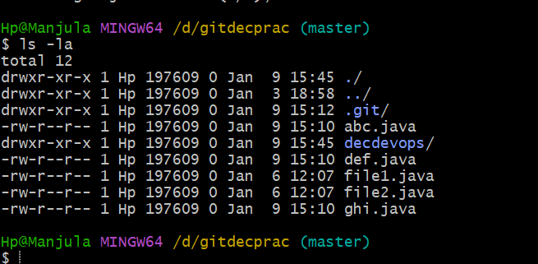

By using **cd folder name**, we can enter in side the GitHub repository

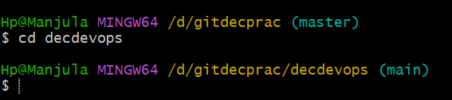

**ls -la** – show file contained in decdevops

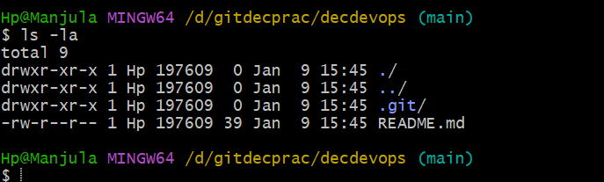

Here we can create some files

We create empty files using **touch** command



By using **git status,** we check where files created

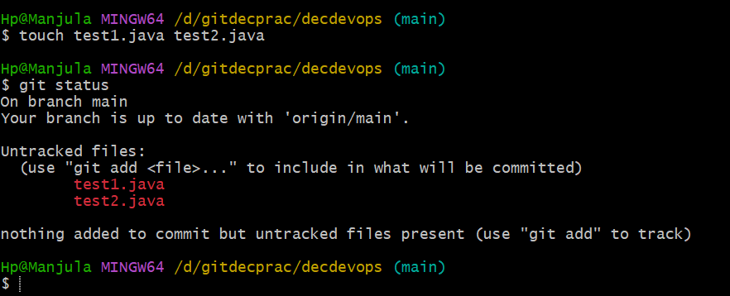

Here files are created in workspace area in decdevops folder.

If **.git** is created by default workspace area, staging area and local repository will created.

To move files form workspace area to staging area we use **git add .** or  **git add filenames**  command

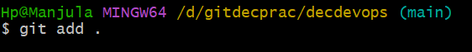

To check now where files is located, we use **git status** command

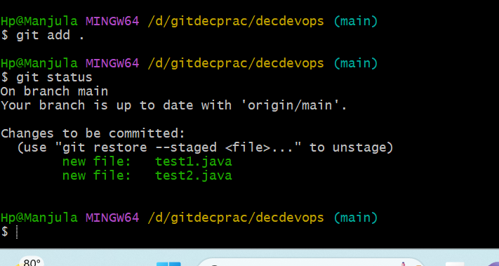

Now files are located in staging area

Now files are moving from staging area to local repository we are using **git commit -m “label message”**

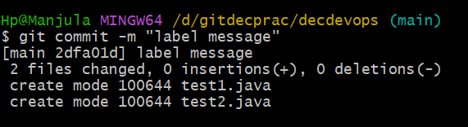

Now we are “**git status**” to check files located area

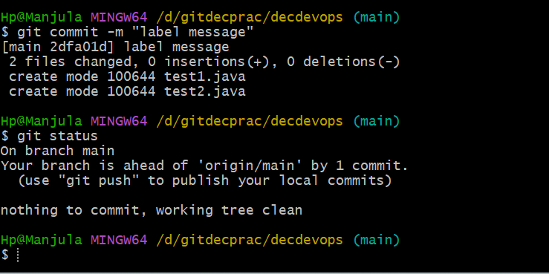

Now our files are located in local repository

Now we need send these two files into GitHub repository. By using **git push** command, we can send

Very first time it will ask user name and password

We need to give user name and password

Then after completing authentication files will moved to GitHub repository

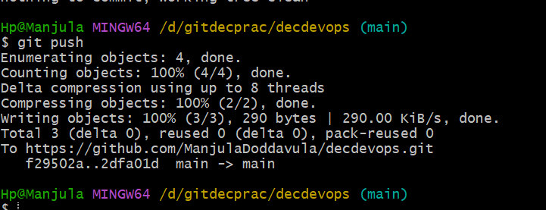

It will show message like main->main

Here we created file with data using **vi filename** command

To check weather data saved in file using **cat filename** command.

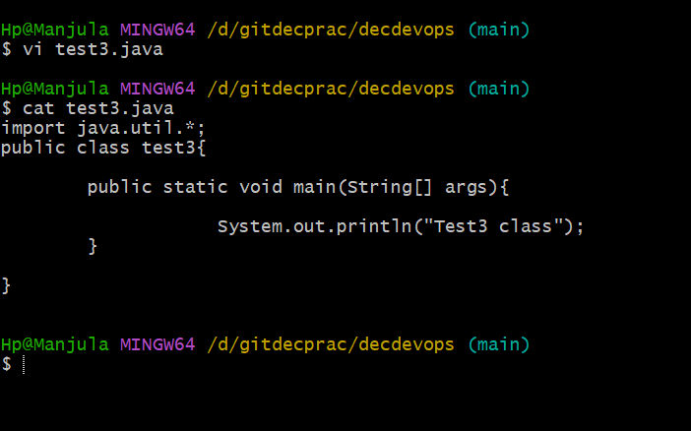

By using **git status,** we checked where file is located

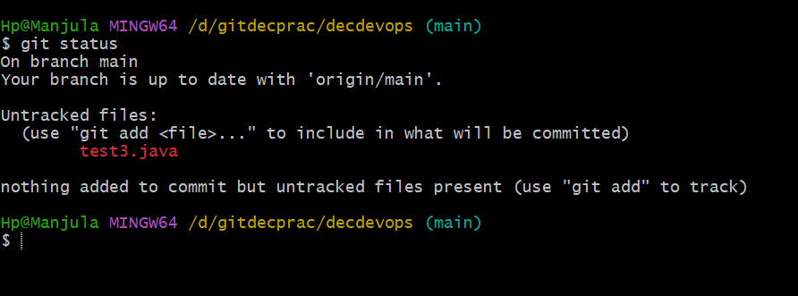

Here file is located in untracked files (means file is create in workspace area)

File form workspace area to we need to move staging area using **git add .**

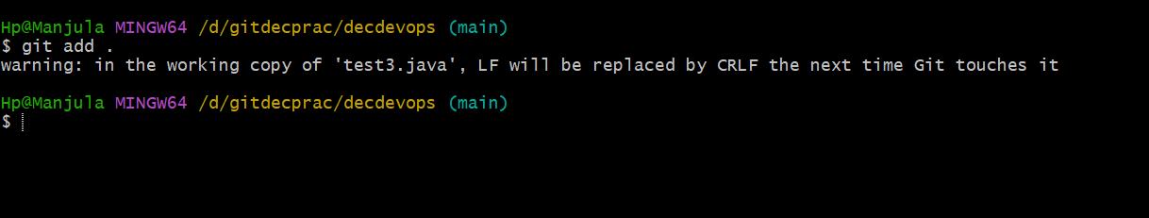

We got warring

To check where file is located by using “**git status**” command

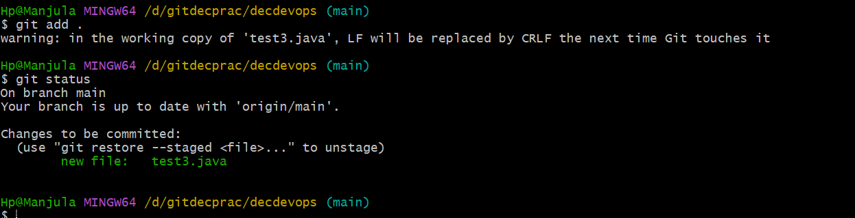

But file is moved to staging area (here it is showing changes to be committed).

**git commit -m “text data in file”** – using to move file from staging area to local repository

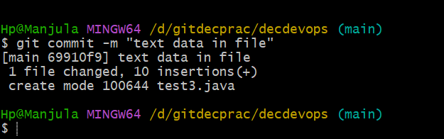

Now we are using **git status** to check weather file moved or not

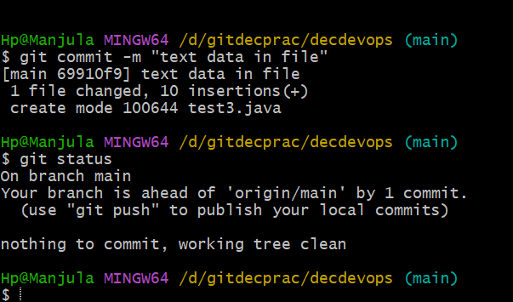

Now file located in local repository

We need to move file from local repository to GitHub repository we use **git push** command

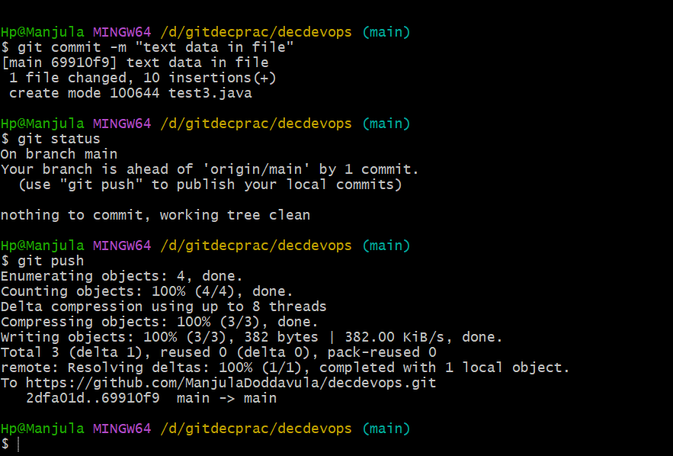

Now file is moved to GitHub repository

Basically, we can store file in GitHub repository where files is created in local

First, we need to clone git

Here we are moving some files which we have created before to GitHub

Using **git status** command, we check status of files

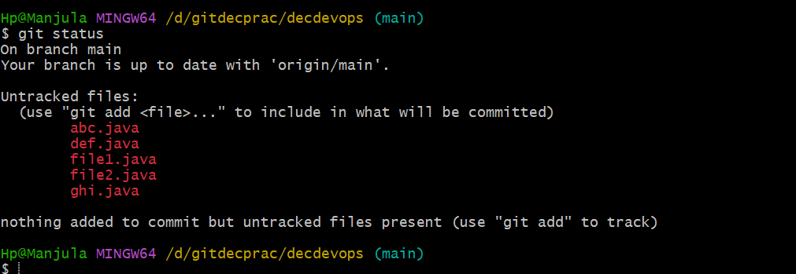

Using **git add .**  command, we change files from workspace area to staging area and using **git status** command to check where file located

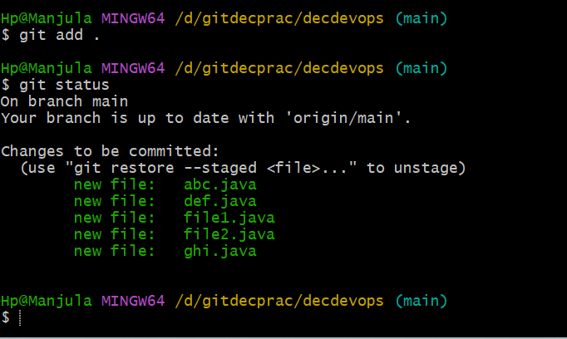

Using **git commit -m “text”** command, we can file from staging area to local repository. **git status** command to check where file located

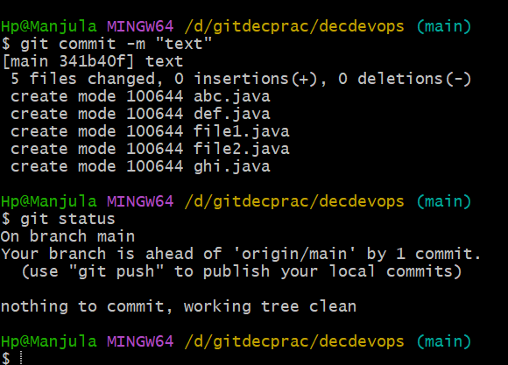

Using **git push** command, we can change file from local repository to GitHub repository.

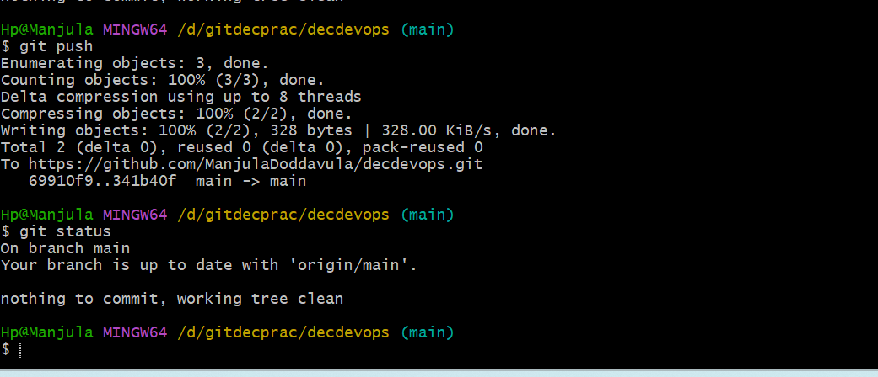

**Date: 04-01-2024**

GitHub

**Class – 3**

Again, we created new repository

repository

First, we need to create some files later we need move files

To GitHub repository

For that first we copy GitHub repository URL

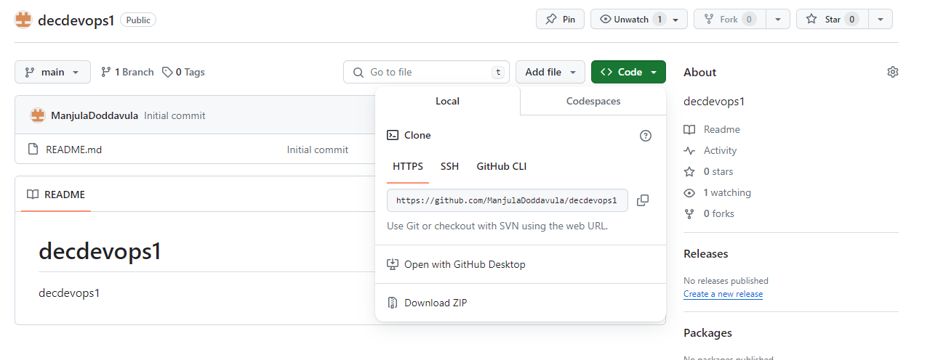

Then we need clone for local repository

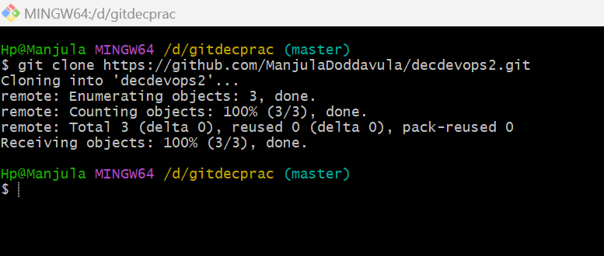

By using that another folder is created for decdevop2 in local repository

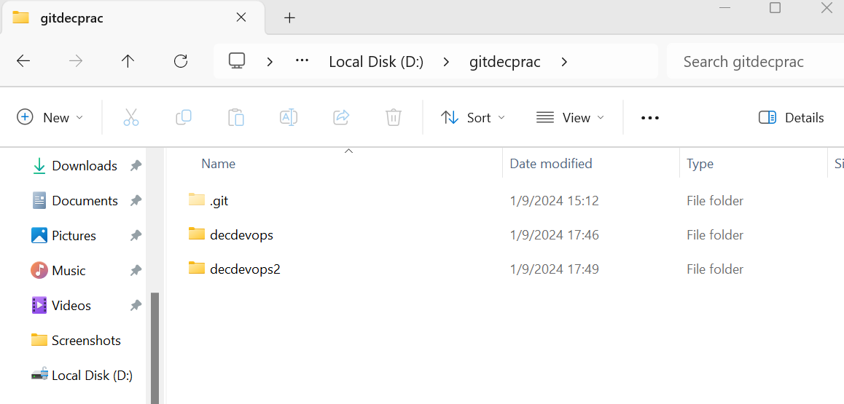

Now I’m in local disk “D:\gitdecprac”

But we need create files in “decdevop2”

By using **ls -la** command we can check files which contained in particular folder

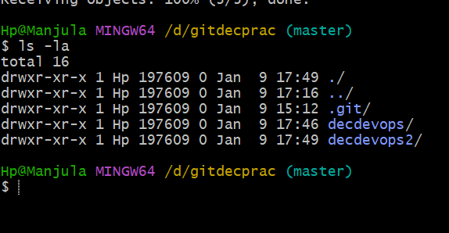

By using **cd** command we are moving into “decdevops2” folder

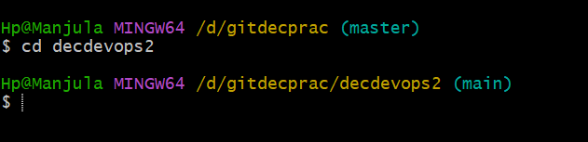

Now we are in “/d/gitdecprac/deveops2”. Here we are going to create files

By using **touch file{1..10}** command.

**touch file{1..10} –** we can create multiple files at a time

by using **ls -la**  command we can check weather files is created or not

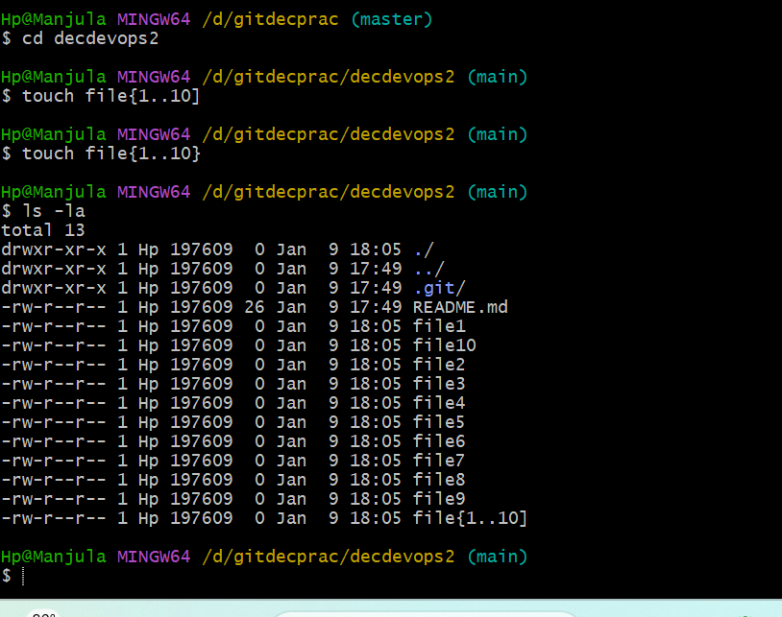

Now all these files are in untracked files (means files are located in workspace area)

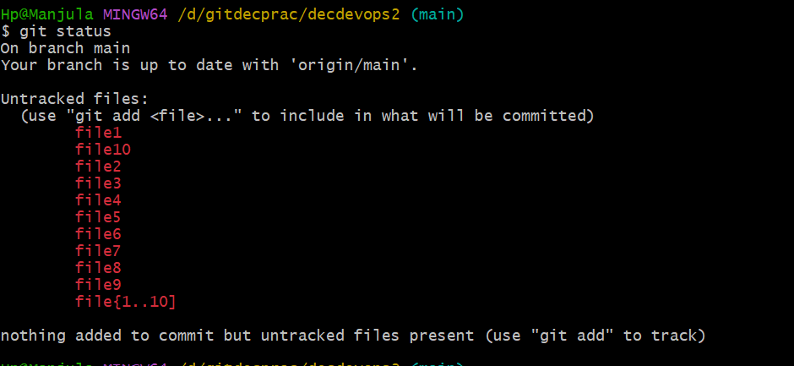

Now we need to move files from workspace area to staging area. By using “**git add .**” command

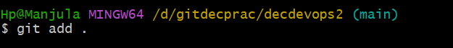

To check weather files are changed to staging area or not

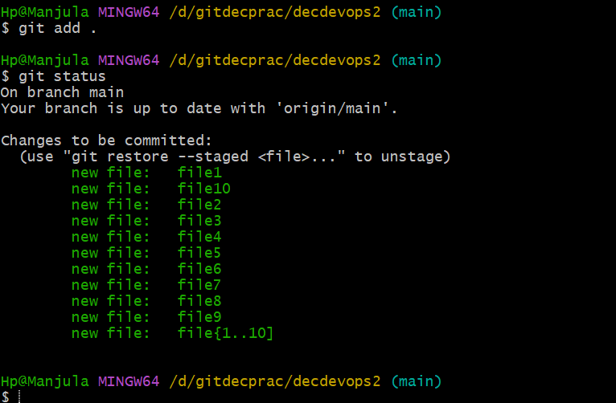

Now files are in changes to be committed (means files are located in staging area)

Now we need to move files from staging area to local repository

By using **git commit -m “test”**

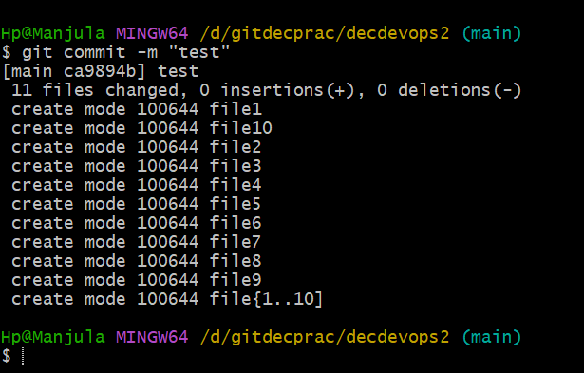

By using **git status,** we are using to check where files located

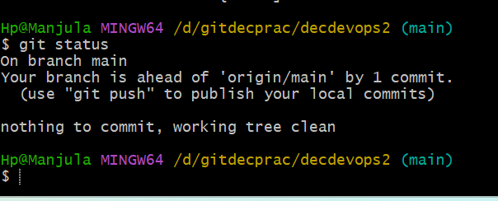

Now files are located in local repository. but here files are represented by seeing working tree clean we are assuming files located in local repository

By using **git log** command to check which files are located in local repository

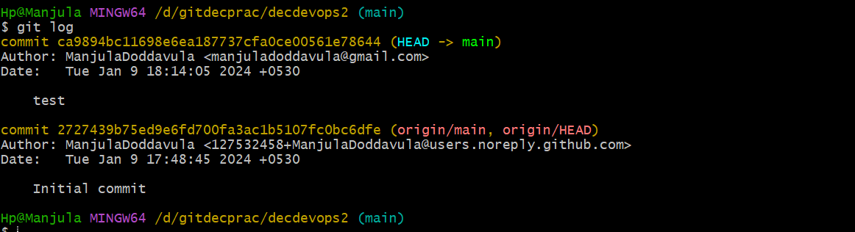

Here **test** is our label message which we have given to change from staging area to local repository

From here we copying commit id. Basically, commit id contains 42characters. commit id’s must be unique.

Initial commit was by default it created while doing clone .git

“git show ca9894bc11698e6ea187737cfa0ce00561e78644”

By using this we can see all files and it shows all phases from where files are transferred

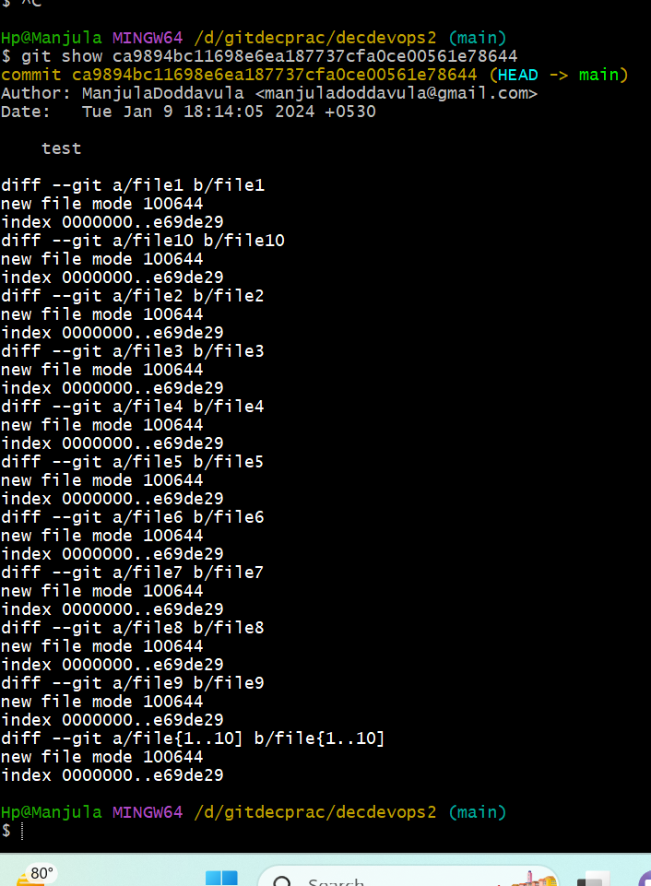

If we are giving git show commit id of initial commit id then it will show

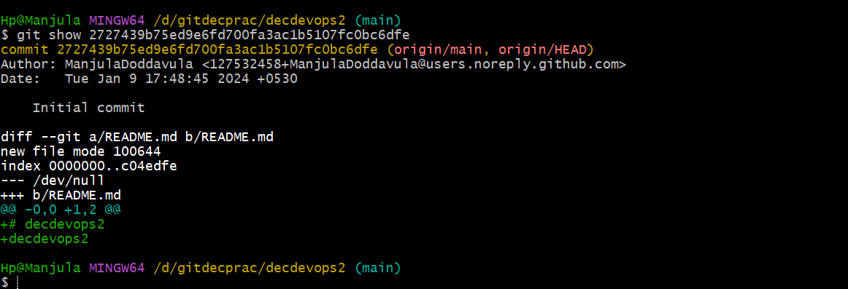

If we are using **git log** command it will show how many commit id’s we are generated

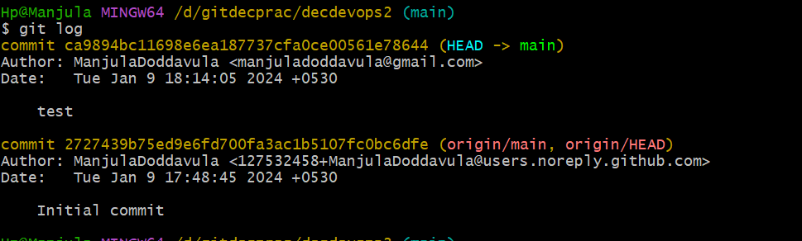

We created only one commit id

Still, we are creating some files

By using **touch filename**

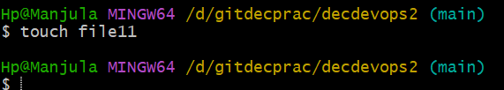

Now we are checking file location by using **git status**

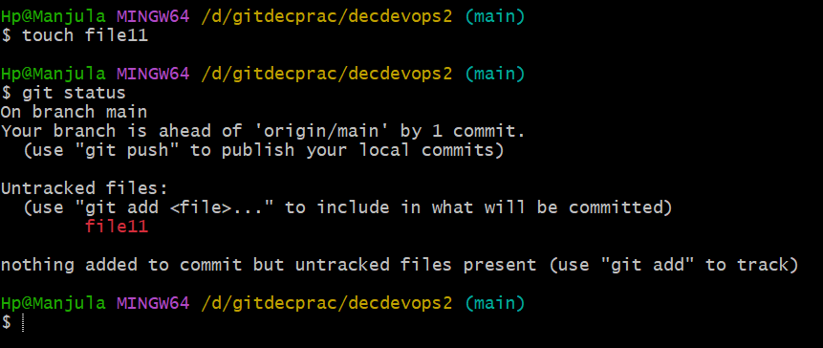

Now file11 located in workspace area.

we need to move file from workspace rea to staging area by using **git add .** command and we check file location using **git status** command

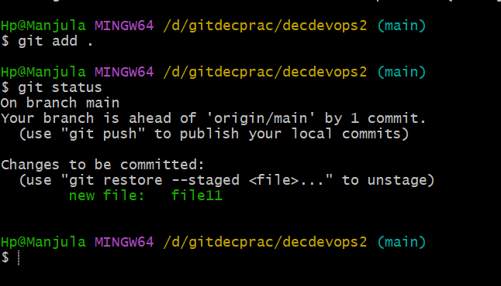

Now file11 is located in staging area

Now we need to move file11 from staging area to local repository. by **using git commit -m "testing"**  command and we check file location using **git status** command

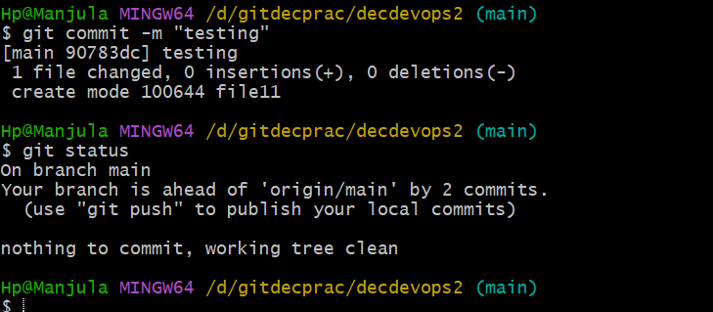

Now file is located in local repository.

To know in-depth, we are using **git log** command.

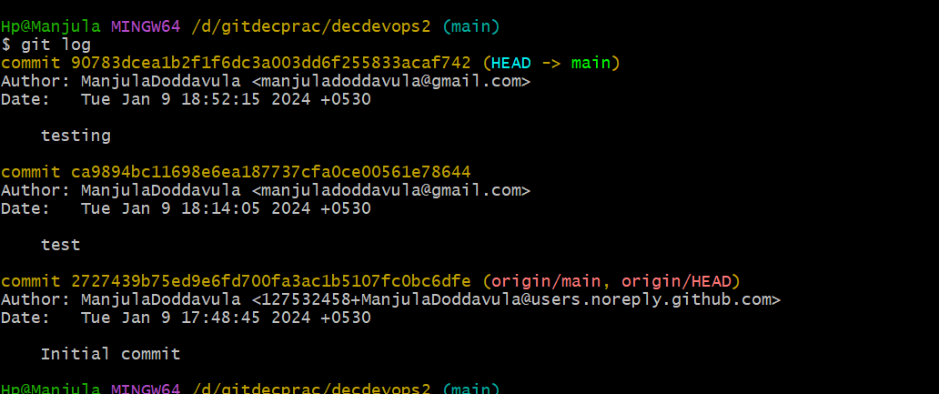

Now here 3 commit id’s created. Here initial commit is created by default while we are cloning. Test is created for files from 1 – 10. Testing is created for file11

If we are using **git show particular commit id** then it will show which file located and file how it came to local repository

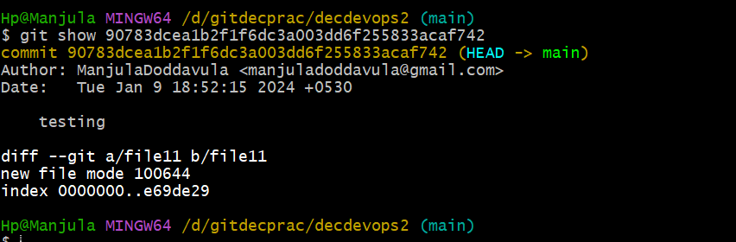

From here to we need to move files GitHub repository. By using **git push** command, we can move files from local repository to git repository

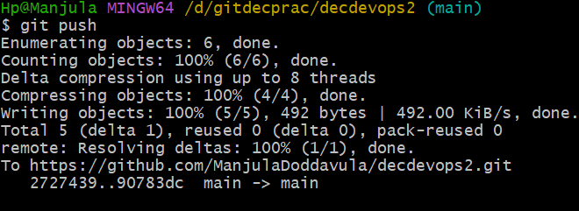

Now files are move to git repository from local repository

Now we create two file and we can commit using same commit message.

commit id’s are same in both local repository and git repository.

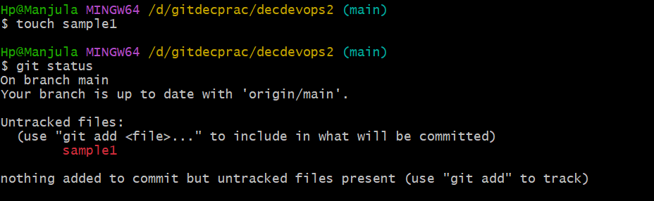

Changing file from workspace area to staging area

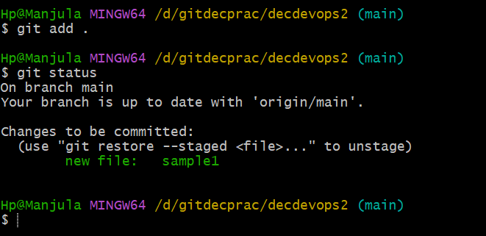

Changing file from staging area to local repository

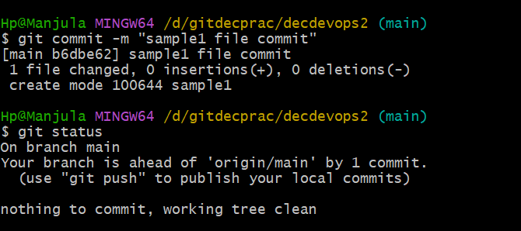

By using **git log** command, we can check commit Id’s

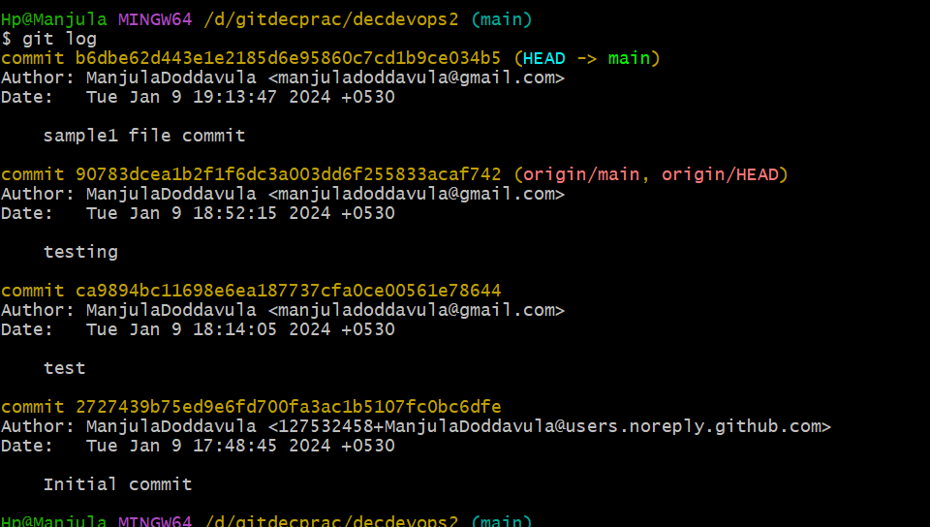

Now I’m trying to commit with same label message by creating new file and used **git status** to check where file located

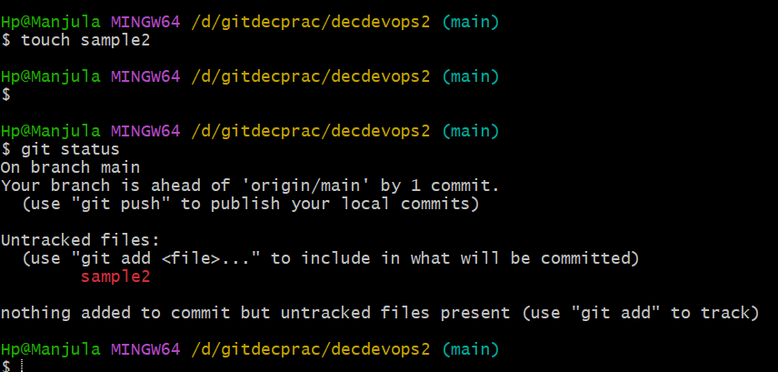

Now we are changing sample2 file from workspace area to staging area by using **git add .** command and using **git status** command we check weather where file is located

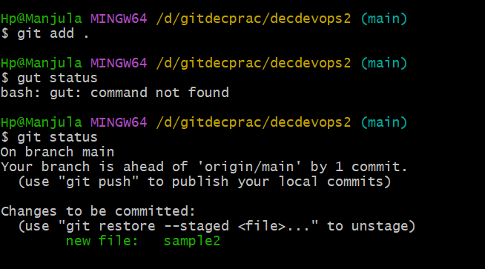

By using same commit message **git commit -m “sample file commit”** – used to change file from staging area to local repository and we check where file located by using **git status** command

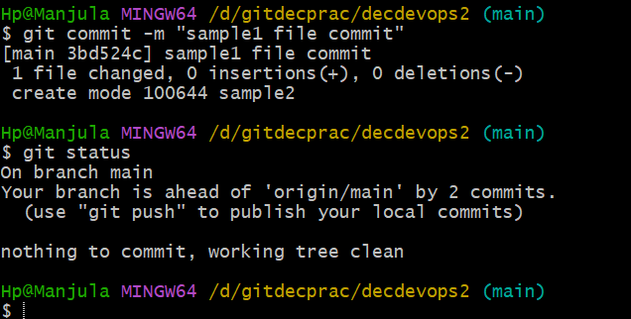

Now both files are located in same label message. Now by using **git log**  command we can check commit id

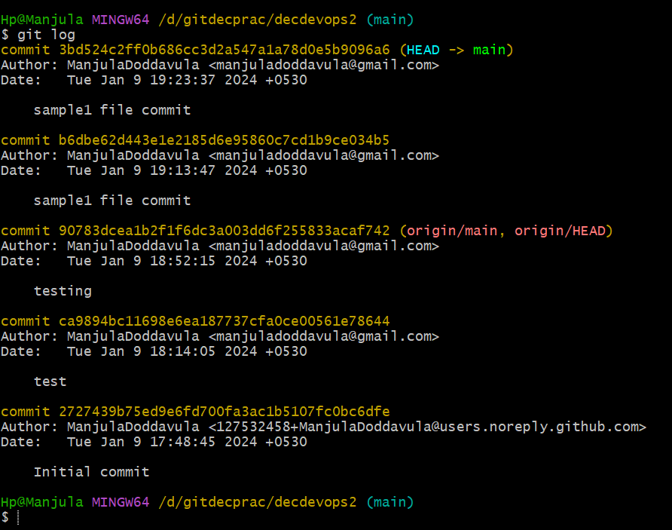

We have same label message for both files with different commit id’s. we can create number of label messages by using same label messages we won’t get any issue.

By using **git show particular commit id** command using this we can see file

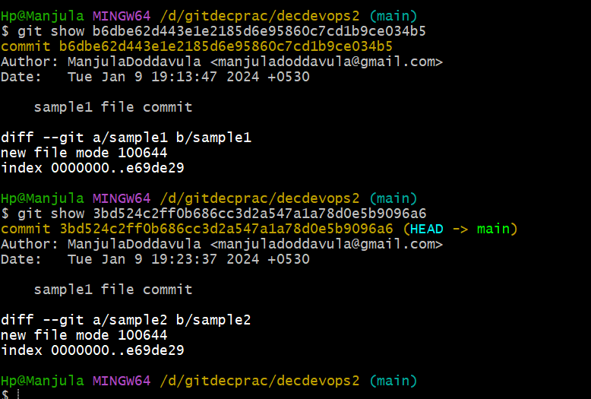

Now file is ready to send git repository. but we have change in sample2 file, so we need to rollback file from local repository to staging area to workspace area

How to rollback file from local repository to staging area to workspace area

If we need to change sample2 then we need to sample1 commit id by using **git reset –soft b6dbe62d443e1e2185d6e95860c7cd1b9ce034b5**

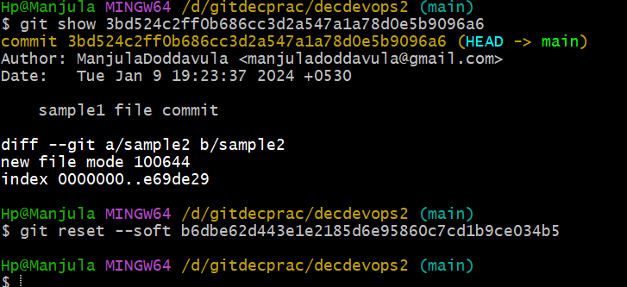

Now we need to check status where file located. By using **git status** command, we check where file is located.

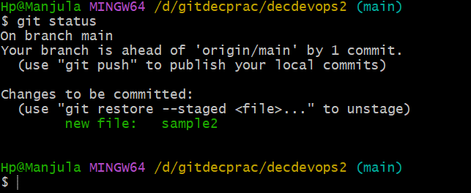

Now file was in changes to be committed (means file is located in staging area)

Now we need to move file from staging area to workspace area to edit file

By using **git reset head particular filename** command and we can use **git status** command to check file location

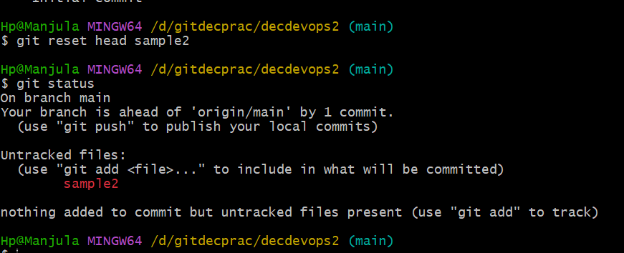

Now file is located in workspace area.

Now we edit file using **vi filename** command

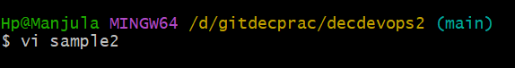

Now file was saved and we need to forward this file

Now by using **git add .** we can move file from workspace area to staging area

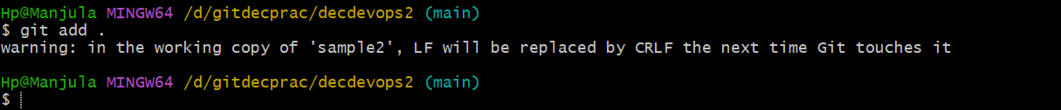

Here we get warning message. Because here we added text in file so we warning message

By using **git status** command, we can check where file located

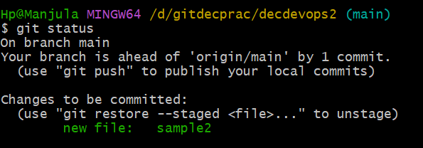

Now file is located in staging area

Now we move file from staging area to local repository by using command **git commit -m “modified sample1 file commit”** command

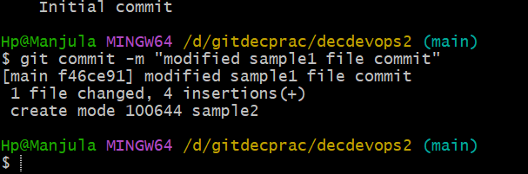

After committing we need to check weather committed id’s are same or different by using **git log** command

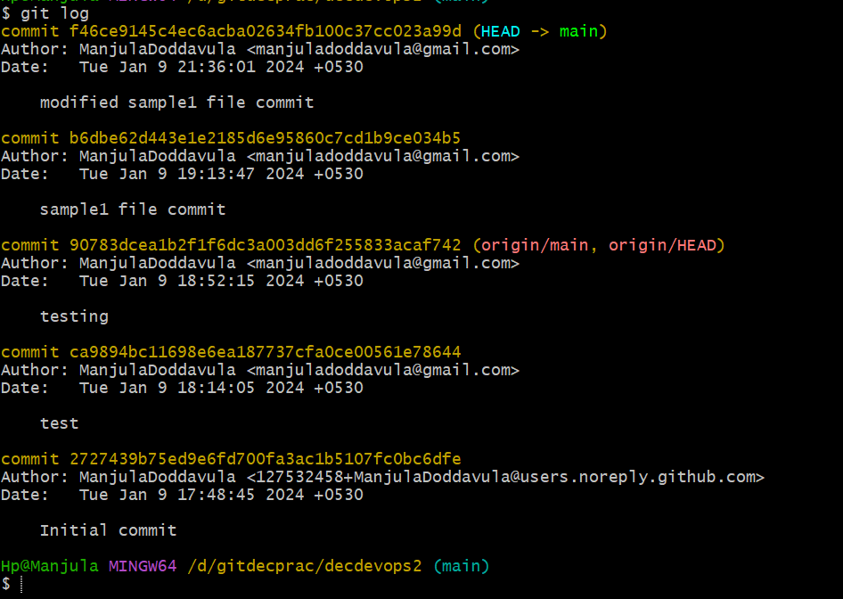

By using **git show particular commit id** command we can which file is located

Here we can see only modified commit id, because here we are modified using same file name by rollback same file so here data will deleted and creates new commit id for modified file

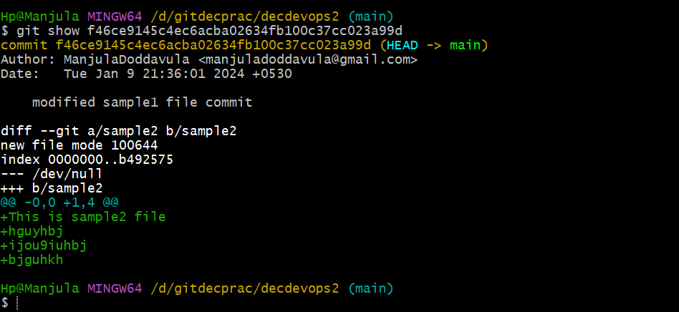

If file is located in local repository, we need bring back directly to workspace area

By using **git reset --mixed which file we need to edit below commit id we need to give** and to check file location we using **git status** command

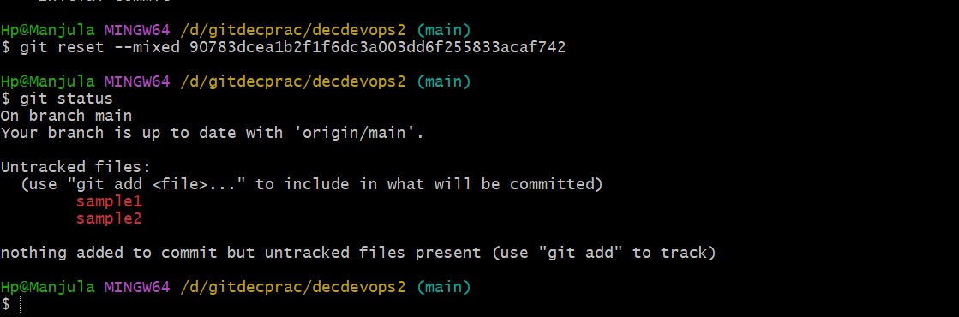

Now sample1, sample2 are in workspace area. If we are giving initial commit id the all file will be reverse back from local repository to workspace area. Then we can edit file what we need to change and we save the file later we perform forward operations

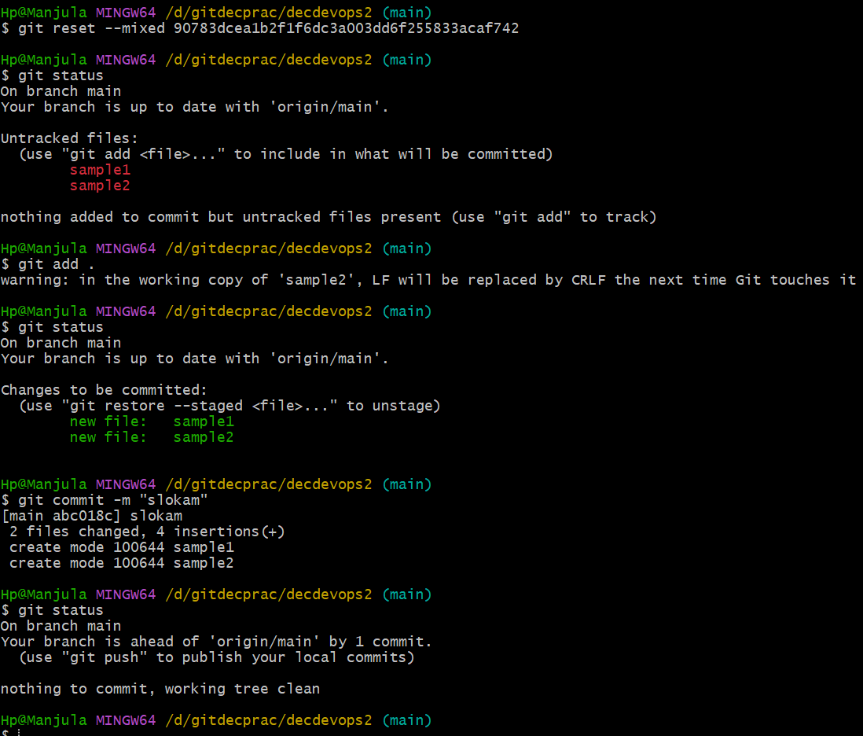

Now once we can use **git log** command

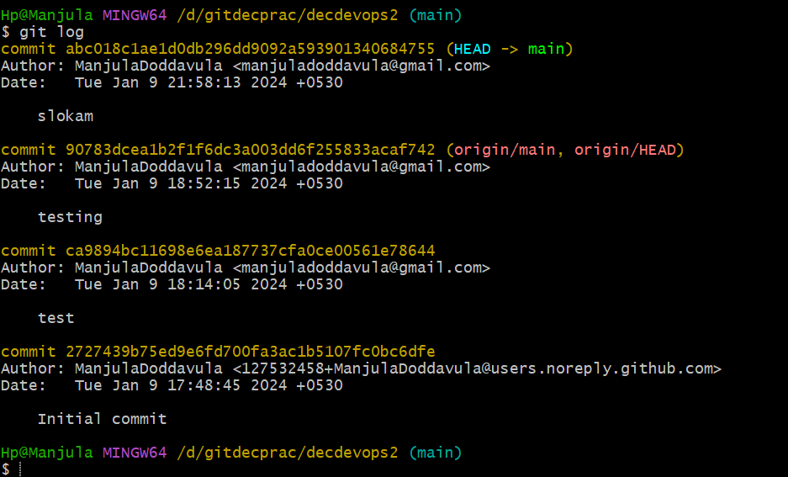 

Here we can observe in previous we have 5 commit id’s after modified we 4 commit id’s because in slokam commit id contains two files we can by using **git show particular commit id** command

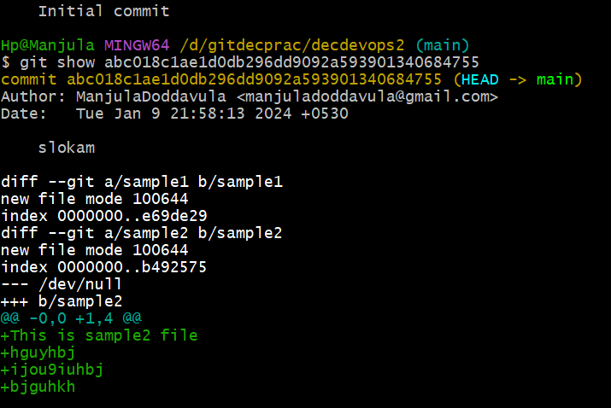

Now we are using **git log** command to check commit id’s

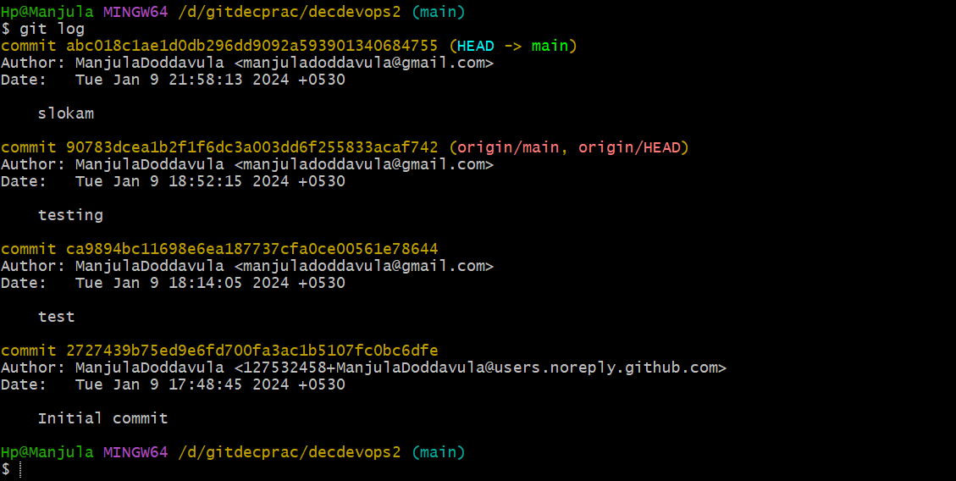

Now we are taking initial commit id by these all files are reversed to workspace area directly

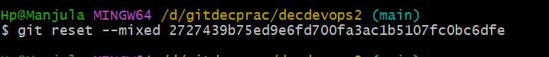

By using **git status** command, we can check file location

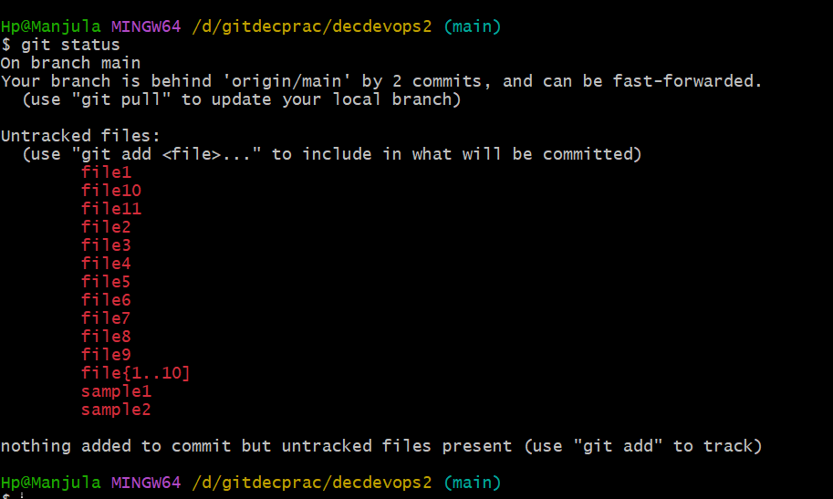

Now all files are located in workspace area

In these files we can change specific file using **vi filename** command

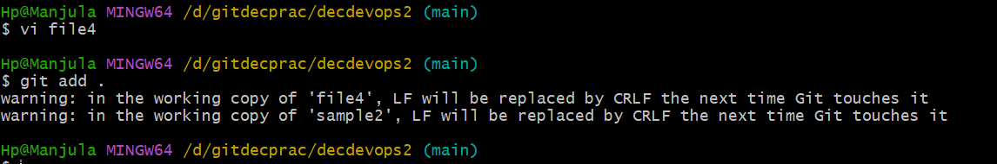

By using **git add .** command we move files to staging area from workspace area after saving the edited file

By using **git status** command, we can check file location

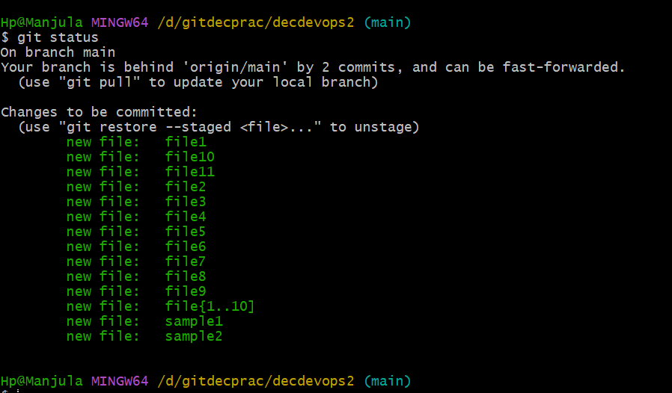

Now all files are located in staging area

From staging area to we can move file into local repository. By using **git commit -m "final commit"** command and to check file location we use **git status** command

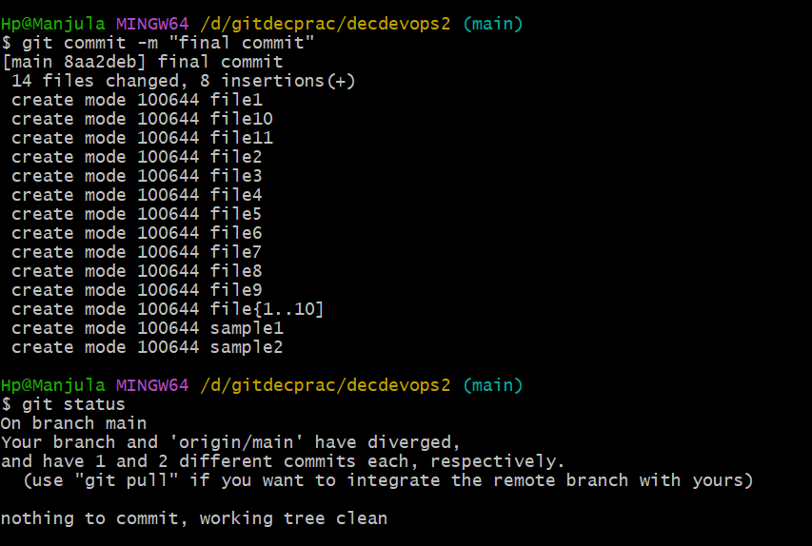

By using **git log** command, we can see weather we can have previous commit id’s or created new commit id

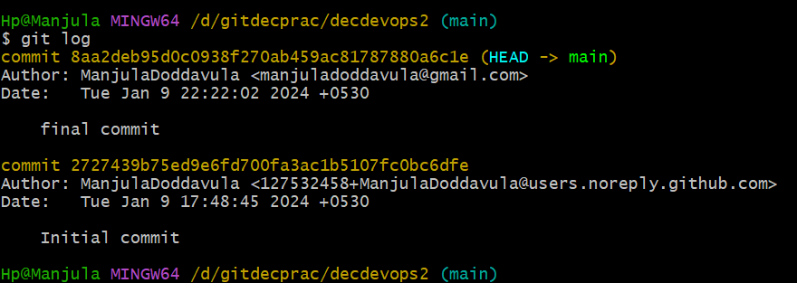

We have 2 commit id’s initial commit is generated by default while cloned the git repository. final commit we created now we check by using **git show particular commit id** command

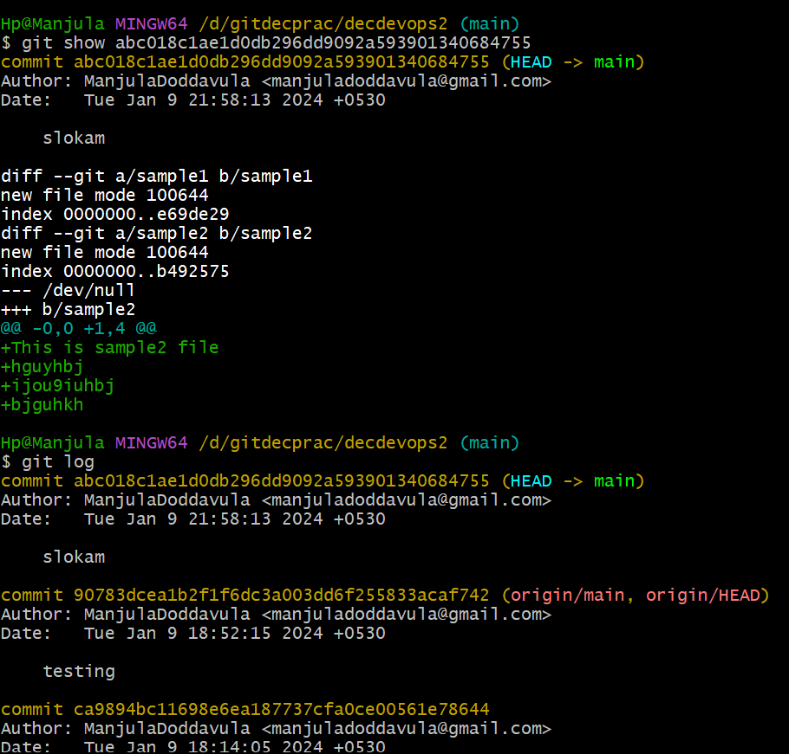

All these files are located in final commit

From here we can directly push to GitHub repository using **git push** command

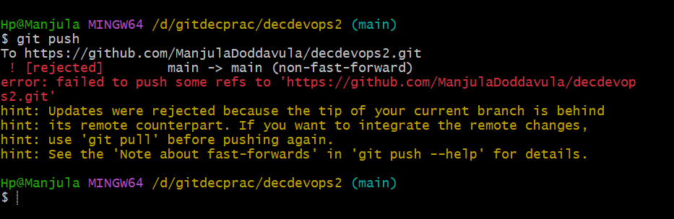

We are getting error because already few files are modified and again we are modifying the all show here it throws error.

If we are getting we use **git** **pull** command and save the data by pressing ecs:wq! Again, we use **git push** command now files will change to GitHub repository from local repository with latest label message.

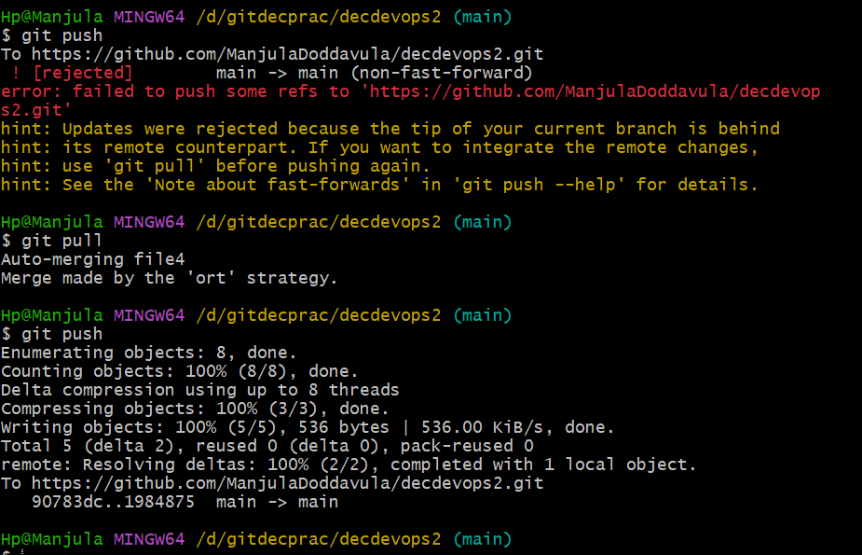

**Date: 05-01-2024**

**Class -4**

**git log** – shows number of commit id’s

**git show commit id** – shows particular file

**git reset** – used to change from local repository to staging area to workspace

**git pull** – used to solve error

**git push** – used to send files from local repository to GitHub repository

**Branches –**

For example, for one tree we have different types of branches same like this in **git we have branches**

How to **git branches** in real time?

For example, we are taking amazon E-Commerce application if we are login in amazon application in normal days, we can select product and we will pay money. But if we are opened same application in special days like new year festival etc.… they will keep sales up to 50-90 percent on products. These will happen only on special days. In this application every day 1000 customers are doing shopping but in special days 10000 customers are using this application. If the developer is designed application to use only for 1000 users, then it will create problems and time waste. For these updates are done in background to use customer without any issues.

All these updates done by using **git branches** entire software use git branches for updates.

Branches is used for modify for already using applications

How branches will look?

In real time branches are

Branches

main master

By default, branch is **main** in GitHub

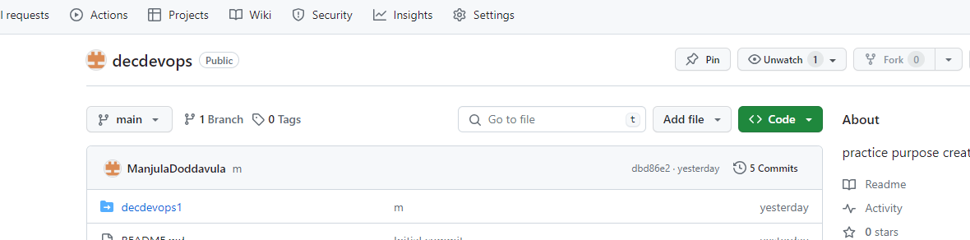

By default, branch is **master** in Git

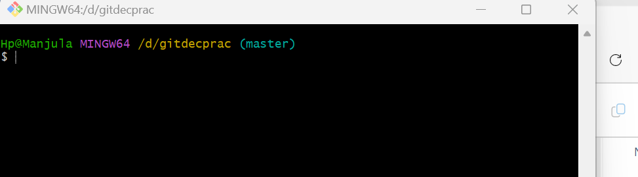

Here we are observed **master** in git bash.

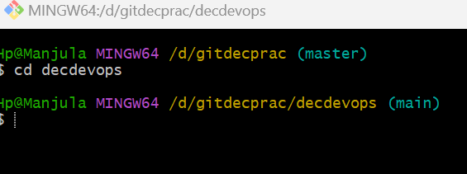

Now we see after cloning with git repository the branch was change to **main** in git bash. If we are entering into cloned repository, we will ger **main** branch

For example, we have launched application like google. 5 developers are designed google application and released into market now every end-user can accessible by clicking URL. Now this application was using o from 2 months now client got new idea in particular applications need to change naming convention and font size, style etc.… all these thing clients discussed with organization. Normally application will be in running only and updates will happen. If we are removing application from production server for 2 days to update so it will create lot of problems and organization will get more loss for particular application.

So, updates must do in background. When updates are happened successfully then we need to redeploy the application.

How to made changes in applications using branches?

From example, in google application we need to change

* Gmail -> Mail
* Images -> Wallpapers
* New features are added camera option beside google

Already application is running. For this application related code is available in **main branch** in git same code we can see in running production server. If that server is running, we can see how UI will display

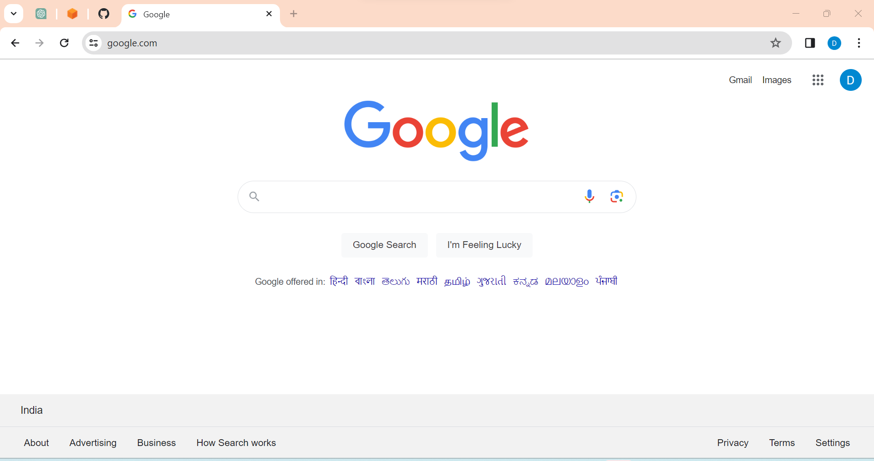

We create our own application

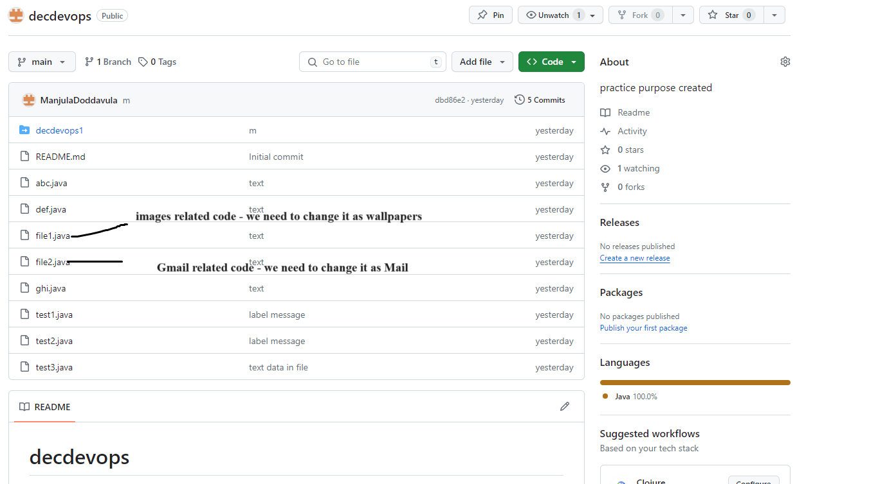

In git we can edit files

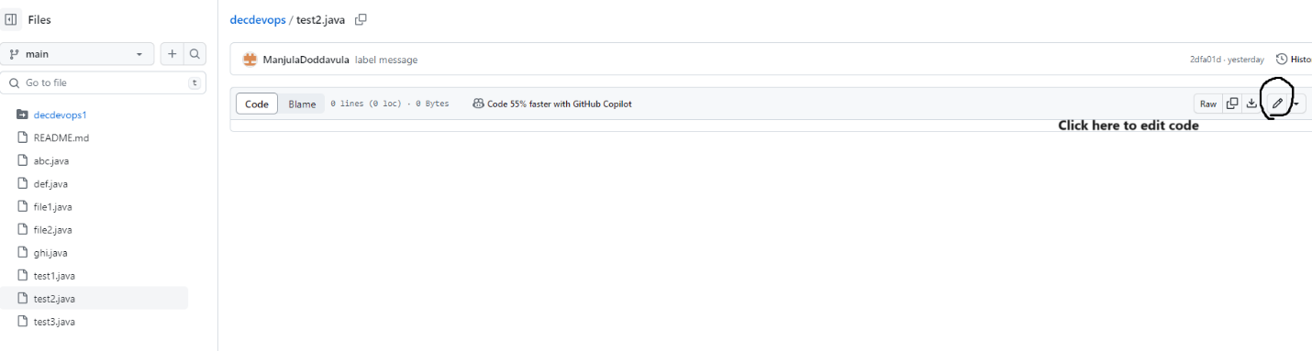

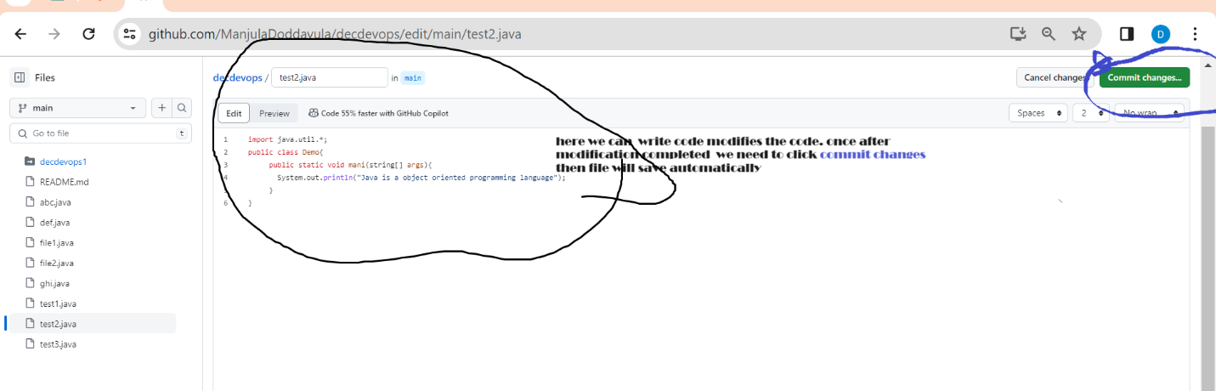

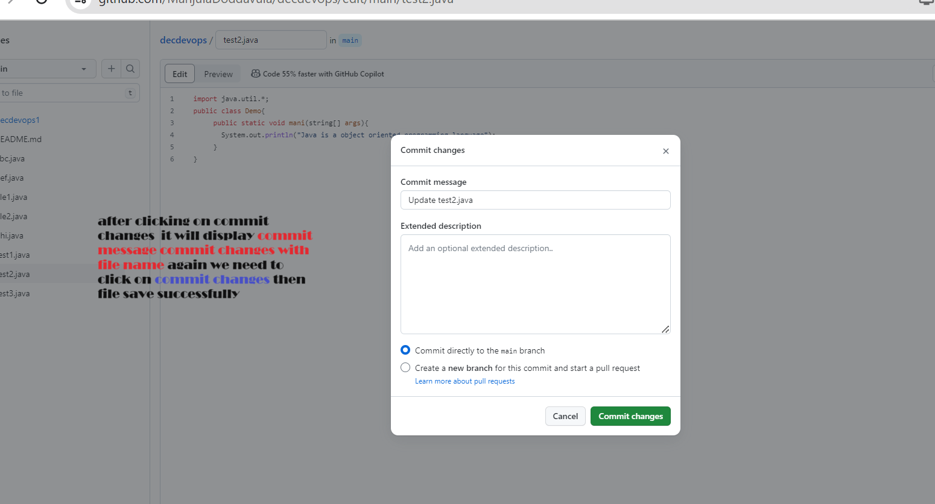

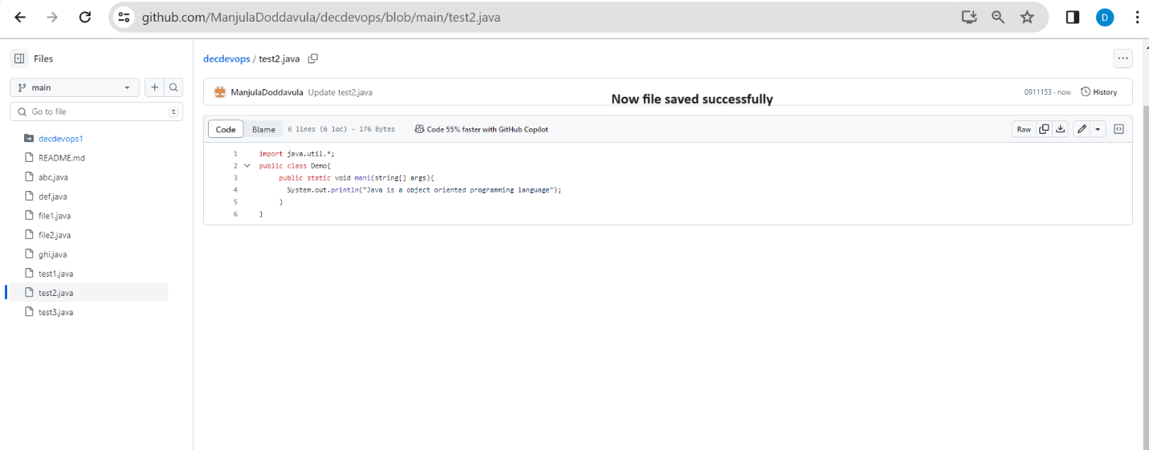

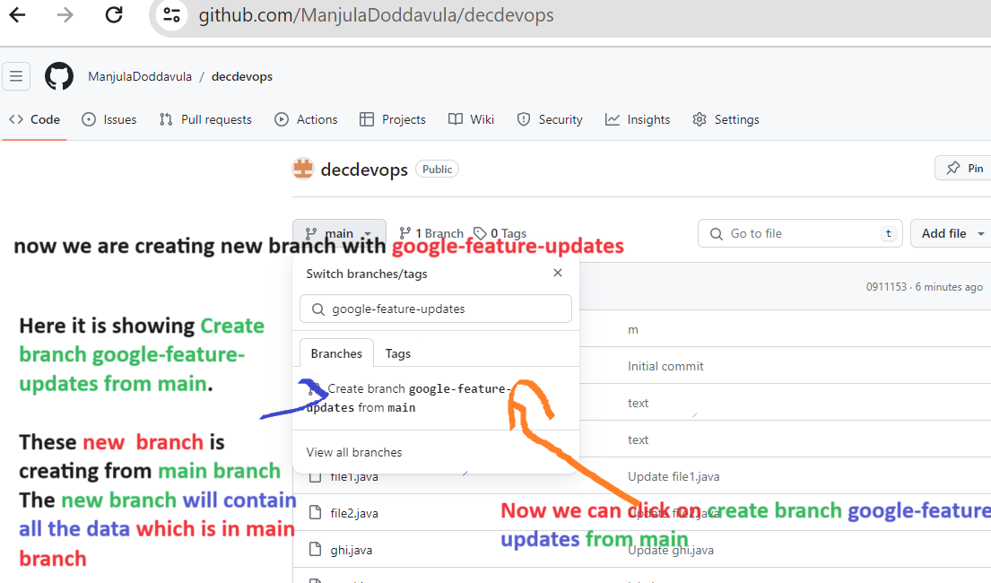

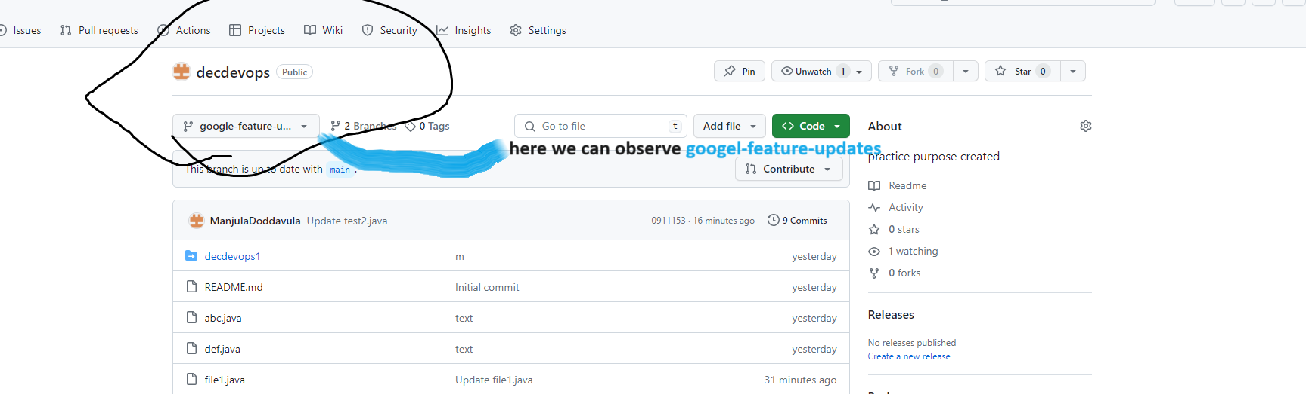

We can see all the files which is located in main branch why because we are created new branch by using main branch.

By default, branch is main. In that branch has some files. Now I’m creating **new branch** based on **main branch** with name **google-feature-updates** now files are located in **main branch** that files automatically contain in **google-feature-updates branch.** Now I’m creating new branch using **google-feature-updates branch** now new will contain all files which contained **google-feature-updates branch** because we are creating new branch based on **google-feature-updates branch** so new branch will contain all files which files contained in **google-feature-updates branch**

Now we entering into **google-feature-updates branch** and we are changing file1 data from **image related code** to **wallpapers related code**

In file2 data we are changing **Gmail related code** to **Mail related code**

We are a new file with **Camera option** in that we are giving data is **camera related code**

Now developer has started changing code in **google-feature-updates branch** here developer changed 3 files **File1**(here developer changed **image related code** to **wallpapers related code**) **File2**(here developer changed **Gmail related code** to **Mail related code**) and developer created one new file with **Cameraoption**(here developer added data was **camera related code**)

Now when the **google-feature-updates branch** is combined with **Main branch** then we can deploy main branch code in server until unless developer which is written code in branch we cannot deploy directly.

The file which is in **main branch** that files are applicable for **deployment**

Here we can see **compare & pull request** we need to click on that the files which we have changed it will updated in main branch and it ready to deploy

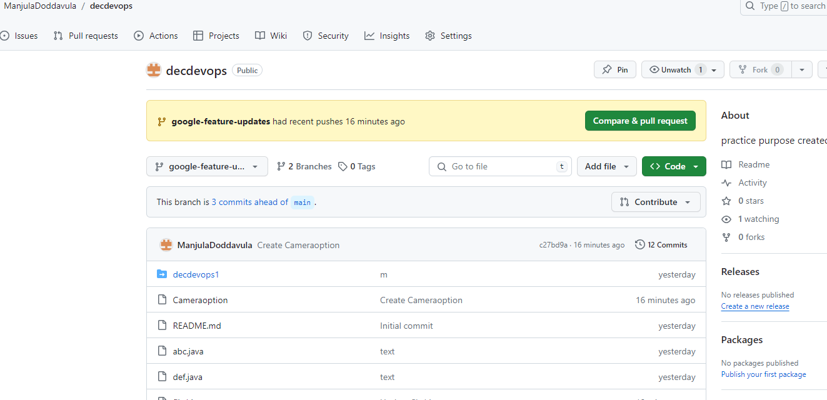

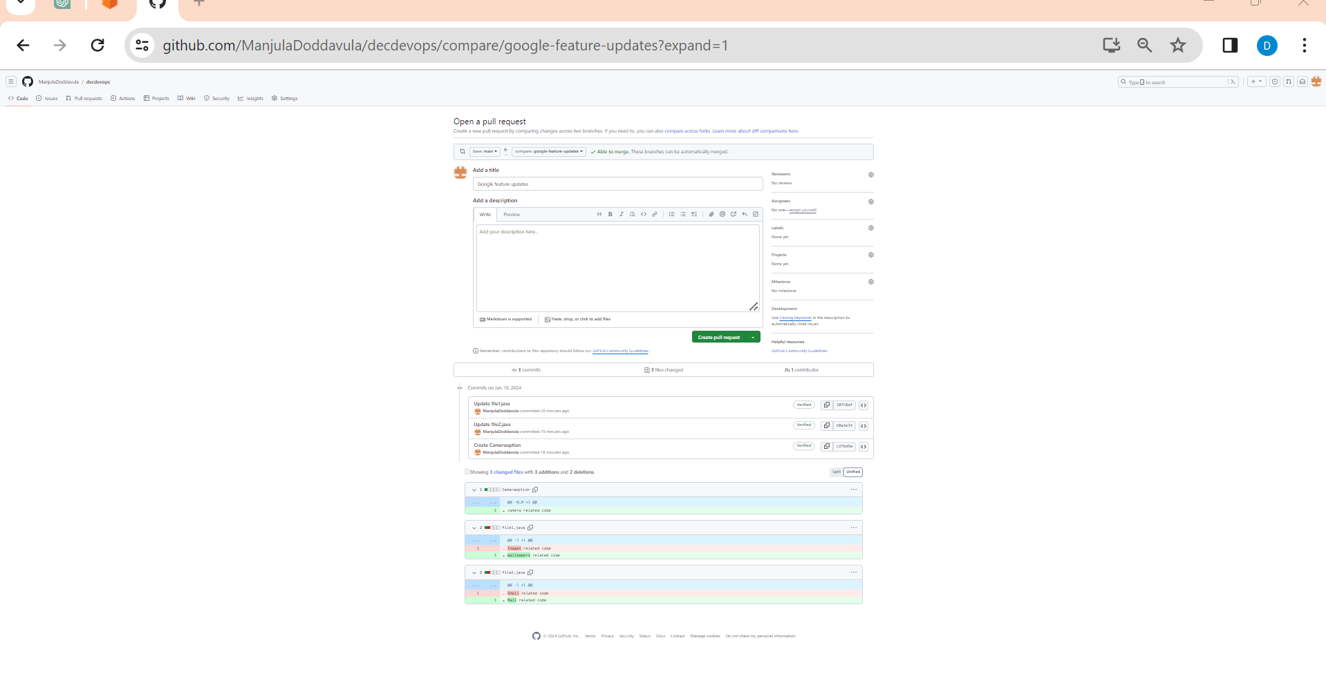

Here the updated files area moving to main branch from google-feature-updates

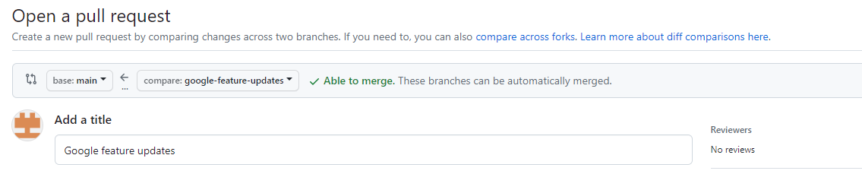

These changes are moving to **main branch**  from **google-feature-updates**

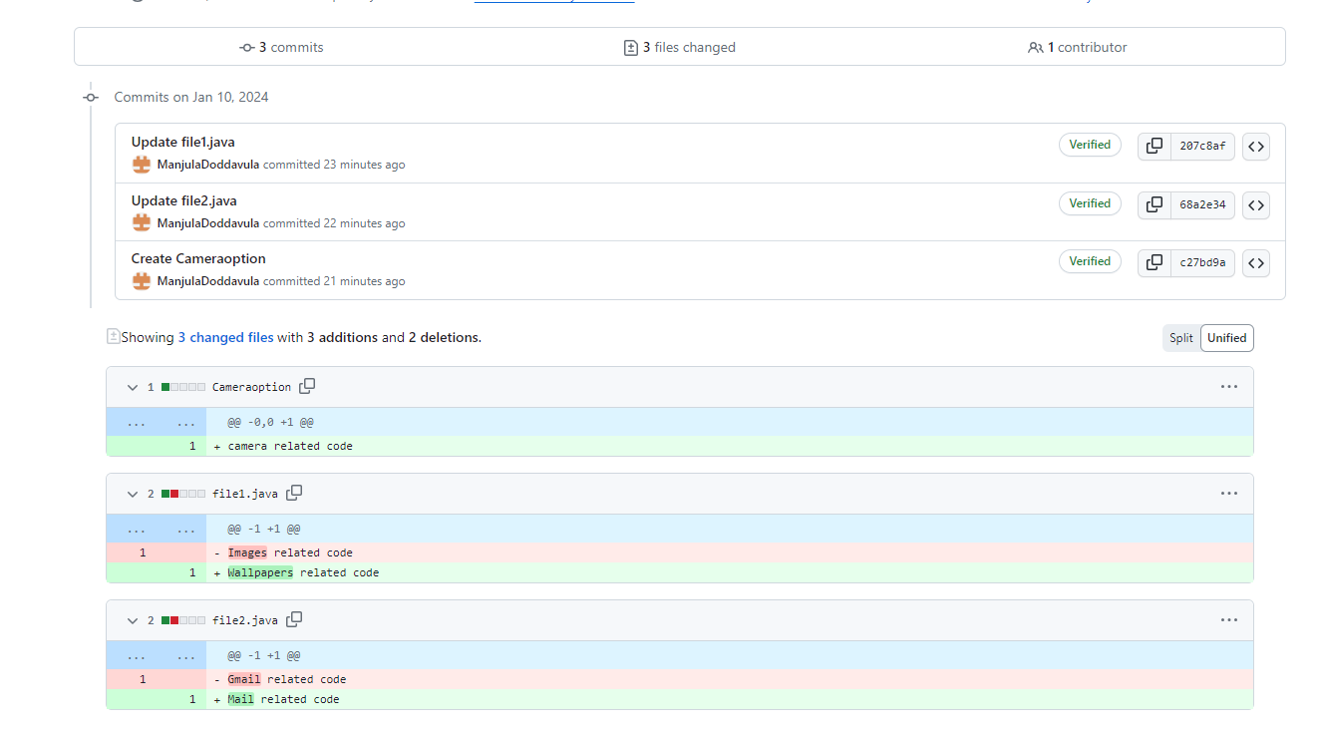

Here we need to click on **create pull request**

After clicking on **create pull request** then **pull request** will rise **merge pull request**

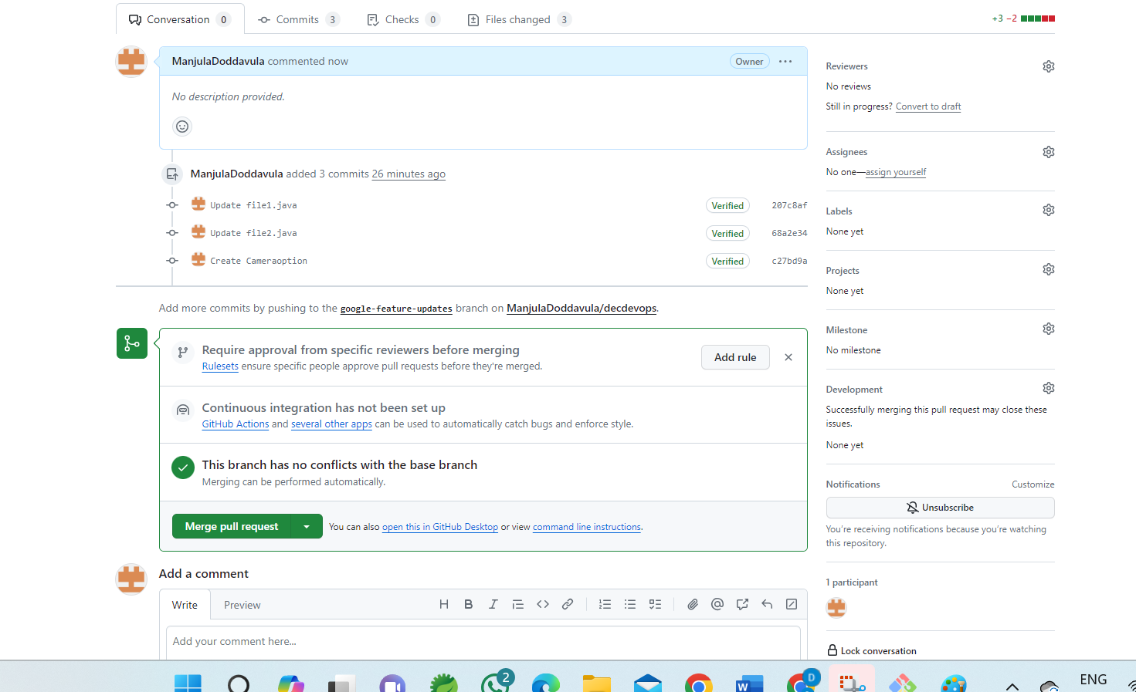

After this we can check once in main branch weather changes are occurred or not. Still, we didn’t observe any changes in **main branch**. We didn’t after rising **pull request** again we need to **merge pull request** then we can observe changes in **main branch**

Click on **Merge pull request**

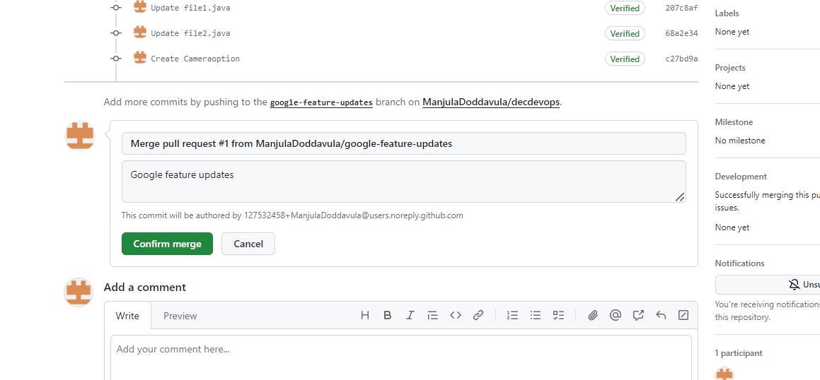

Here it will display **Confirm merge** click on that. Now we observe the files merged successfully in main branch

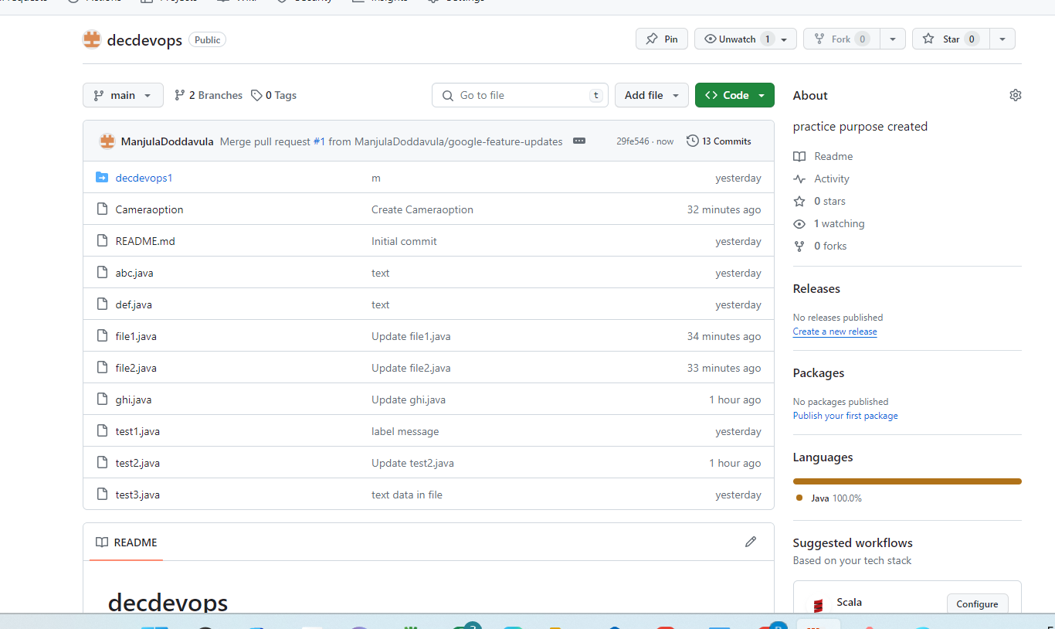

We can observe cameraoption file and file1 and file2 are changed. Now we have did client expected code. Developer was created branch and developer wrote code in new branch later developer merged in main branch now code is ready to deploy.

If we are deploying code in server, we can observer changes in application

By using branches, we can do changes in running application.

Live application related code contains in **main branch** so we can create **new branches** from **main.**

Now we created **ABC branch** by using **main branch** and we have added new file in **ABC branch** but it won’t display in **main branch** or **google-feature-updates branch**

If we want add the file **main branch** we need to **compare & pull request** here it will compare **Main branch <- ABC branch**

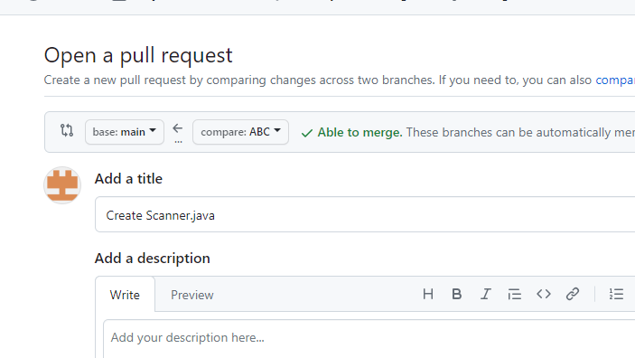

it will compare the file which have created Scanner.java weather these files occurred in **main branch** or not. If it is not there it will shows in green color

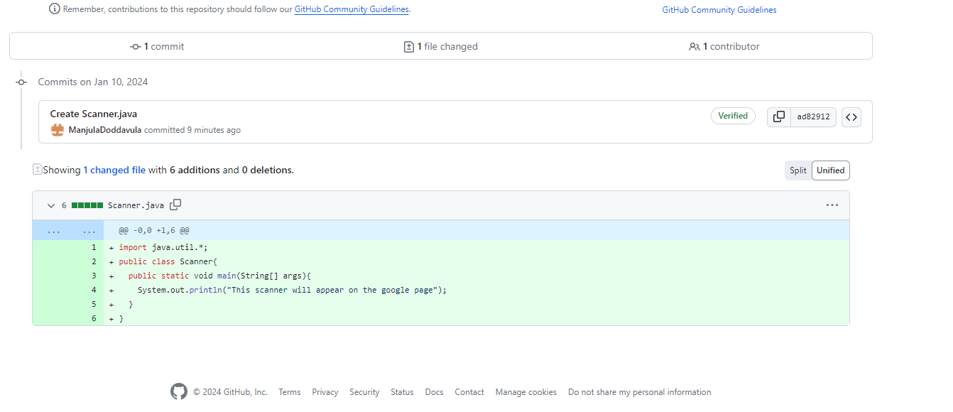

Then we need to click on **pull request**

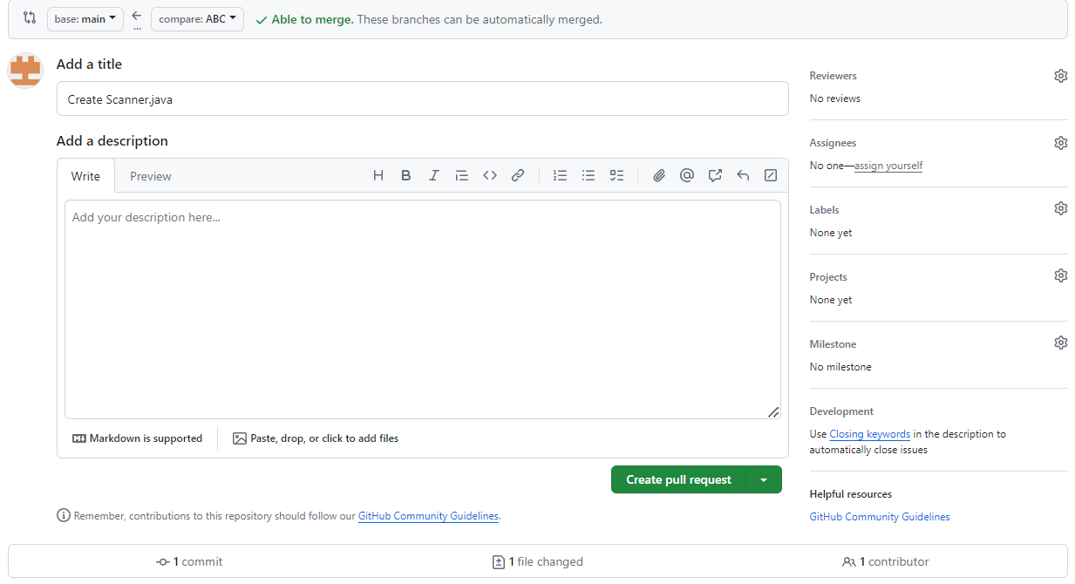

Then it will show **merge pull request**

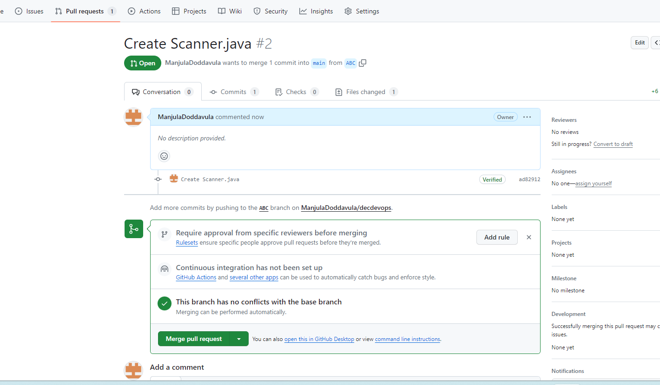

Click on **Merge pull request**

Then it will shows **Confirm merge**

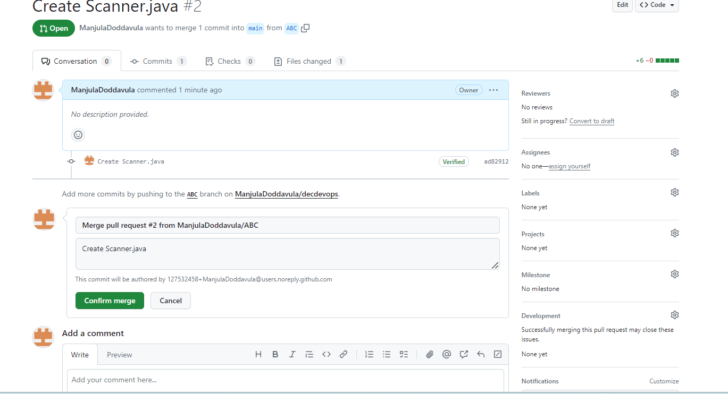

Click on **Confirm merge** then changes will occur in **main branch**

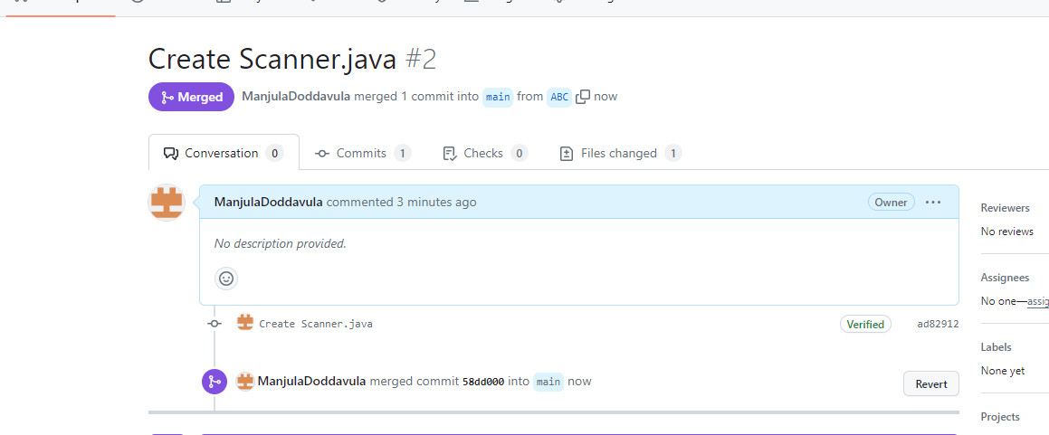

Now we can see change in **main branch**

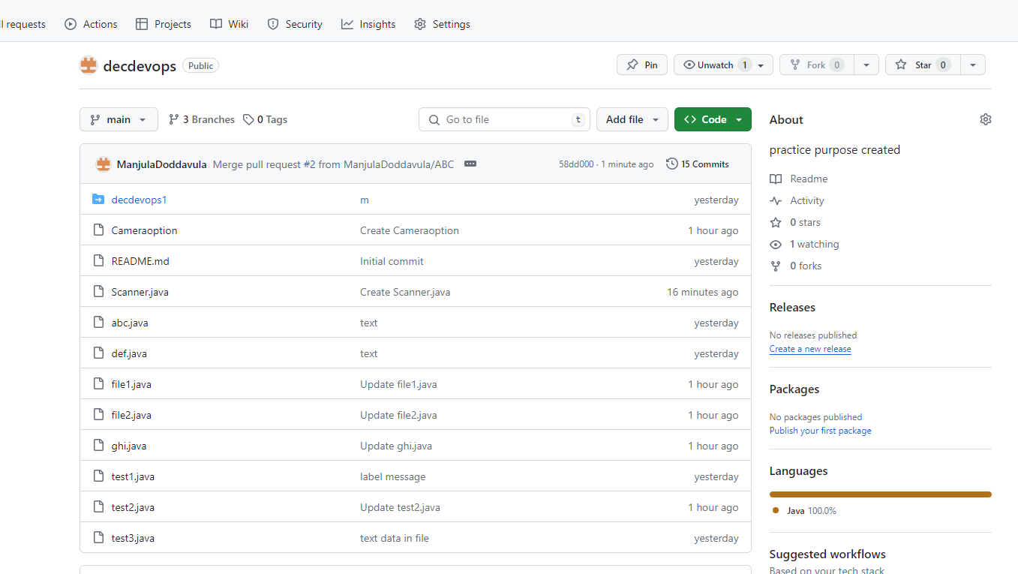

Here we can see **Scanner.java** file. Now deployment team will retrieve code from main branch and used for deployments.

What ever we are creating files we must merge in to **main branch**

We can not do changes in **main branch** because maybe it will affect so we are creating new branches using **main branch** so that we can copy same data to **new branches** and we modify the code in **new branches** later we can do **pull request & merge** it into **main branch.** Now we can use for deployment

**Date: 06-01-2024**

**Class-5**

**git branching strategy:**

if we are created any repository by default **main branch** will create. In this **main branch** contains application related final code.

By pointing **main branch,** we can create **many branches**.

But in real time final code will contain in **main branch** and also in **develop branch.** In organization developers maintain in both branches may be incaseif code will affect due to changes in **main branch** so for backup purpose, we can use **develop branch** will use.

Naming convention must be in particular manner **feature-update-task related syntax.**

Eg:

* **feature-update-mailnotification-changes**
* **feature-update-cameraoption-changes**

In real time we cannot create any main/develop branches we can develop application code using main/develop branches

If we are identified **bug** in our application for example Gmail was not located in current position it was misplaced in webpage. So, this is a bug which developer was identified. Now we need to fix bug by using code then the branch name will be **bugfix-Gmail-release.** This is also called as branching strategy. **bugfix** also known as **hotfix** (means necessary to act immediately upon an undesired status of master)

**releases – release1.x –** three or more new features we can perform at a time.

releases – means branches support preparation of new production.

feature – means branches are used to develop new features for the upcoming release

All these are known as branching strategy.

**Naming Convention:**

**Main, develop branch –** contains final/raw code of any application

**feature-update-mailnotification-changes, feature-update-cameraoption-changes –** used to work on new task or changes will be done here

**bugfix-Gmail-release –** used to fix issues

Now all things will do in terminal, so now we created new folder with **gitdecbranches**

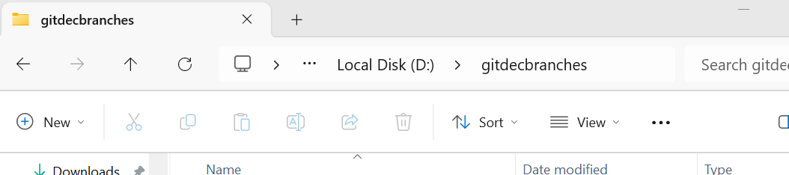

Right click and select **Open Git Bash here**

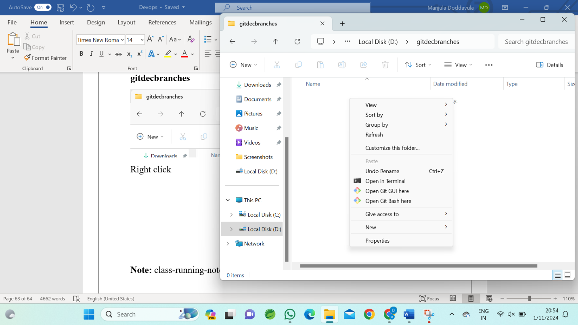

Now terminal will open

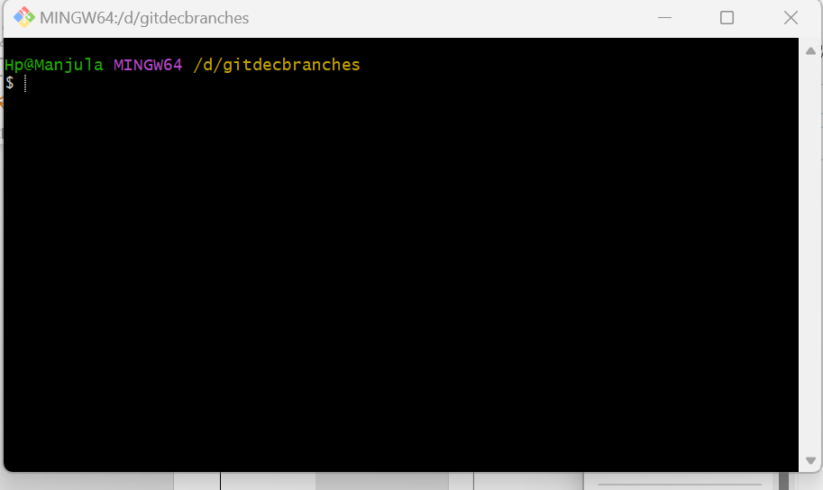

Now clone local repository and git repository

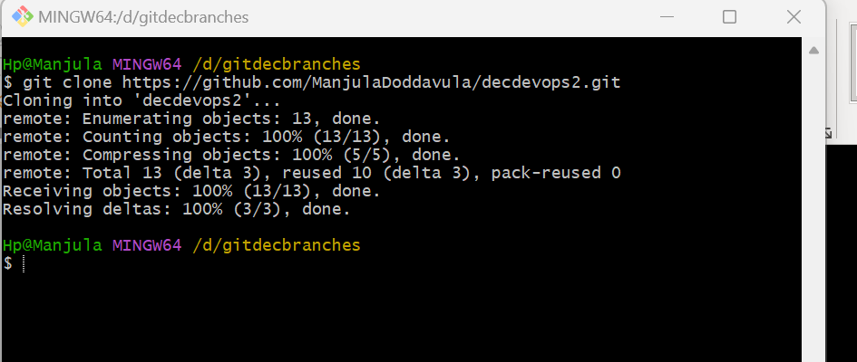

Now we can see the folder created in local repository.

We have checked in terminal after cloning using **ls -la** here we find new folder which is created from git repository. We have moved to that folder in terminal using **cd decdevops2**

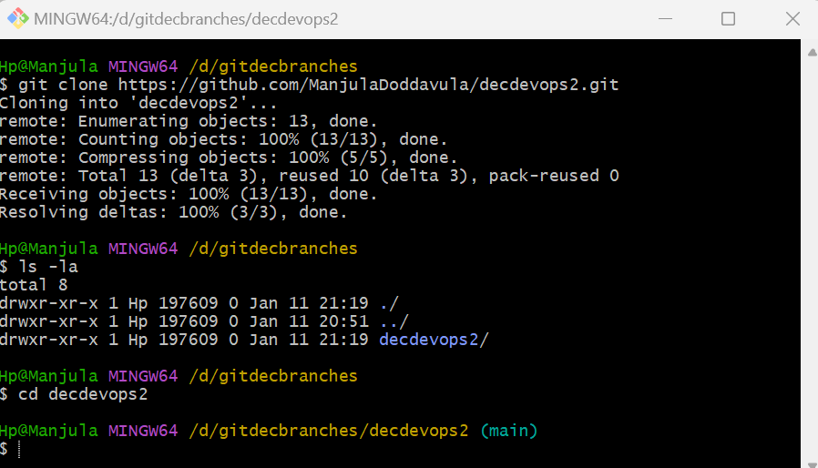

Now we can observe **main** because we are pointing **main,** we copied **URL** so here we can see **main**

We can also find in which branch we are working/located by using **git branch**

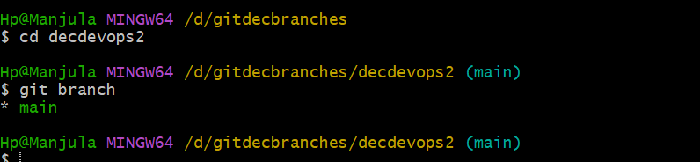

How to create branch in terminal?

**git branch feature-updates-sample-changes by** using this command we can create new branch by pointing **main branch**

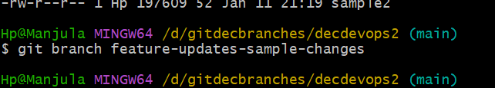

To check weather branch is created or not using **git branch** command

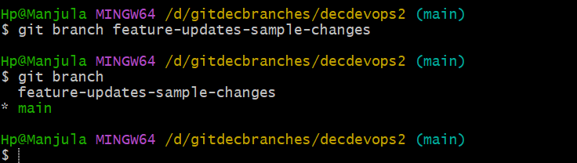

Branch is created but it is pointing to **main branch**

Now we need to move into newly created branch by using **git checkout particular branch name** command

**git checkout feature-updates-sample-changes**

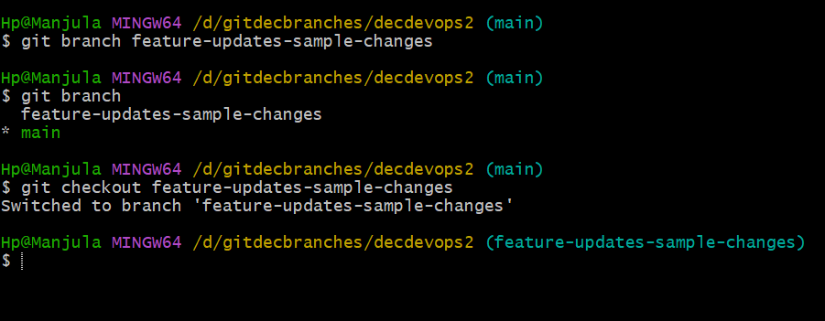

Now we are in **features-updates-sample-changes** branch

If we are using **git branch,** we can see star indication for **features-updates-sample-changes**

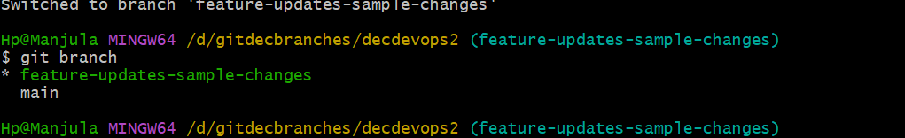

Now we can check which files are located in **features-updates-sample-changes** branch using **ls -la** command

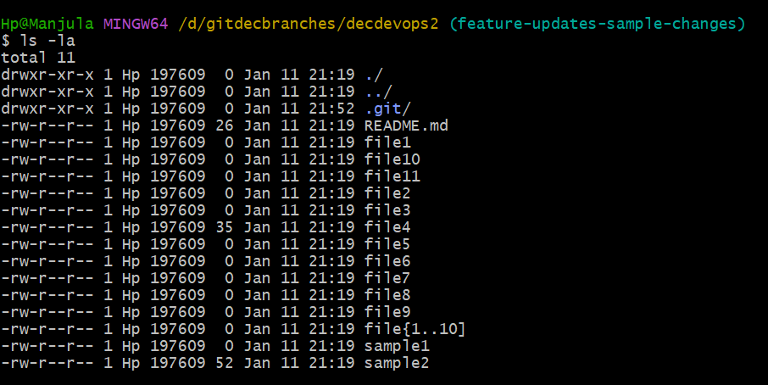

Now here we do any changes. For example, here I’m creating some files in **features-updates-sample-changes** branch using **touch file name** command

**touch sampletest10 sampletest11**



Now by using **git status** command we can find where files located

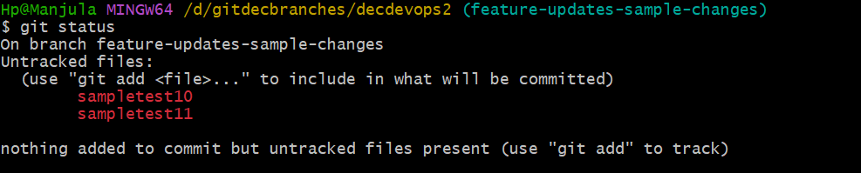

Now files are located in **untracked files**(workspace area)

Now we need move files from workspace area to staging area by using **git add .** command and by using **git status** command we check weather file changed to staging area or not

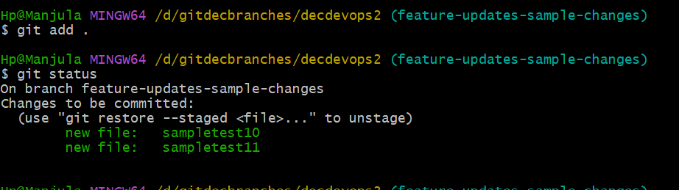

Now files are in staging area. Now we need to move files from staging area to local repository by using **git commit -m “label message”** command

**git commit -m “branches prac”**

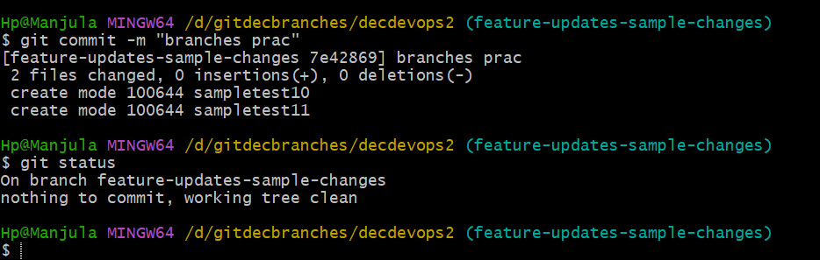

Now files are inlocal repository

By using **git log** command, we can number of commits happened in our branch

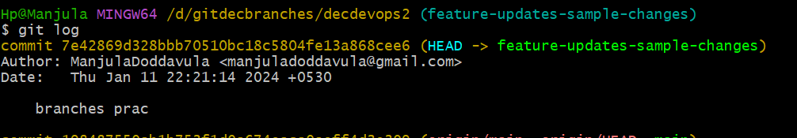

This our latest commit.

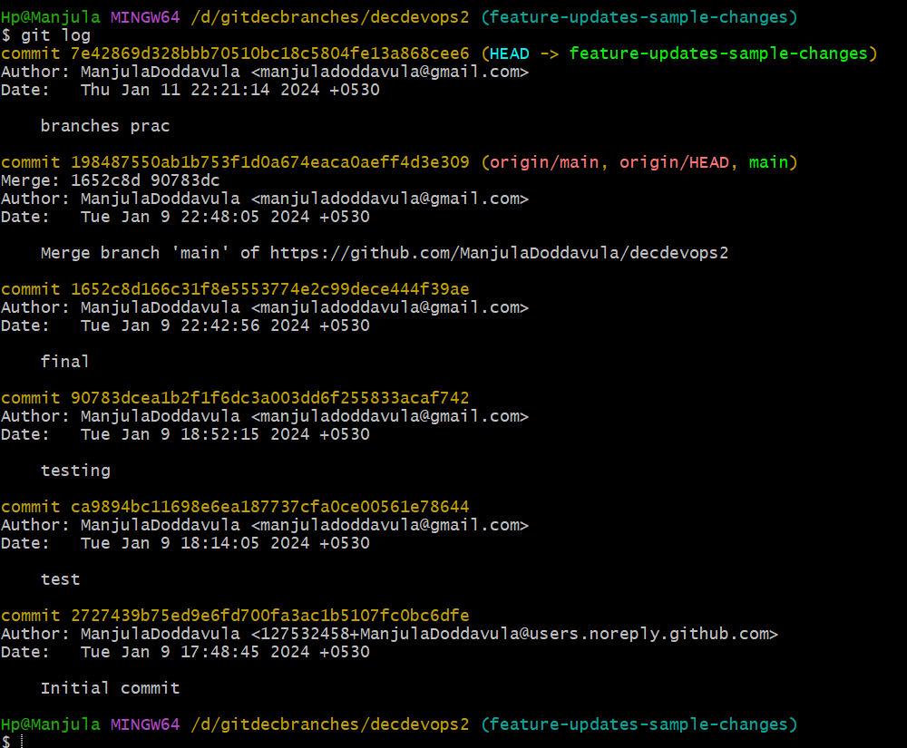

How to check files by using commit id?

By using **git show particular commit id** command we can check files.

**Git show 7e42869d328bbb70510bc18c5804fe13a868cee6**

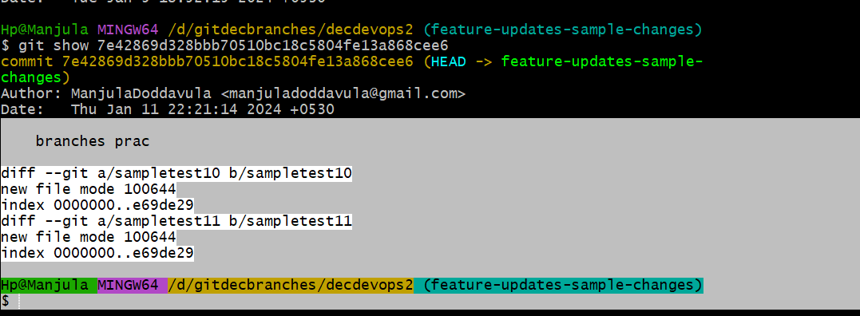

Here we can observe 2 files sampletest10 sampletest11 and gives details information from where the files moved to local repository

Now we need move files from local repository to GitHub repository by using **git push** **origin feature-updates-sample-changes** command

For **main-main** we use **git push** command to move files from local repository to GitHub repository

If we are moving from new branch we use **git push** **origin feature-updates-sample-changes** command

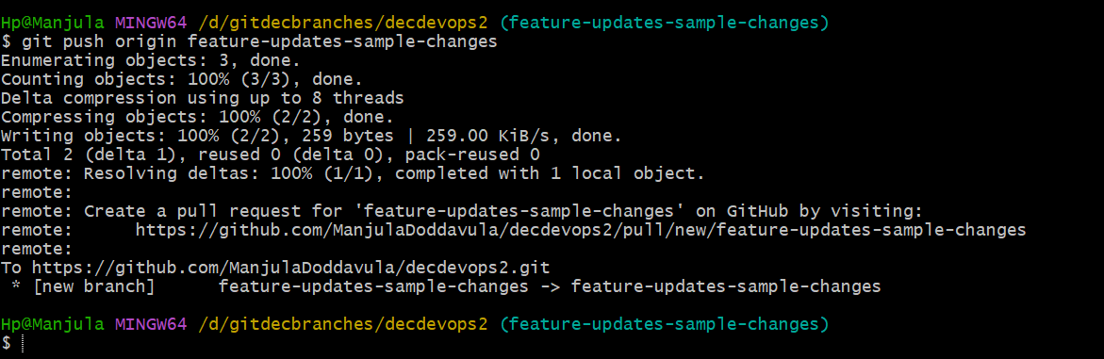

Now files are moved to GitHub repository

Now we can see changes in GitHub

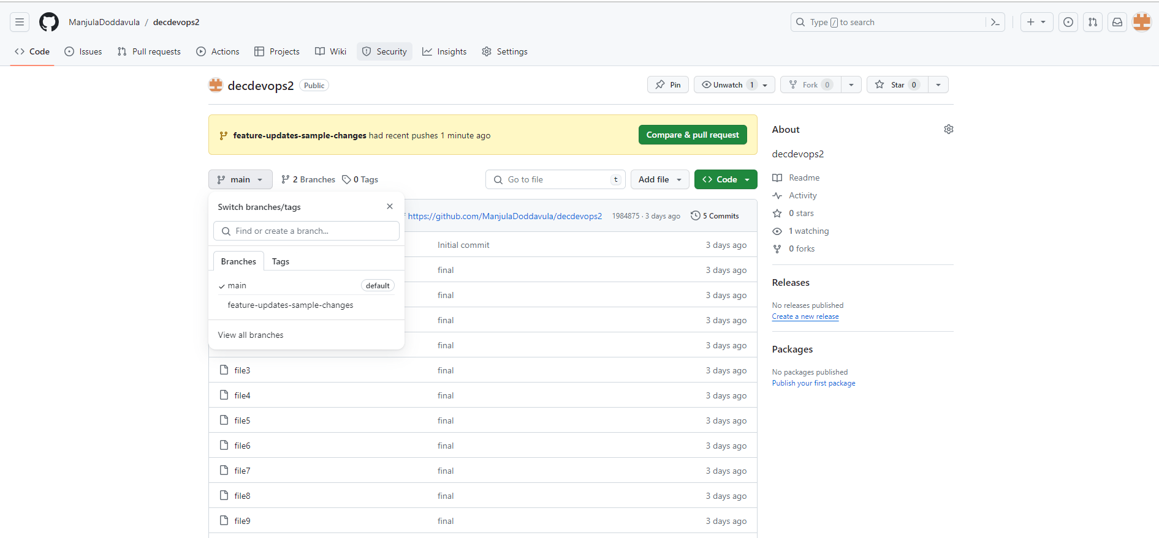

Here we can observe the feature-updates-sample-changes branch. We created this branch in git terminal by using **git push** command we can see changes in GitHub repository

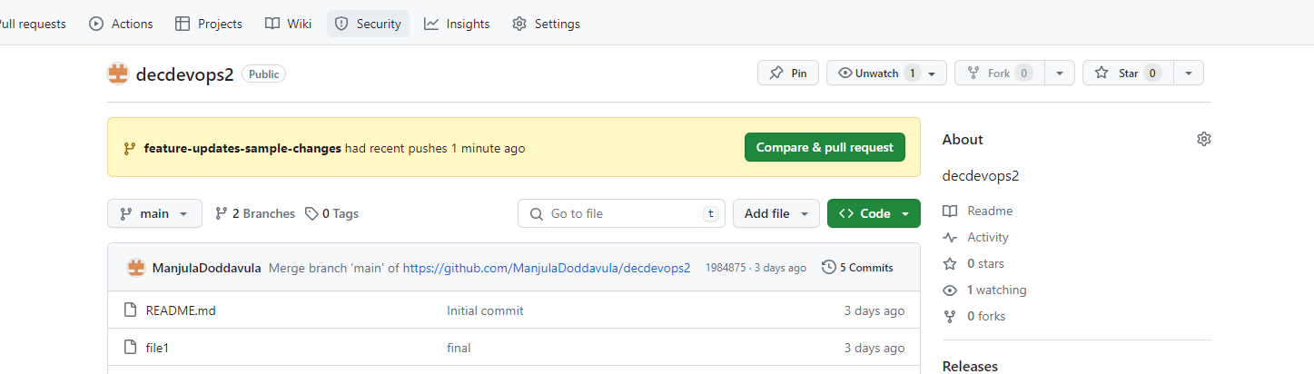

Now we need to **compare & pull request** for changes

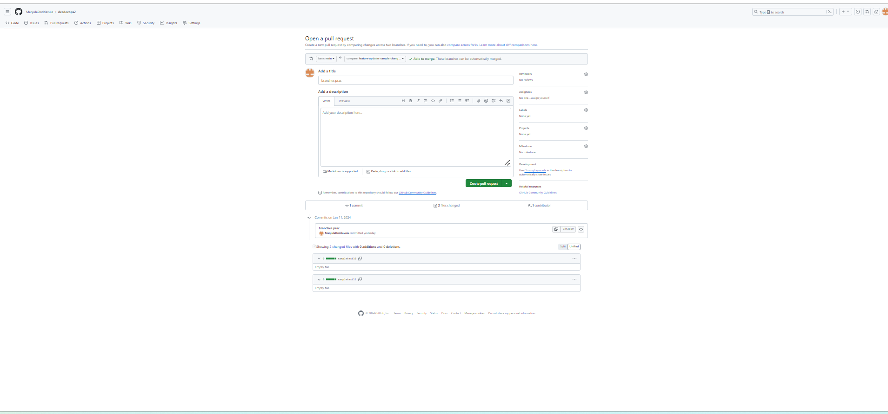

All changes need to occur in main branch

Click on **create pull request**

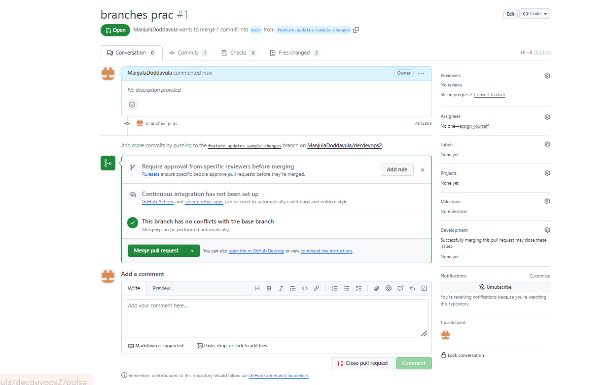

Now click on **merge pull request**

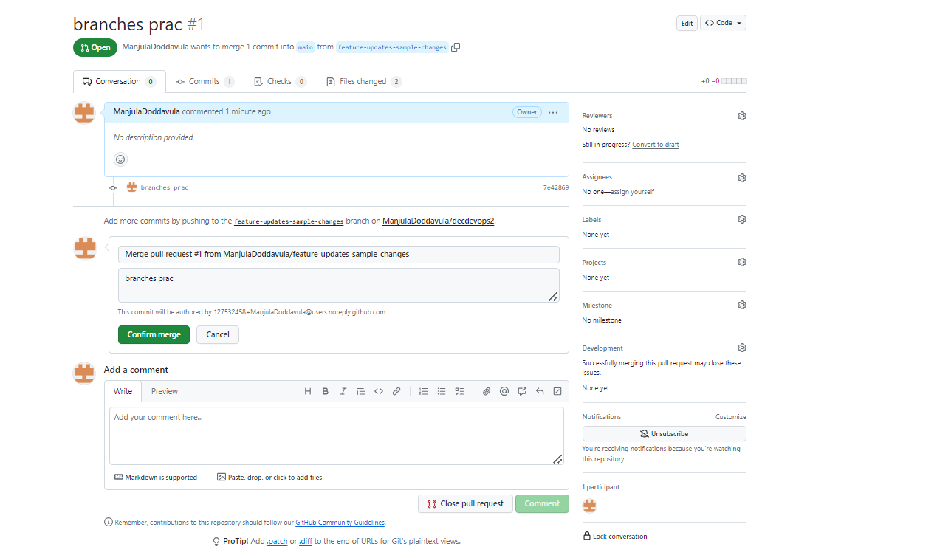

Click on **confirm merge**

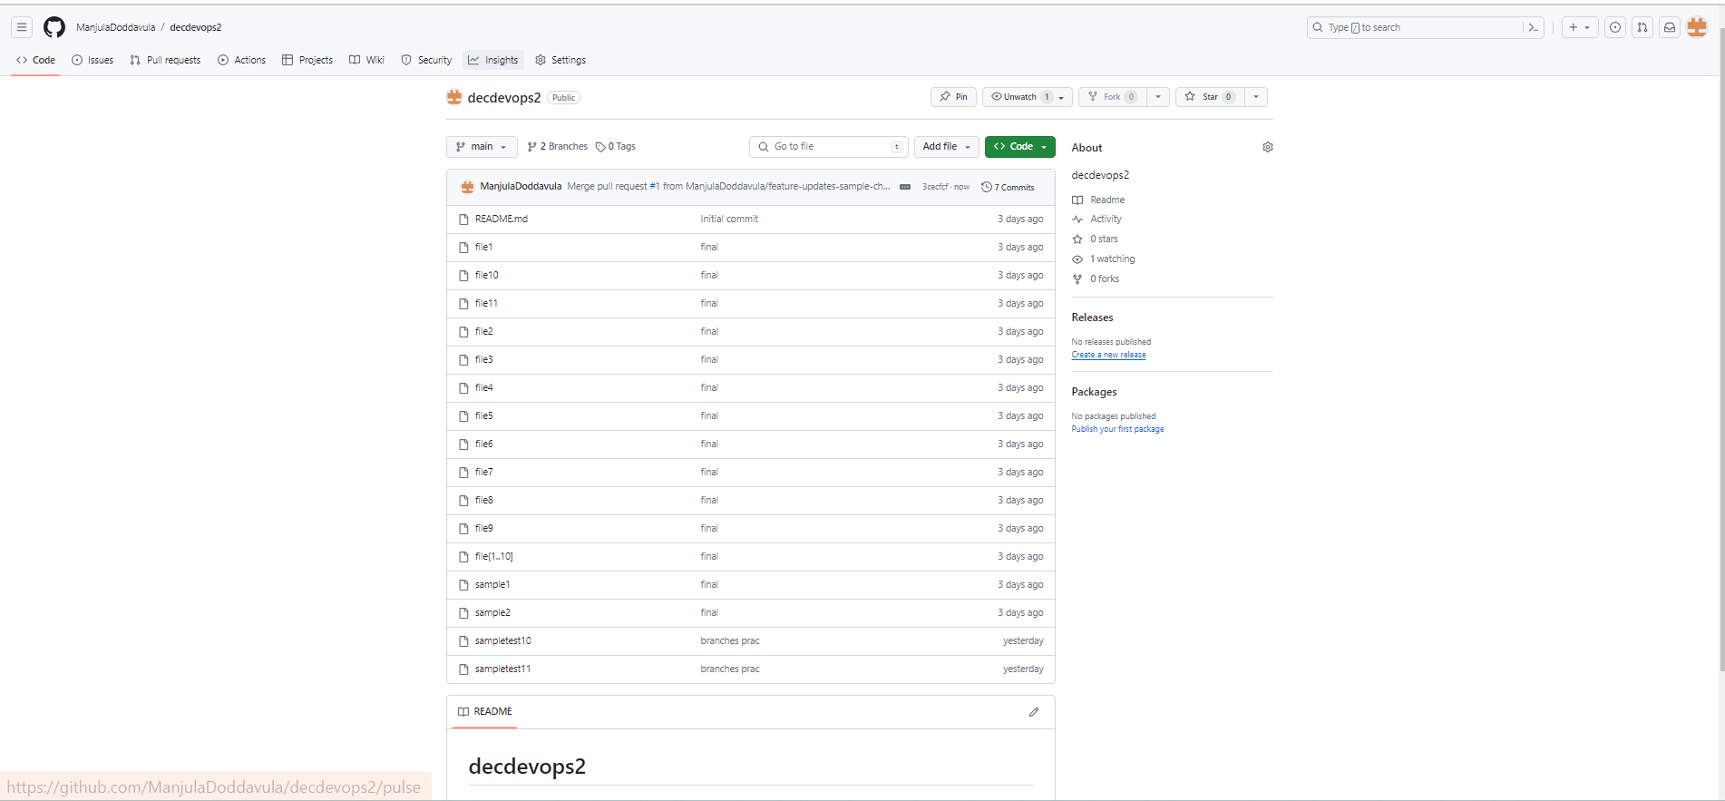

Now we can observe changes occurred in **main branch**

Now code is ready for deployment

By using **git branch** command, it will represent no of branches are created

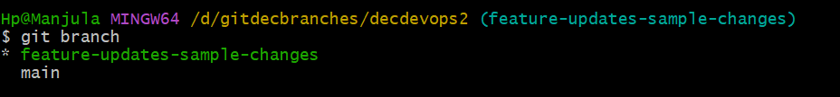

Present we are in **feature-updates-sample-changes**

Now we need to move **main branch** by using **git checkout main** command

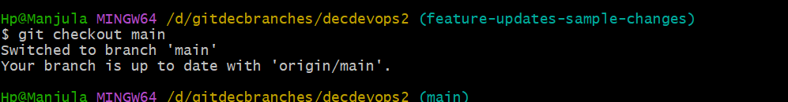

Now we are located in main branch

Here we need to check files which is located in main branch by using **ls -la**  command

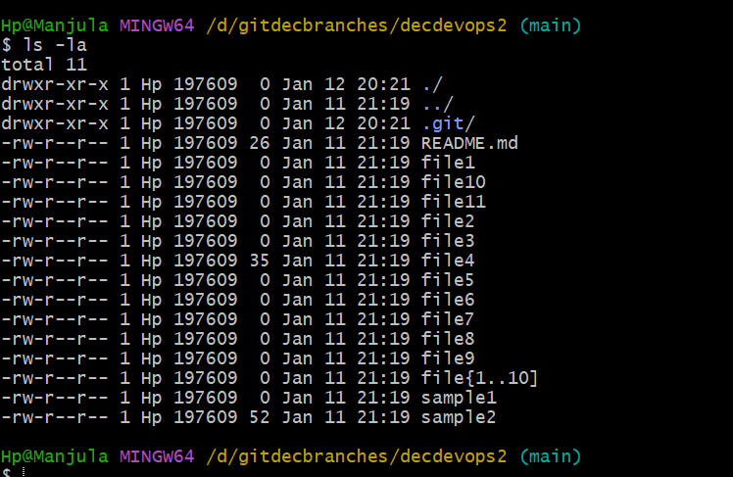

Here we observe pervious files only we can not see any changes which we have done in **feature-updates-sample-changes**

In GitHub repository we have observed changes. These changes need done git terminal means using **git pull** command we can observe changes in git terminal main branch also we can also see those changes using **ls -la** command

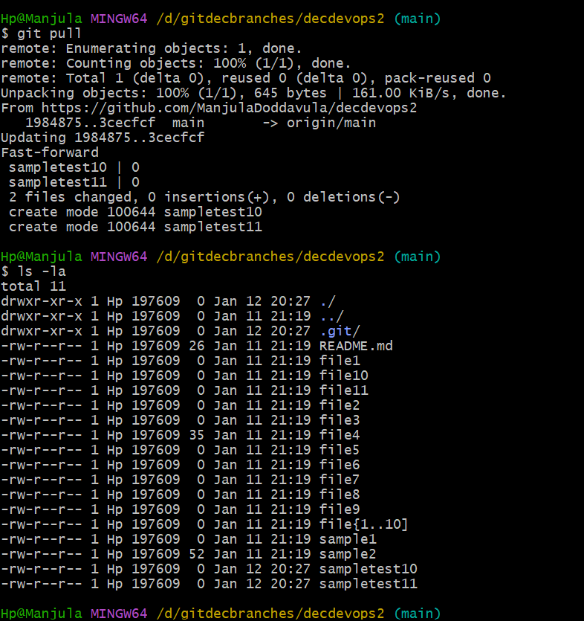

Like this we can create n-number of branches

If we want to work on features updates, we use **git branch** **feature-updates-sample-changes**

If we want to work on bugfix, we use **git branch bugfix-samplepractice-release**

Now we are creating another branch using bugfix from main branch

To check weather branch is created or not we use **git branch** command

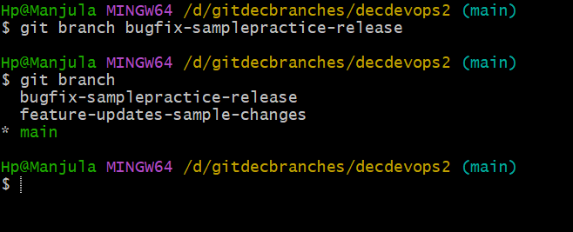

To move from **main branch** to **bugfix-samplepractice-release** we use **git checkout bugfix-samplepractice-release** command

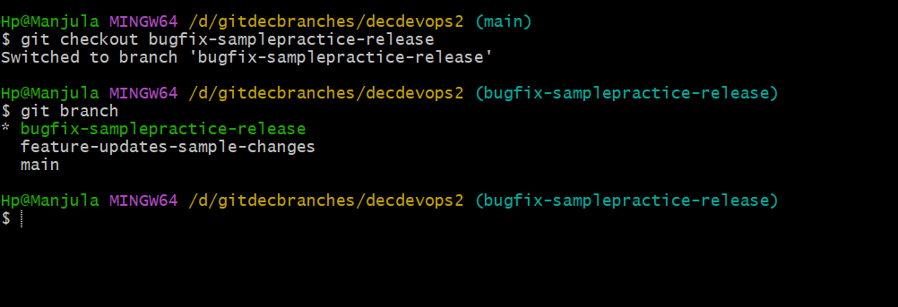

Now we are in **bugfix-samplepractice-release** branch

Now we can use **ls -la** command to check files in **bugfix-samplepractice-release**

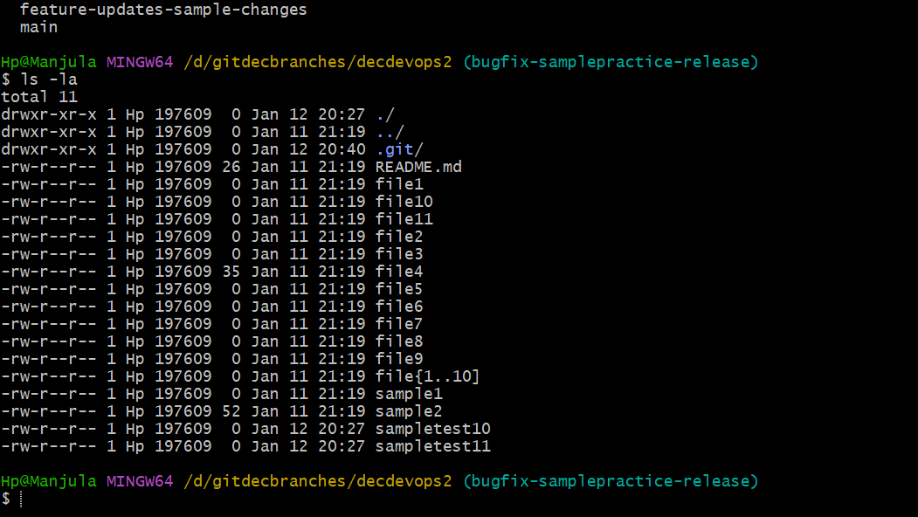

Now by using **vi sampletest10** command. Here we fixed bug

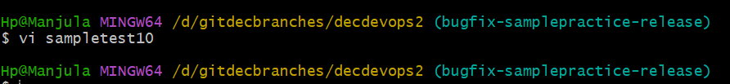

Now we need check **git status**

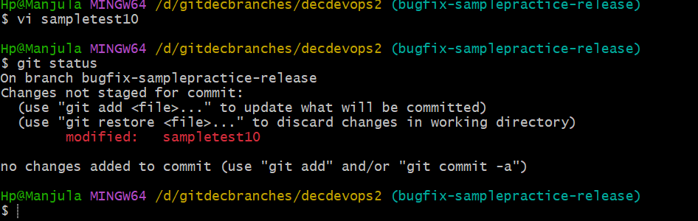

Here we can observe “**Changes not staged for commit**” message because we added data in file

Now file is located in workspace area

Now we need to move file from workspace area to staging area by using **git add .** command and we can check status weather changes done or not

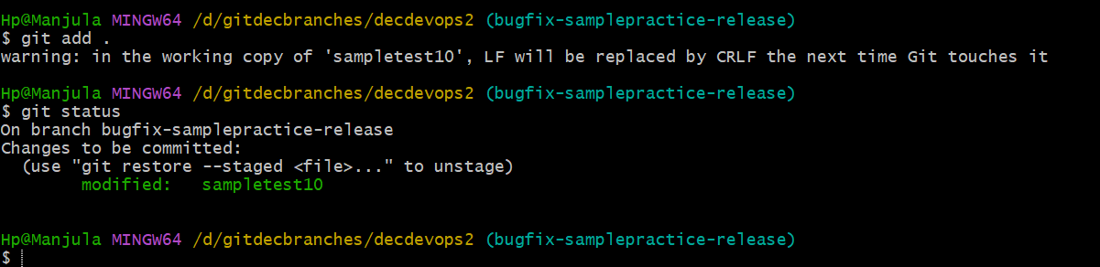

Now file is located in staging area

Now we need to move file into local repository using **git commit -m “bugfix test”** command and we can check status here

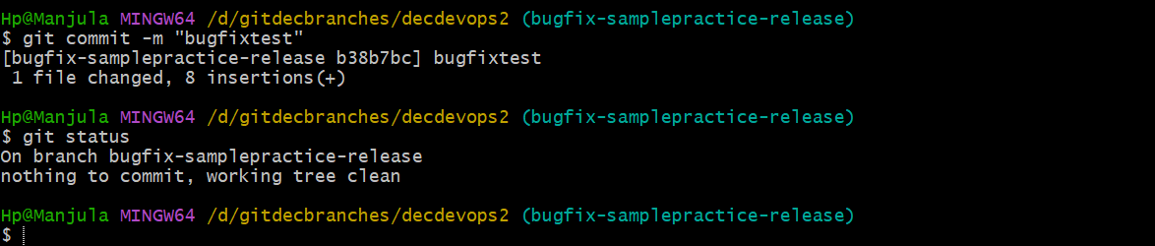

Now file is located in local repository

From here to we need move file git repository by using **git push origin bugfix-samplepractice-release** command

Now file moved to GitHub repository from local repository

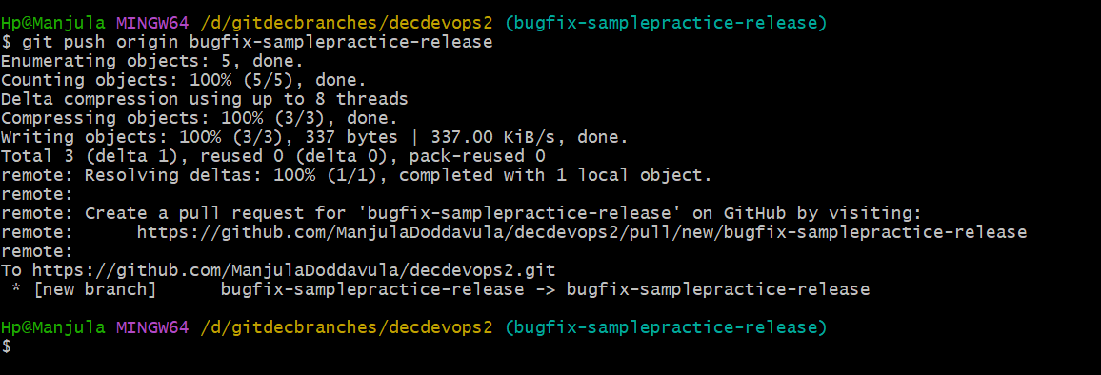

Now in git repository we need do **compare & pull request** to make changes in **main branch**

Changes occurred in main branch in git repository after merging both bugfix-samplepractice-release and main branch

In git repository changes occurred

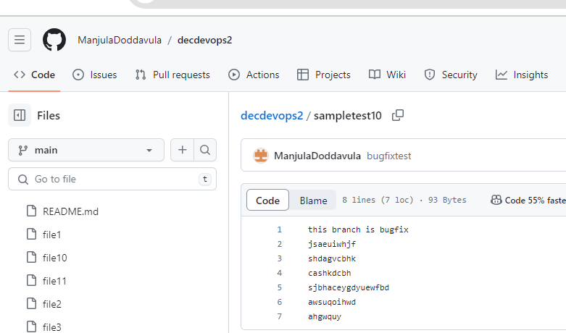

Here we can observe changes occurred in main branch

Now we need to move from current branch to main branch using **git checkout main** command

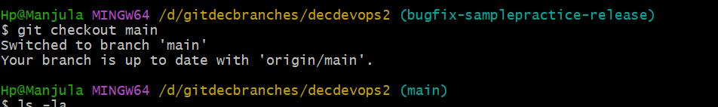

Now we use **ls -la** to check weather changes occurred or not in files. To check weather in sampletest10 file changes occurred or not we can use **cat sampltest10** command

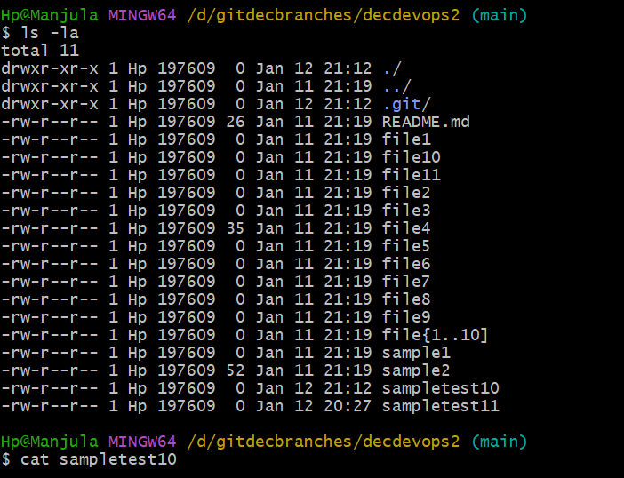

Here we can not see any changes which we have done. Now we are using **git push** command to modify the files. After this we are using **cat sampletest10** command to check weather changes occurred or not

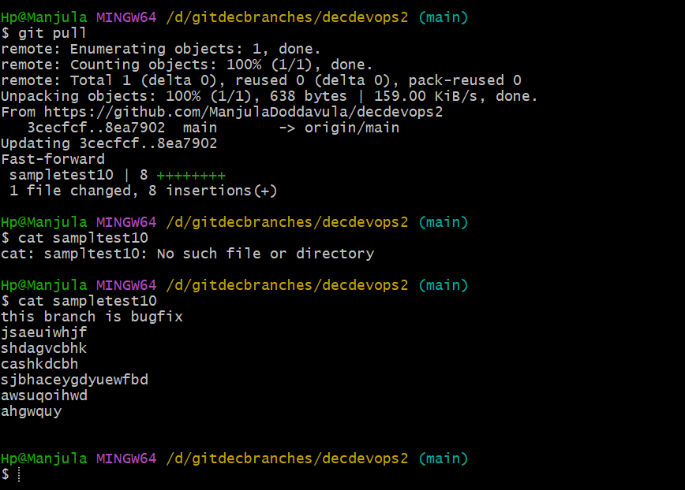

Now we can see changes occurred in file sampletest10

**Note:** class-running-note

Topic: Branching Strategy

Feature, Develop, Releases

By default, main branch is created in git hub

Main branch contains application related code

In real time final application related code contains in main and develop branch

Main branch and develop branch used to deploy the code

By using main branch, we can create new branches

If we are creating new feature

If we are working for bugs to fix

**bug fix -Gmail –** naming conventions

hot fix is nothing but bug fix – used to solve or fix the bugs

feature -update used to update the specific name

**Releases** – in one application we have to create 3 or more new features or new production

Command used to create religious – **releases 1.x**

We can use main or develop branch we can create bug fix etc.…

But better use we use develop to create **bugfix, feature branches, releases**.

**git branch** – used to check where file is located.

**git branch -branch name** – creating new branch using main branch

**git checkout -branch name** – entering to new branch from main branch

**git push** – changing from local branch to GitHub – used only at main branch

**git pull** – changing from GitHub to local branch

**git checkout main** – changing to main from other branches

cat file name

**Date: 08-01-2024**

**Class – 6**

git architecture:

1. workspace area
2. staging/indexing area
3. local repository

GitHub architecture:

GitHub

1. repository
2. by default, we have main branch

git

repository

main

Local repository

Staging area

Workspace area

All these are used to move files from local repository to GitHub repository by using terminal based or by using command line

All these now we are going to do UI.

1. How to create file in UI?
2. How to commit file in UL?
3. How to create branch in UI?

All these we can learn now

We have multiple UL’s

* Gitlab
* GitHub desktop
* Directly we can do directly in GitHub page

Present we are going to practice in GitHub directly

Now we are going to create new branch using “**newtest**” from main branch

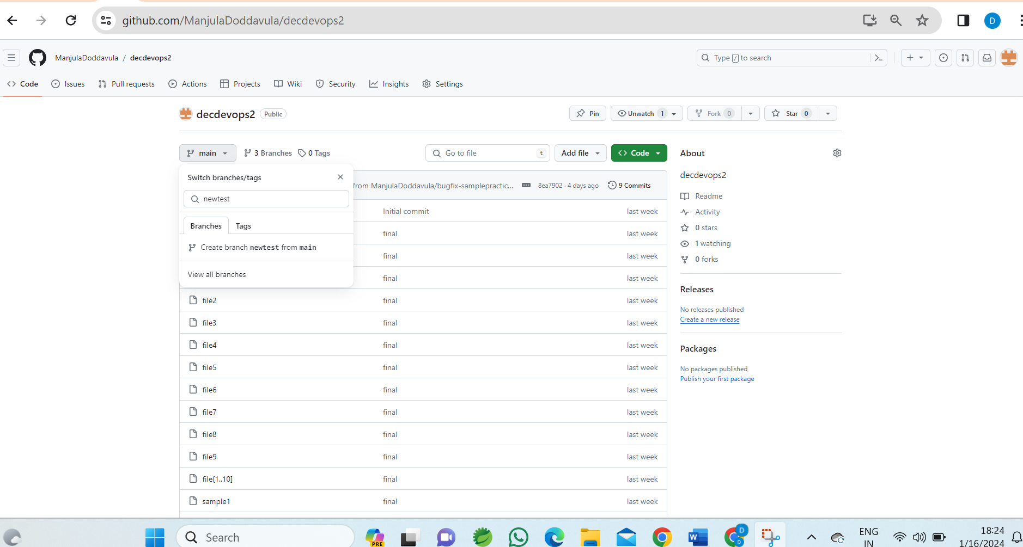

By clicking on “**CREATE BRANCH NEWTEST FROM MAIN**”

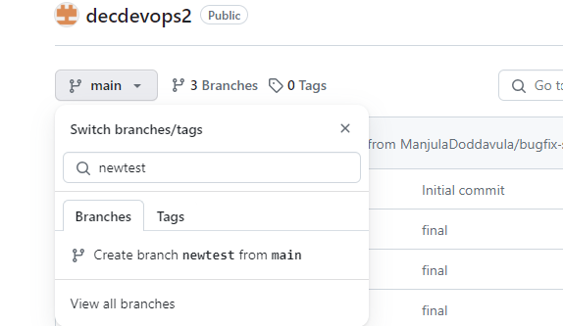

Now new branch is created with “**newest**”

In terminal we need to use **git branch branchname** command to create in terminal In UI we need to give **branch name**  and click on “**CREATE BRANCH NEWTEST FROM MAIN**”

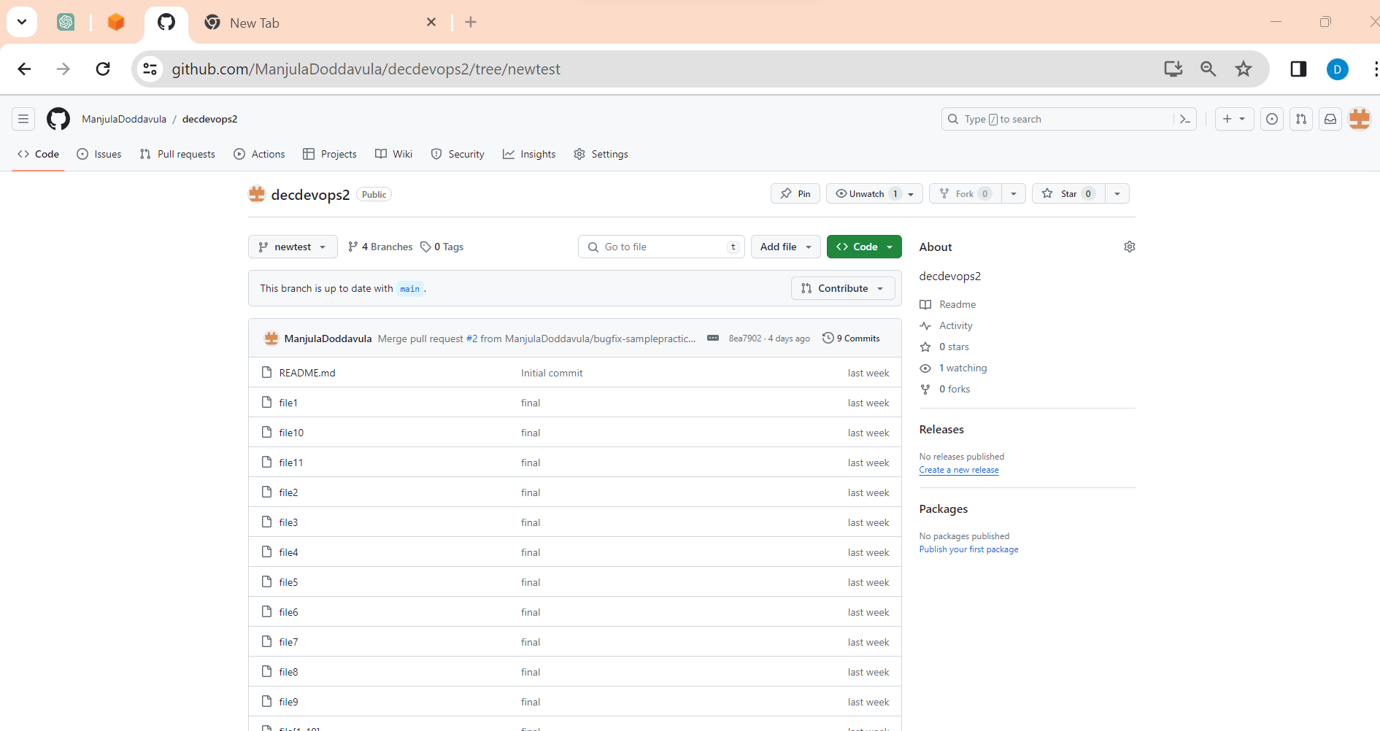

All these files are coming from main branch

How to create File in terminal and UI?

In terminal we can use **touch filename/VI filename** command to create file in terminal

In UI we can use by using **Add file**

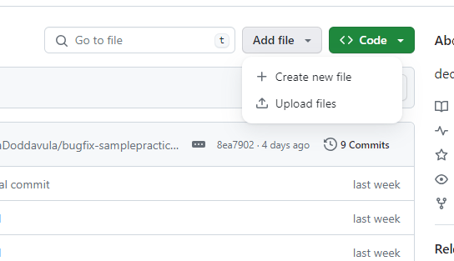

Here we can **create new file** for creating new file

If we have file, we can **upload** file directly

Now here we are creating **new file** in **newtest**

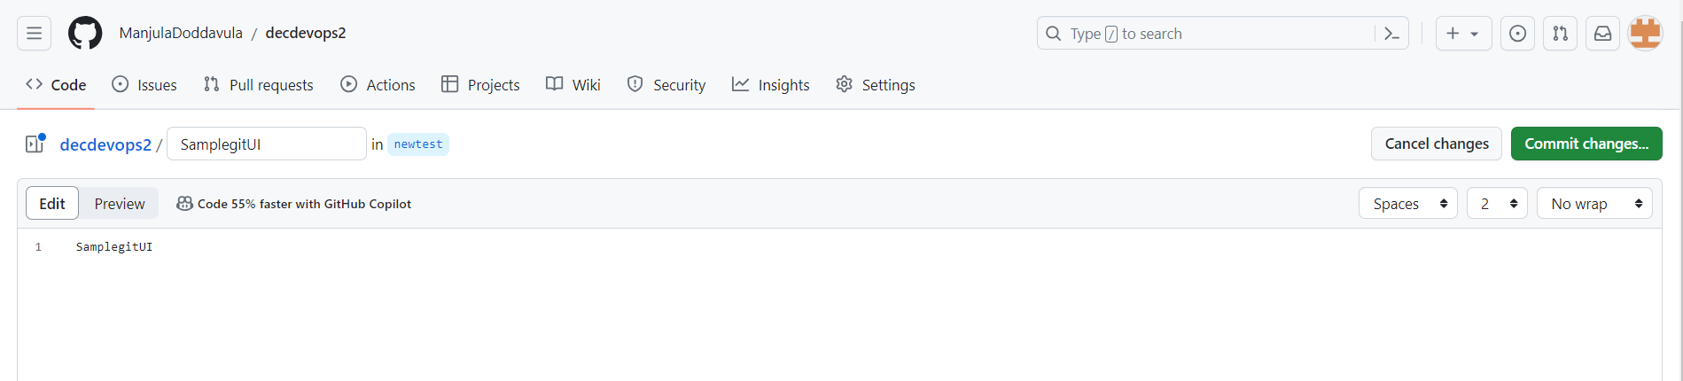

Here we are creating new file with “**SamplegitUI**” by clicking “**commit changes**”

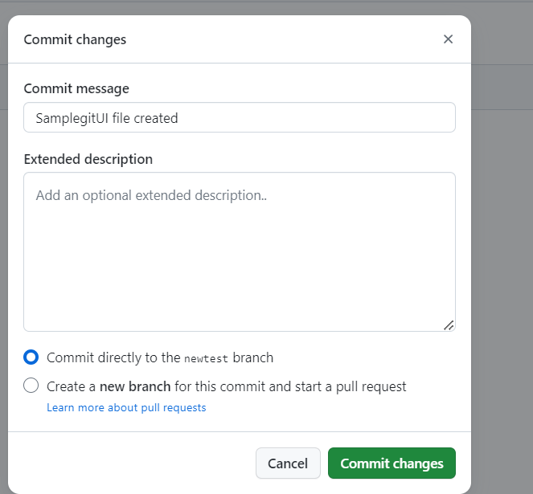

Click on **commit changes**

Now SamplegitUI file is created in “**newtest**” branch

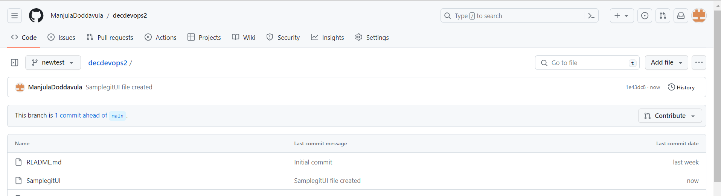

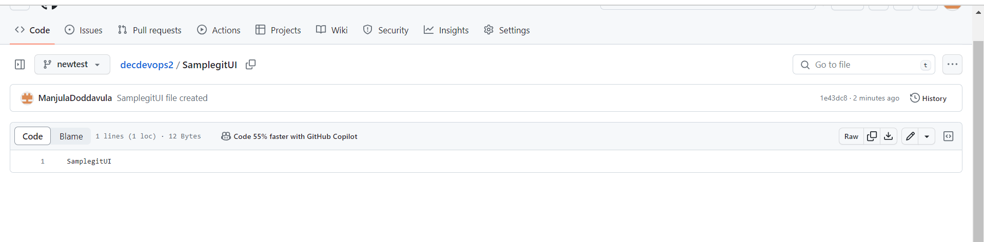

In terminal we can use **git log** command to find commit id’s

Based on label we can find commit id for our file and also using **git show particular commit id** we can see file name

Now we need to click on **compare & pull request**  to occur changes in main branch

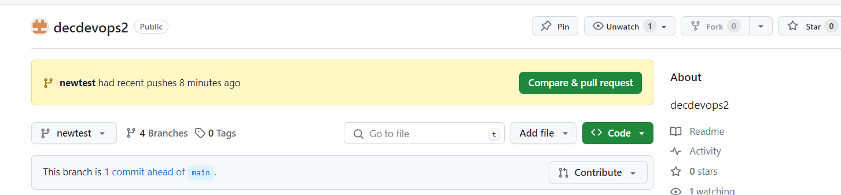

Here we observe file which we created

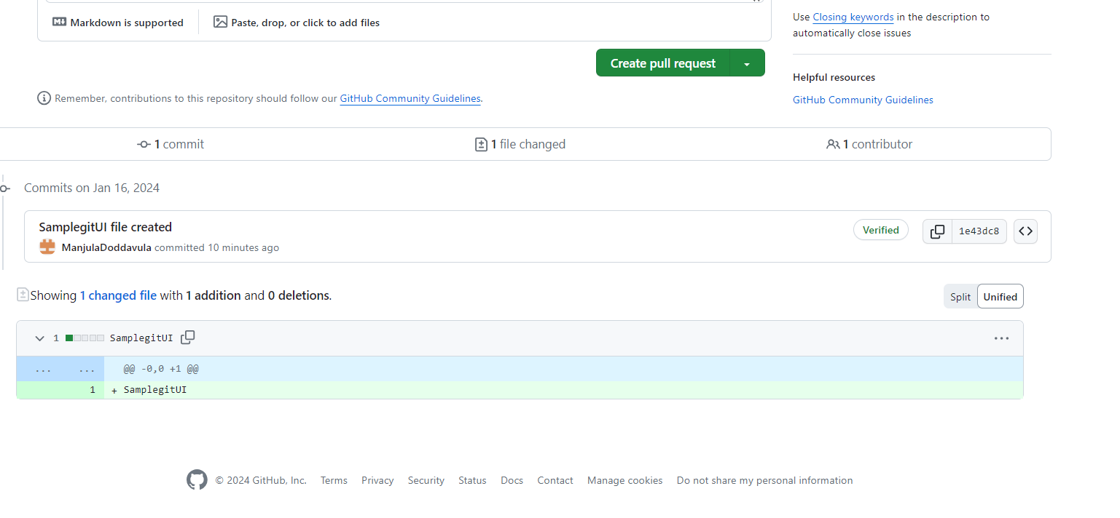

And we can give description why we created file

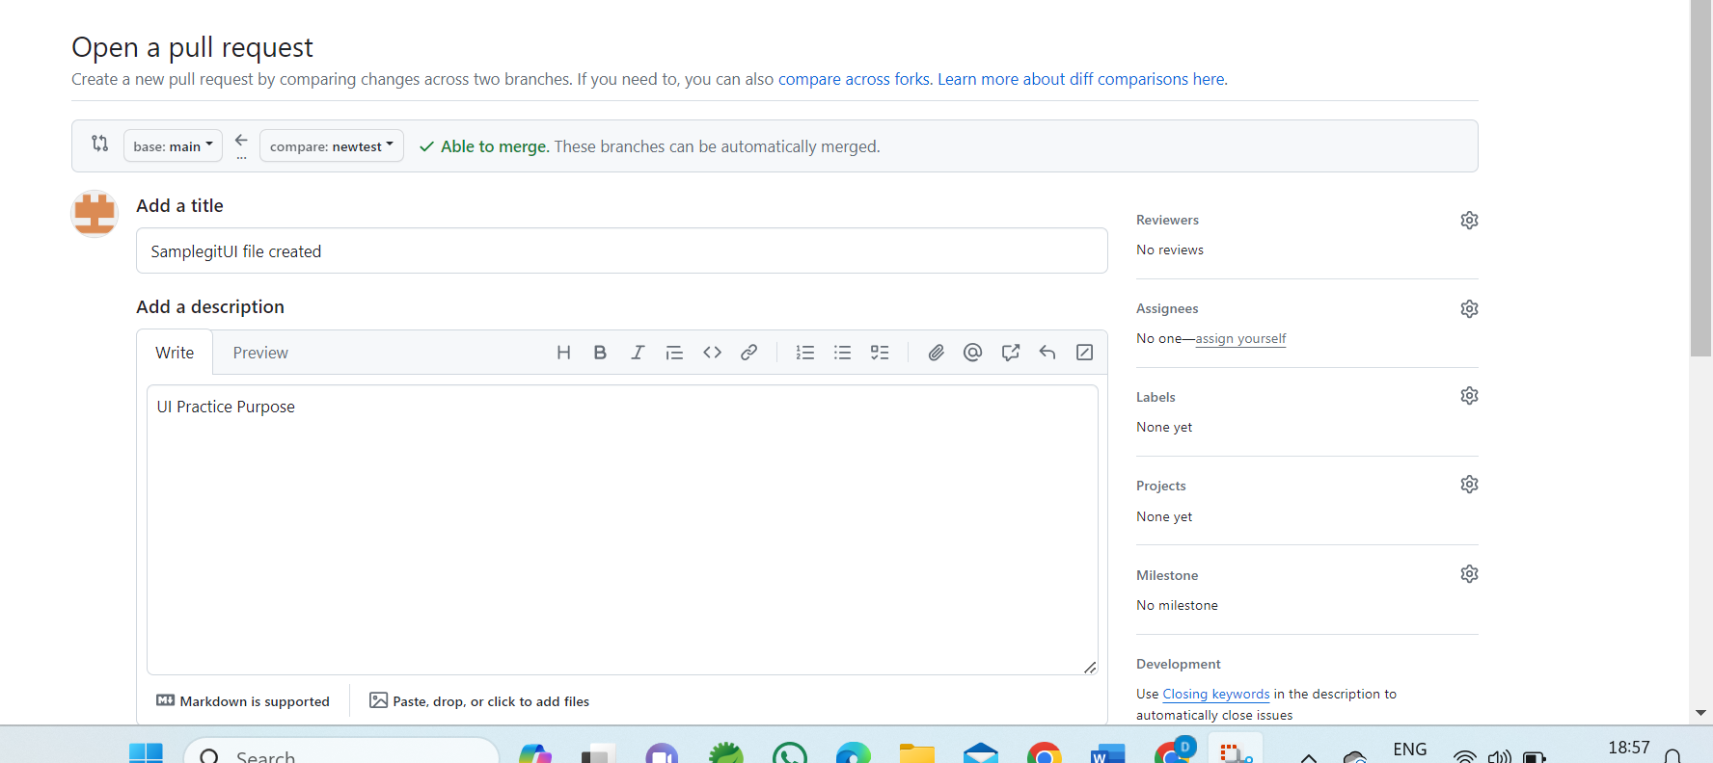

After adding description, we can click on **create pull request** and we observe **merge pull request**

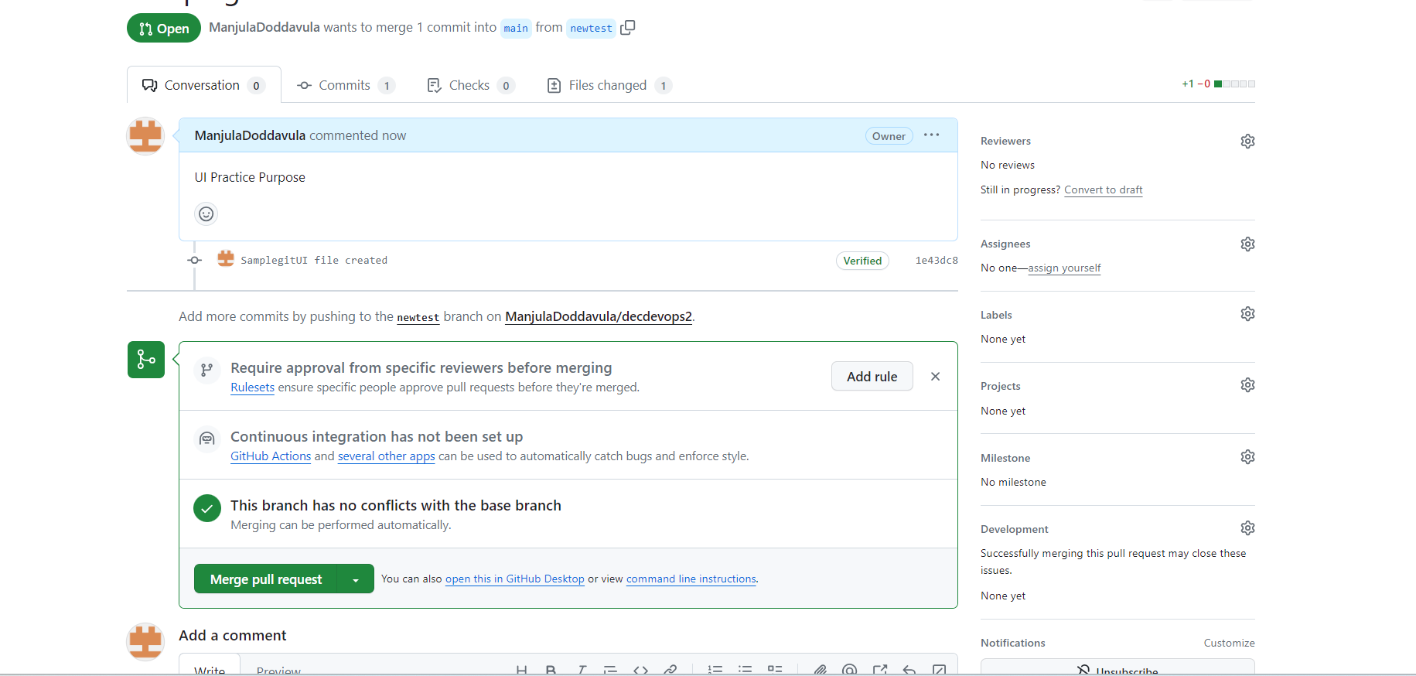

By clicking on **merge pull request** we can see changes in **main branch**

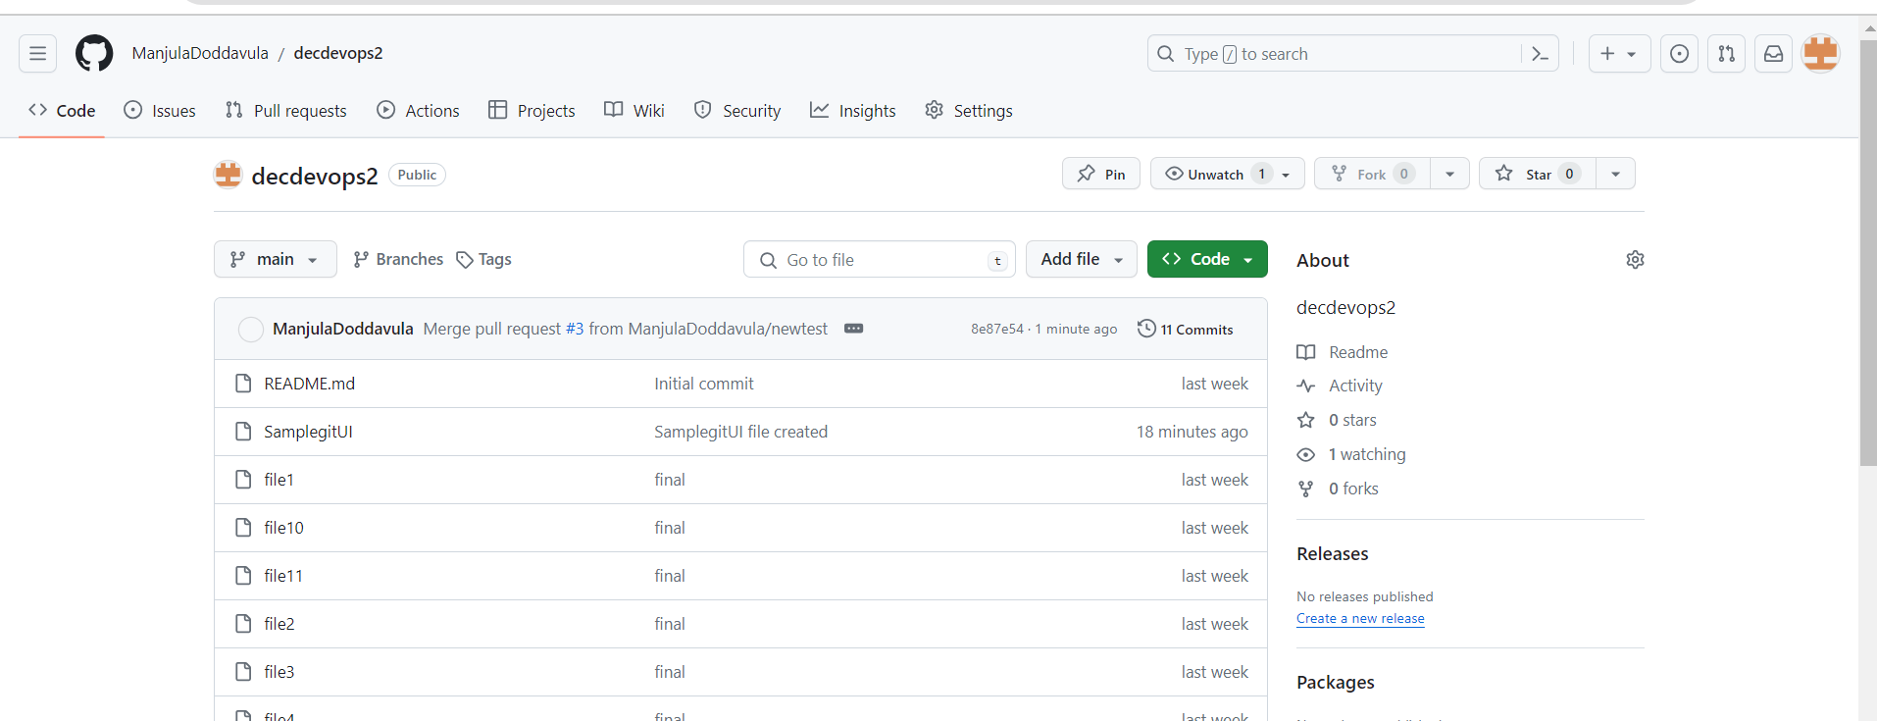

Here we can observe changes in **main branch**

We can also delete branches directly

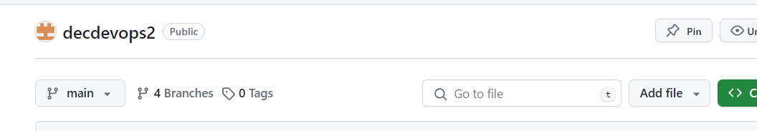

By click on branches we can see all branches which we have created

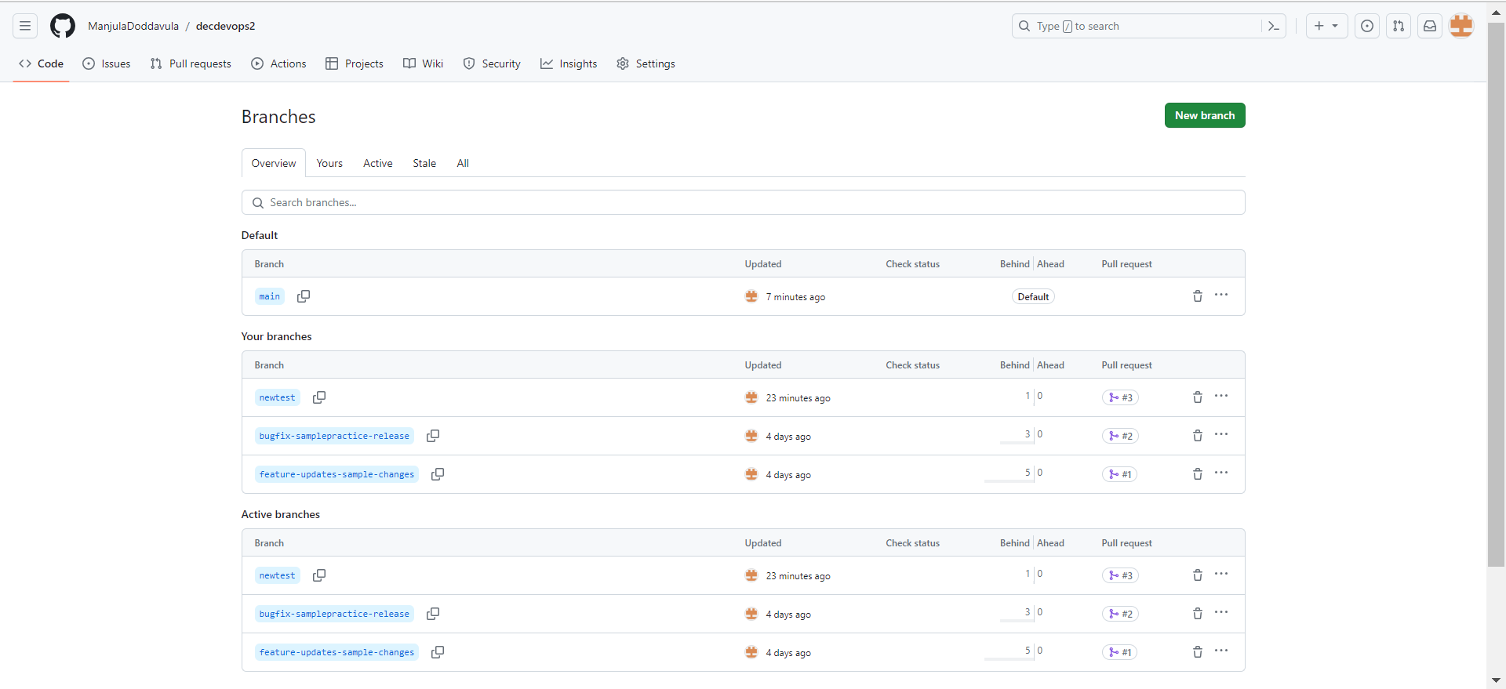

Here we can see delete option 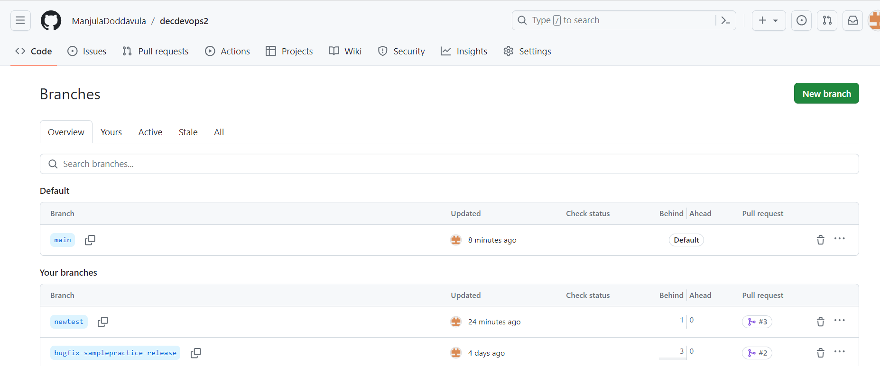

By using delete option we can delete branches directly

Again, we create new file in main branch by click on **Add file – create new file**

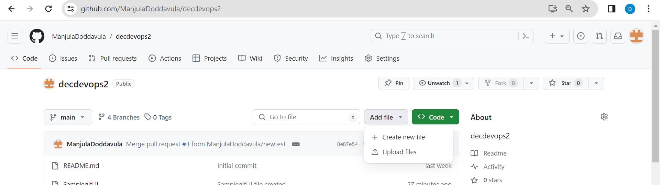

Here we are creating file with “**SamplegitUI2**”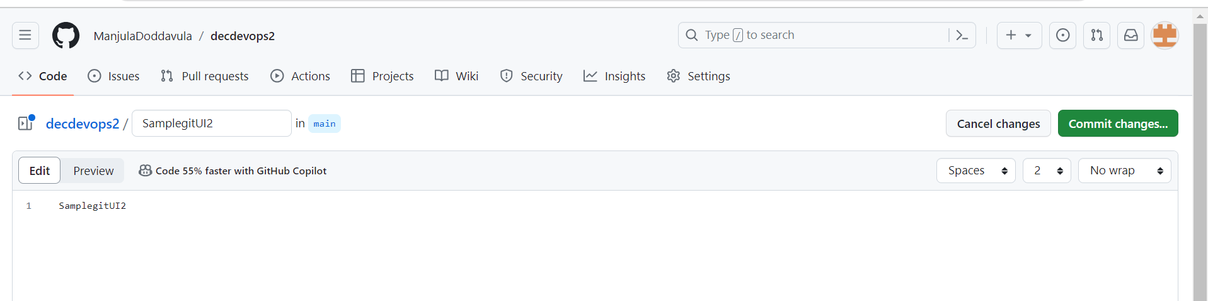

Now click on **Commit changes** then we need to give description “**Created new text file**” then we can observe changes in main branch

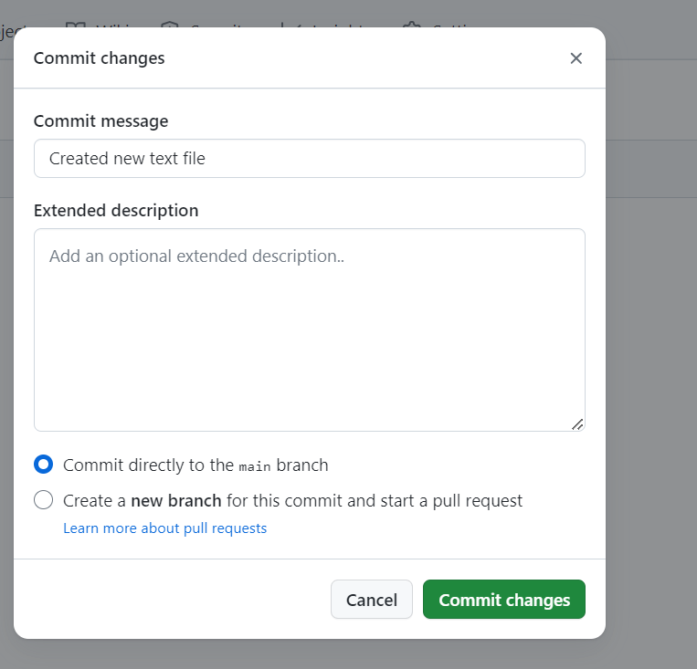

Click on **Commit changes**

Now we observe changes in main branch

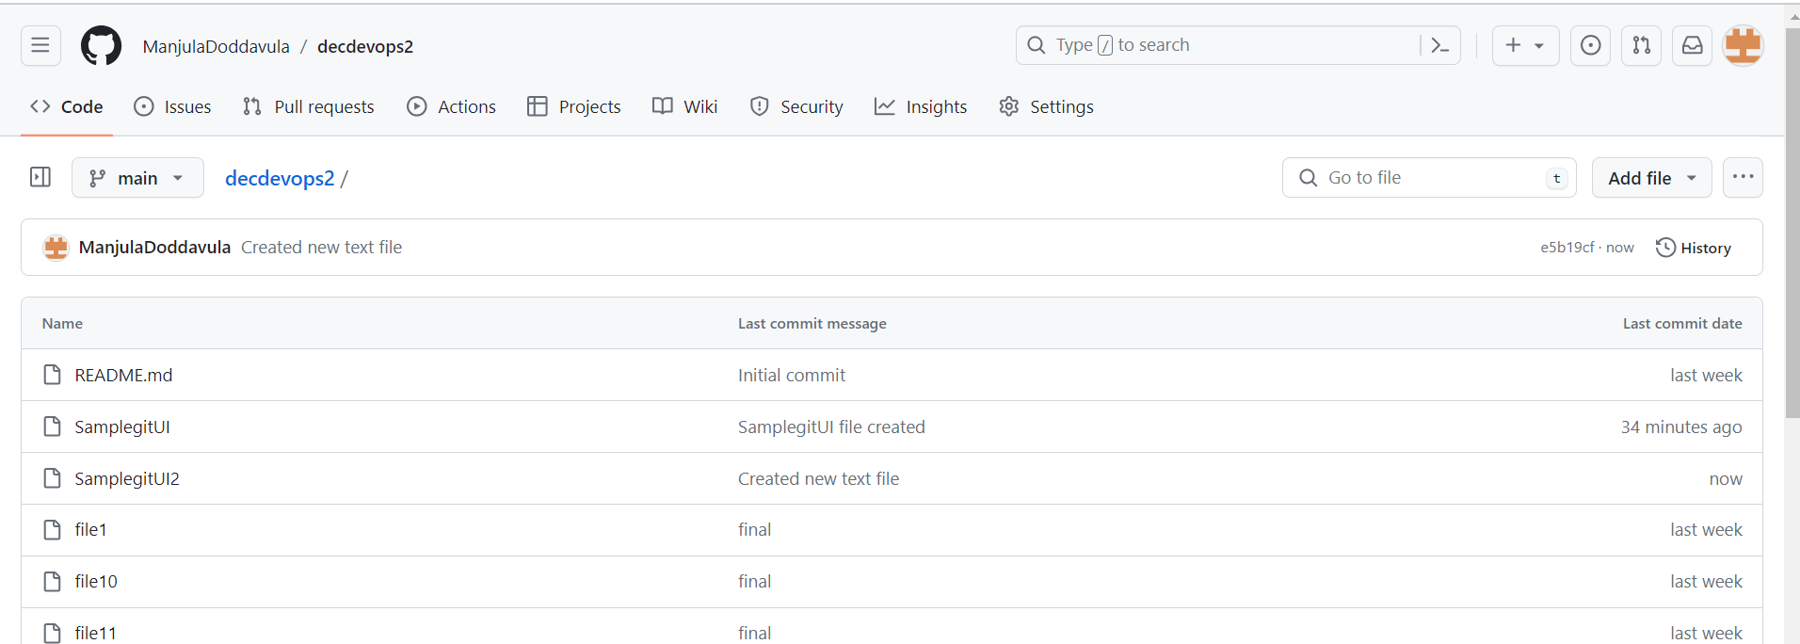

We created new files in git repository and these files weather we can observe in local repository

In local repository we cannot find files which we have created new files

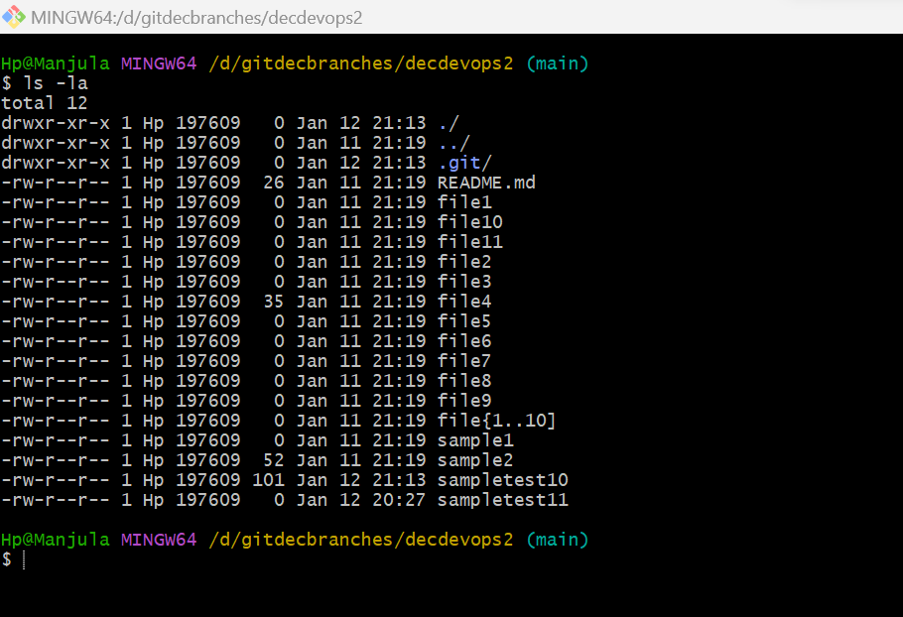

Now we use **git pull** command to see changes in local repository also which we have changed in GitHub repository

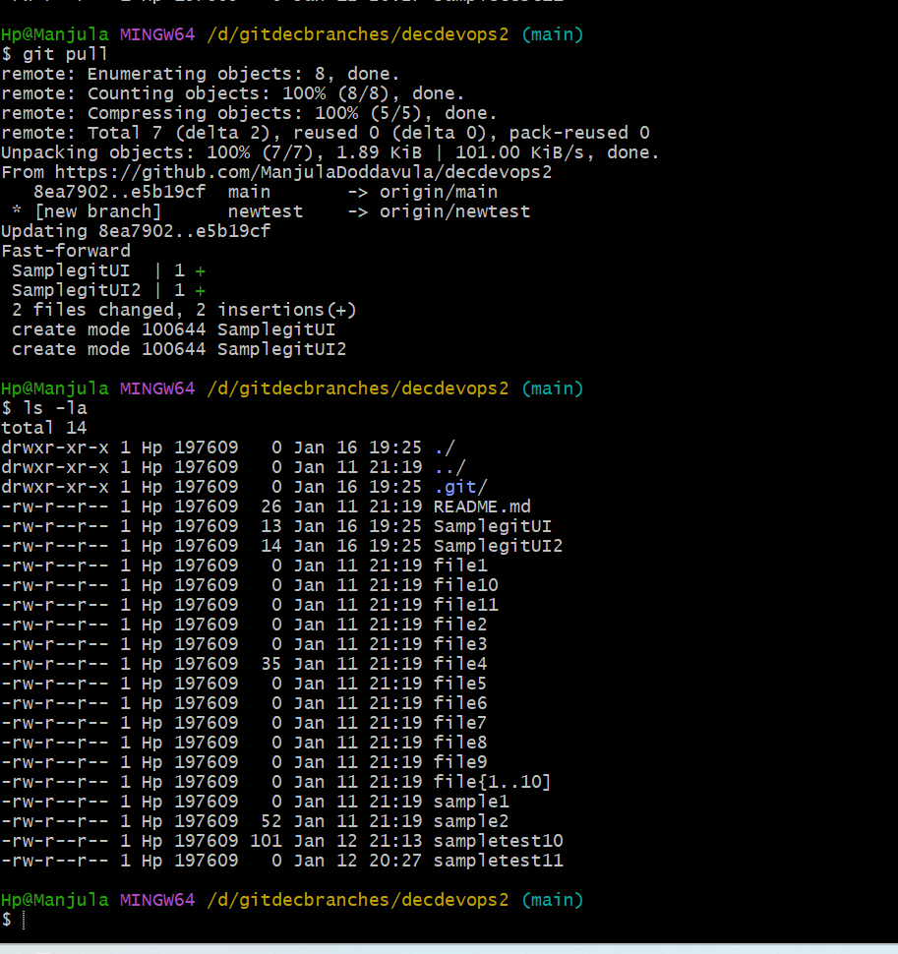

Here we observe files are added which we have created in GitHub repository

How create pull request and merge request in terminal?

Here also we find main branch. Along with main branch we can see which branches are created by using **git branch** command

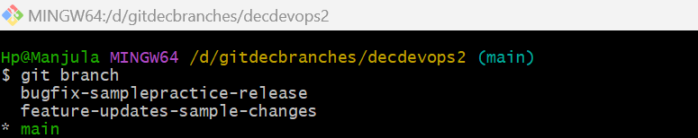

Now we are creating new branch using **git branch branchname** command

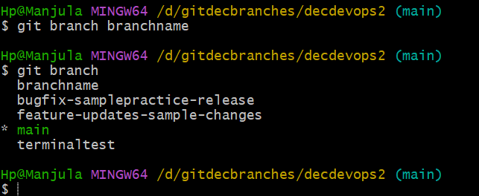

Here we can observe branch is created from main branch

How to change from **main branch** to **terminaltest**?

We can change from **main branch** to **terminaltest** Using **git checkout terminaltest** command

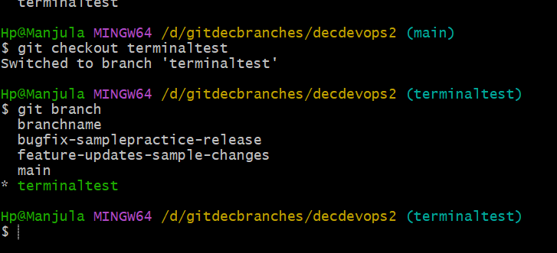

Now we are in **terminaltest** we can find in two ways in which branch we are located currently

* By using **git branch** command and which branch is indicated with **star**  that branch is currently activated
* By seeing **Hp@Manjula MINGW64 /d/gitdecbranches/decdevops2**

**(terminaltest)**

By using **ls -la** command we can see files in **terminaltest**

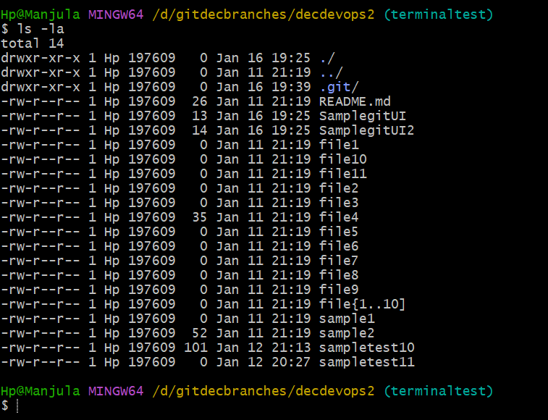

All these files are came from main branch

Here we are creating new file using **touch Test.java** these file created in **terminaltest**

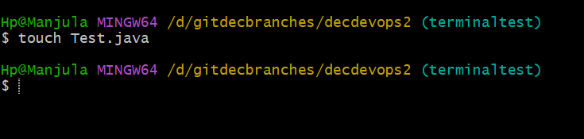

By using **git status** command we can see where file is created

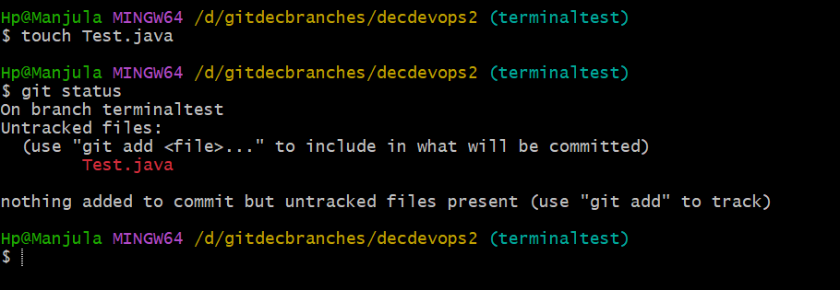

Here we can file is located in workspace area(untracked files)

Now we need move file from workspace area to staging area using **git add .** command and we use **git status** command weather changes occurred or not

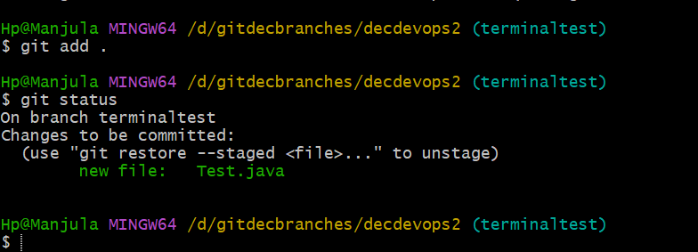

Now file is located in staging area(changes to be committed)

Now we need move file from staging area to local repository by using **git commit -m “terminal changes”** command and we use **git status** command to check file location

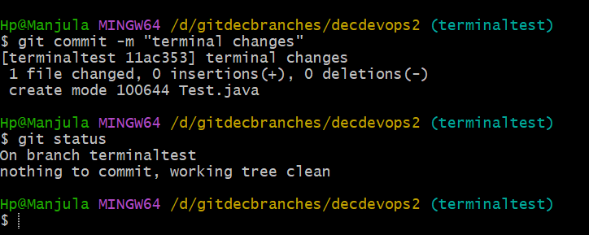

Now file is located in local repository(working tree clean)

From local repository to we need push file in to GitHub repository

Now all these changes are located in **terminaltest** from here to we need push changes to **main branch**

* First, I’m moving to **main branch** by using **git checkout main** command

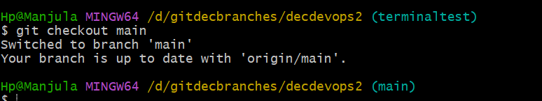

Now I’m in main branch.

By using **git merge terminaltest** command. We can observe changes in main branch using **ls -la** command

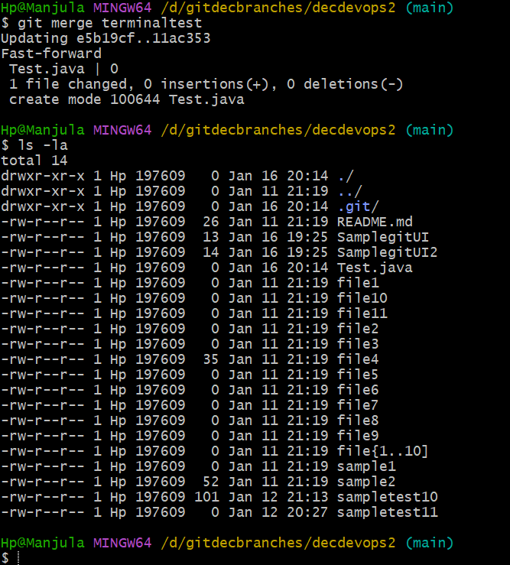

We can observe changes in main branch

Now we can push file directly to GitHub repository from local repository by using **git push** command

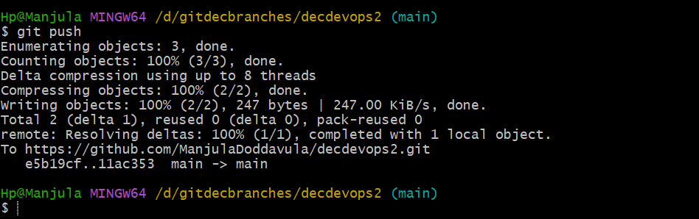

Now we can observe **Test.java** file in GitHub repository

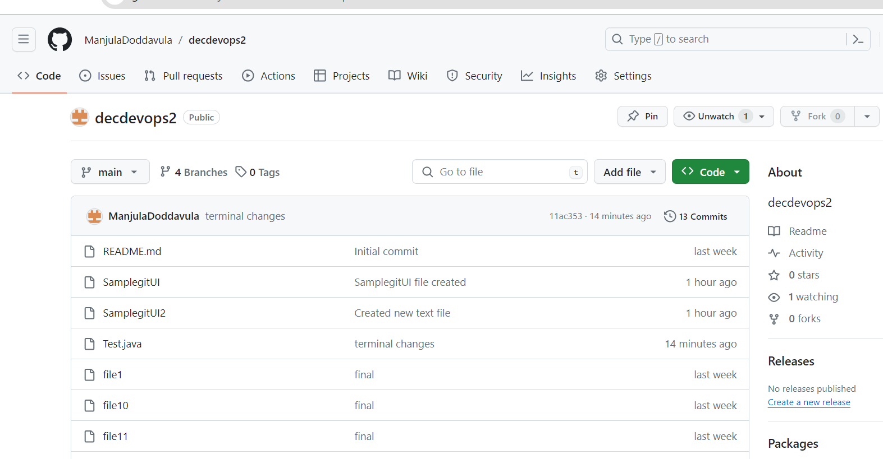

Now we are in **main branch** from here we are moving to **terminaltest branch** by using **git checkout terminaltest**

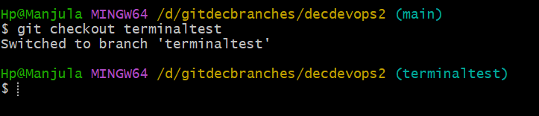

Now we are in **terminaltest** branch, here we are creating new files using **touch Test2.java** command and we use **git status** to check file location

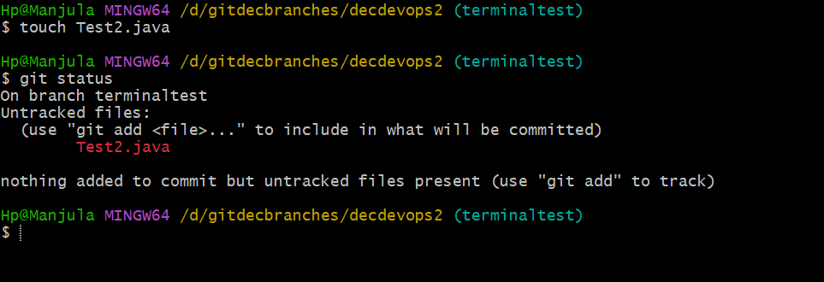

Now file is located in workspace area(untracked files)

We need to move file from workspace area to staging area using **git add .**  command and to check file location we use **git status** command

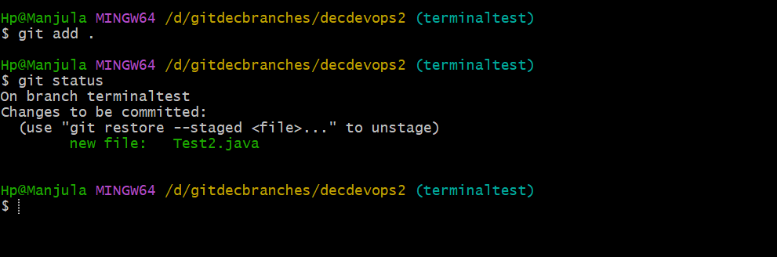

Now file is located in staging area(changes to be committed)

We need to move file from staging area to local repository using **git commit -m “new file creation”** command and to check file location we use **git status** command

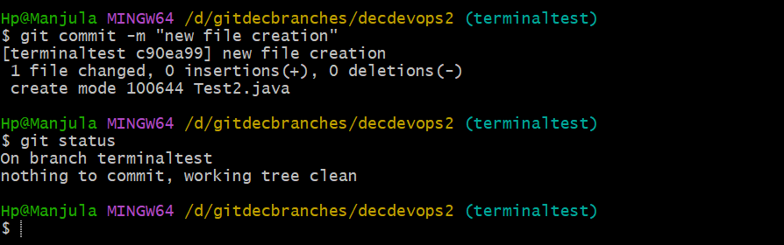

Now file is located in **local repository** from we need to move **main branch** using **git checkout main** command and we need use **git merge terminaltest** command to occur changes in **main branch** which we have done **terminaltest branch** by using **ls -la** command can observe weather changes occurred or not in **main branch**

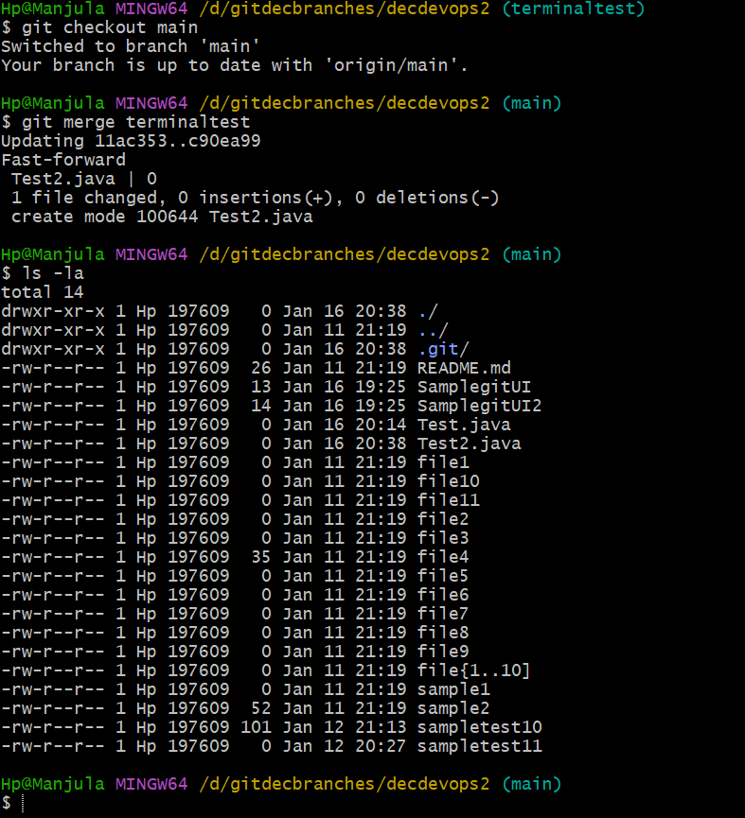

Here we can observe changes in **main branch** in **local repository** from here we push files directly to **GitHub repository** using **git push** command

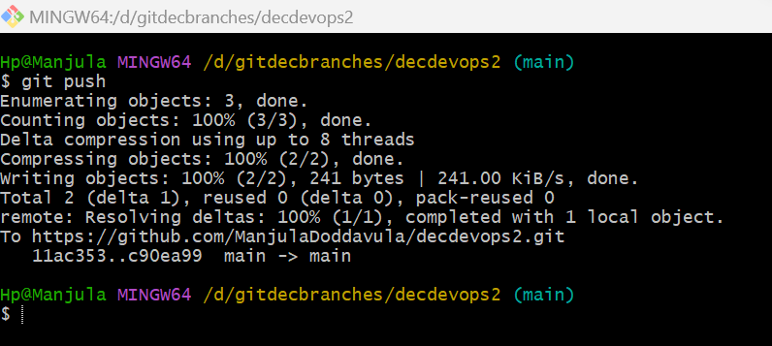

then we observe changes in GitHub repository also which we have changed local repository

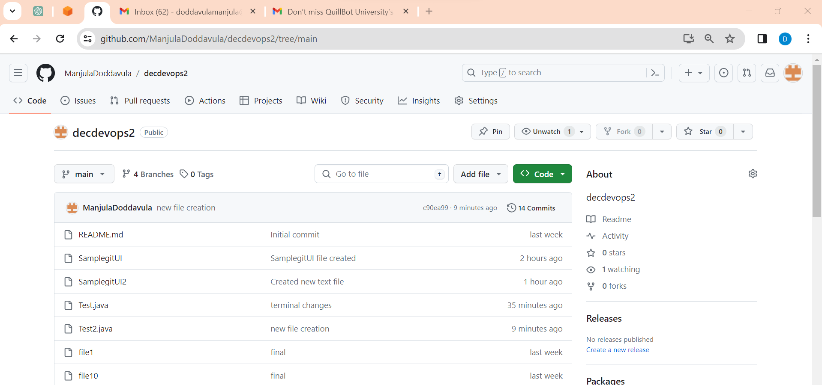

**Date: 09-01-2024**

**Class -7**

**Collaborator access**

**Date: 10-01-2024**

**Class – 1 UI Class**

Normally we can see real time applications like WhatsApp, Instagram, Facebook, Google, etc... all these applications we are using in day-to-day life.

Chrome is one type of browser

One is purely **UI based application** we can prepare

Second is **microservices application** we can prepare

UI based application, Microservices applications and Some other kinds of applications we can do deployments in real time

We can create our own application and deploy. We have different kinds of deployments like Docker, Quenette’s, tomcat server, etc…

Now we are going to discuss about UI based applications.

For microservices we need number of servers, we need to configure at the same time Rest APIS, Rest Clients, postmen etc... we need third party tools

Frontend (Angular Js, react Js, nodes Js, etc..) middleware (Java, C, Python, Ruby, .Net, etc…) we deploy all these applications in Devops.

Devops process is not only for specific technologies deployment in this process we are going create UI based application

For this we need:

* + - JDK
    - eclipse IDE/vs code

How to install JDK?

Open chrome click on search button enter “**jdk 17 download**” press enter

Select OpenLogic website

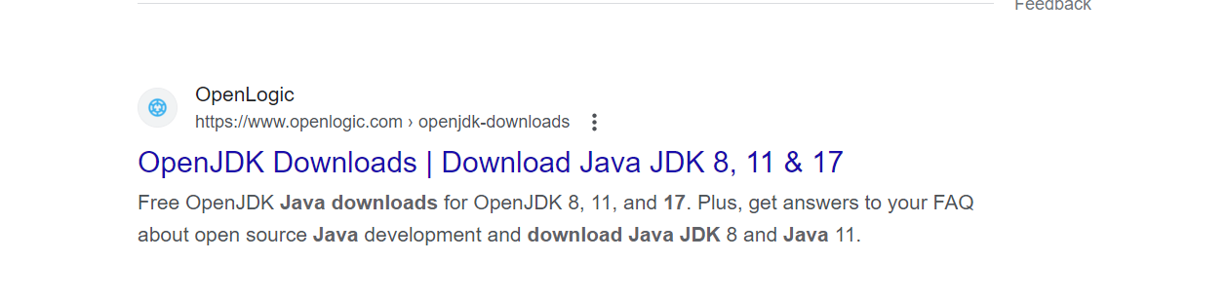

Download for windows

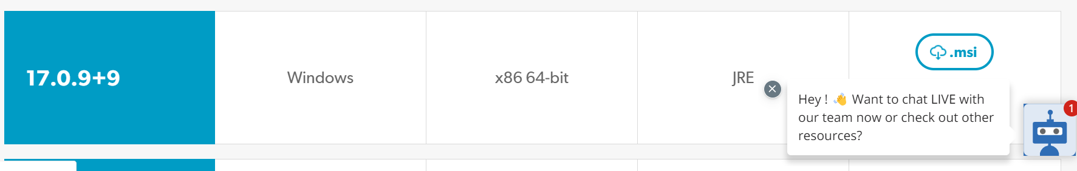

Now click on “**.msi**” file then download will start

Once download completed we can find it in downloads. Now double click and click on next and click on next and install.

Click on finish

How to set path?

Once installation completed the we need set path

* open my computers
* select **c-drive**
* select **program files**
* select **java**
* select **jdk 1.8.0_301**
* select **bin**
* copy address up to bin folder **"C:\Program Files\Java\jdk1.8.0_301\bin"**
* click on this **pc**
* right click on **properties**
* click on **advanced System settings**
* click on **Environmental variables**
* in user variables

\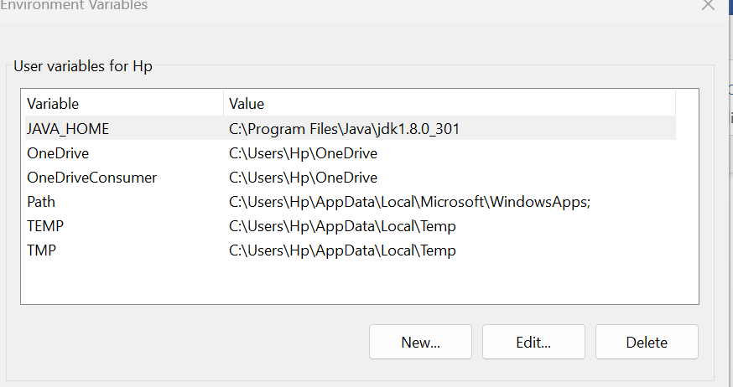

* click on **new**
* provide variable name **JAVA_HOME** and variable value **"C:\Program Files\Java\jdk1.8.0_301"**

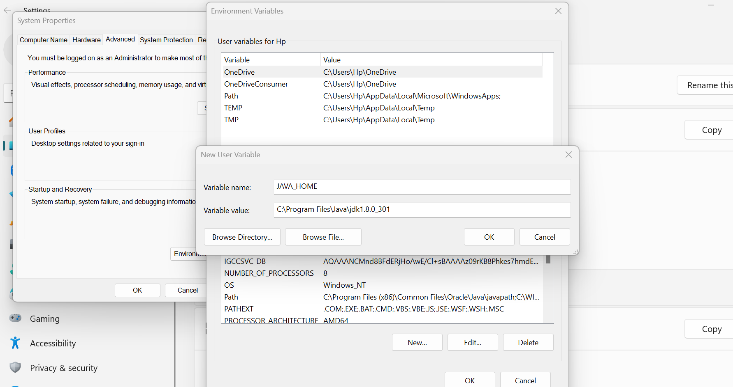

* Click on **ok**
* In System Variables Double click on **Path**

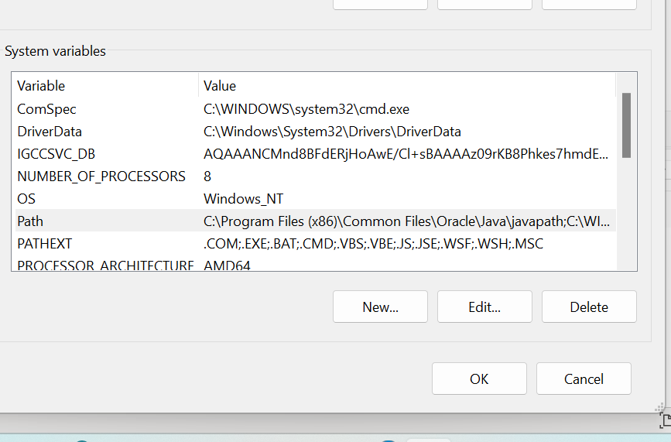

* Double click on **path**
* Provide path "C:\Program Files\Java\jdk1.8.0_301\bin"

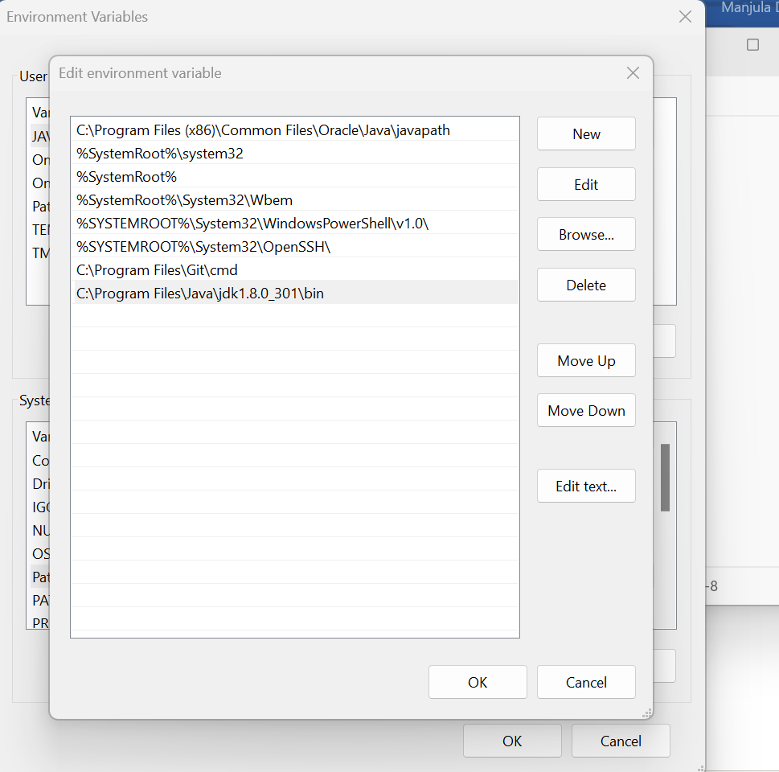

* Click on **ok**

Open cmd and type **javac** it will show some paths it means we have set java path successfully

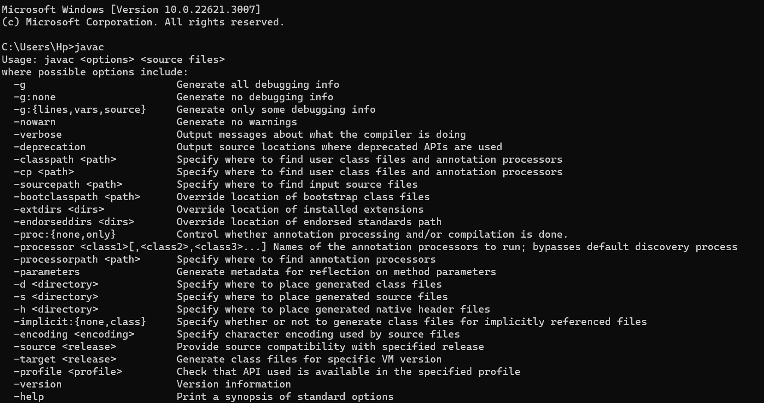

To check version, we use **java -version** command it will show which version we are using currently

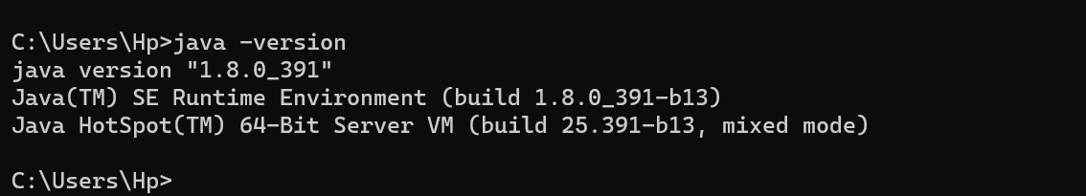

JDK 🡪 download 🡪 installation process 🡪 go to environmental variables 🡪 copy path till bin 🡪 provide 2 entries(user variable, System variable) 🡪click on ok

How to download eclipse?

* Open chrome 🡪 click on search button type eclipse download 🡪 press enter 🡪 Click on this link [**https://www.eclipse.org/downloads/**](https://www.eclipse.org/downloads/)

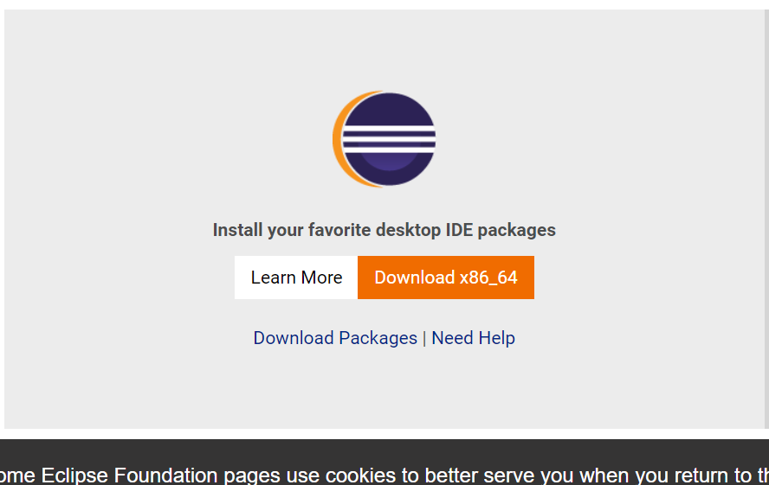

* Click on download
* Go to downloads Double click on **eclipse ide**
* Window will open as shown in the below picture

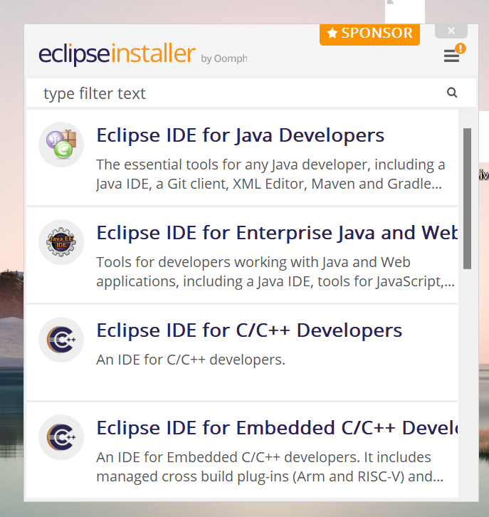

* Eclipse installer is used for multiple developers
* Click on **Eclipse IDE for Java and Web Developers**

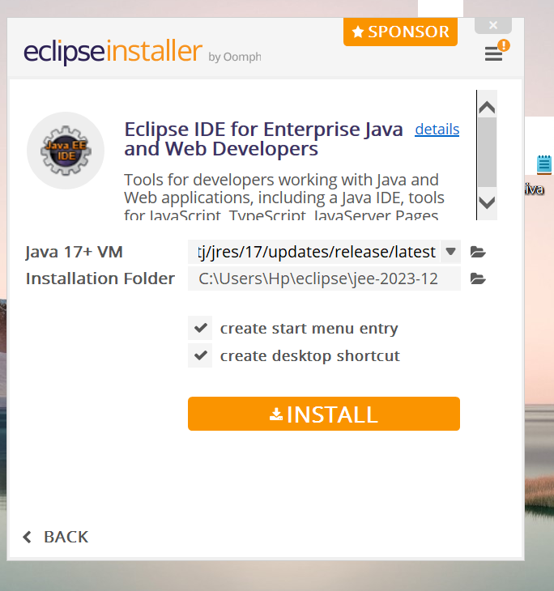

* Click on **install**

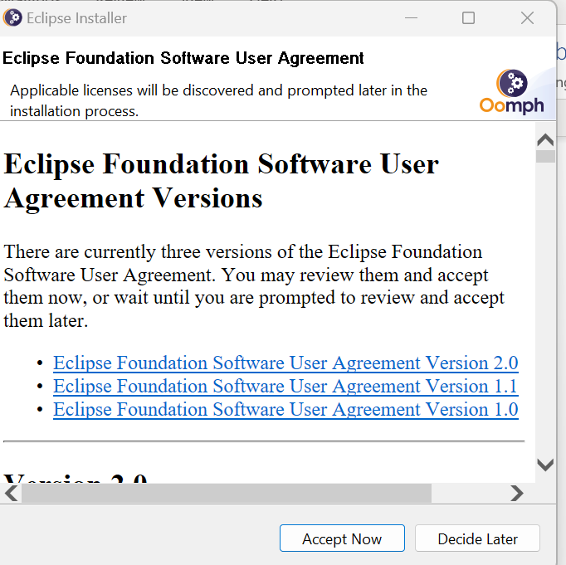

* Click on **Accept Now**
* Once installation completed Click on **Launch**
* Click on **browse** 🡪 select **This PC 🡪** select **D-Drive 🡪**select folder **decuiapp**
* Click on **Launch**

Still in java we have worked on Stand Alone Application means the code which used only for backend in this project we can observe on **src and JRE files** except this we cannot find any other files

Now can observe **src and JRE files** at the same we observe files which is used for Ui application

In eclipse we have created java project with “**Test**” by default we have **src and JRE System Library**

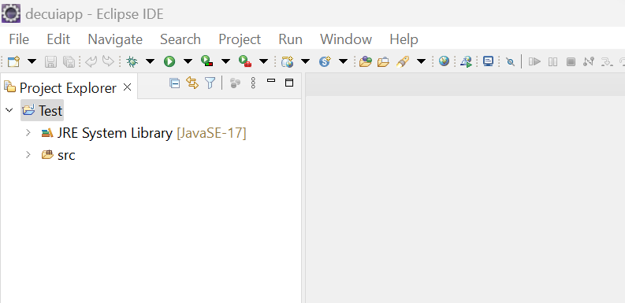

Here in **src** we can create **package** in that **package** we can create number of **classes** and we work on it this one way in eclipse

Like this we have number of ways we have to create classes in eclipse

In real time we **maven based application** we use more

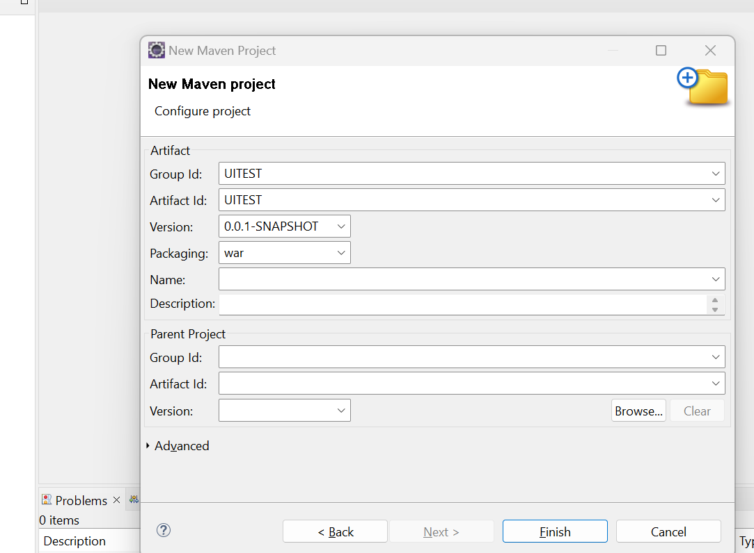

In UITEST we can find many number of files but in Test we observe only **src and JRE System Library**

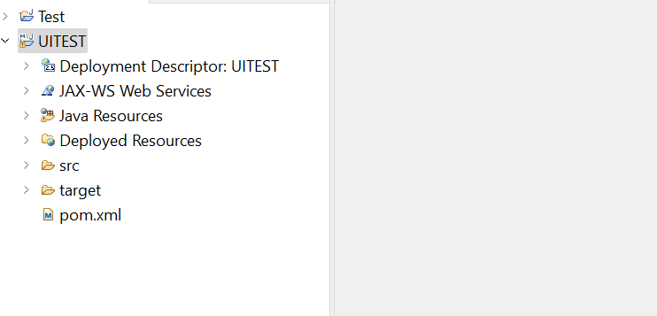

In maven we can develop code for real time applications

**Date: 11-01-2024**